

**McNair Scholars Program Newsletter**

Spring 2021

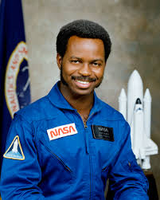

**Ronald E. McNair**

**Congratulations McNair 2020-2021 Scholar Graduates**

**Fall 2020**

Abigail Champion

Julie Enriquez

Sayge Flores

Pilar Harkless

Lauren Williams

**Spring 2021**

Alan Garduno

Esteban Guerrero-Ortiz

Brianna Hurst

Katherine Lanoue

Anna Maree Longoria-Porterfield

Amanda Moya

Paul Perez

Jesus Quintanilla

Isaac Vargas

**Summer 2021**

Valentina Campos

▲2019 Cohort, Spring 2020

Top left to right: Loren Walker, Daniel San Miguel, Eduardo Luna, Ryan Nerios

Middle left to right: Megan Greige, Krystal Garza

Bottom left to right: Gabriella Garcia, Valentina Campos, Katherine Lanoue, Natalia Pellum-Mackey

McNair Scholars 2020-2021

**Jesus Baca Alan Garduno Jasmin Gomez Esteban Guerrero-Ortiz**

Chemistry Engineering Math Education Psychology

**Brianna Hurst Meghan Moore Amanda Moya Paul Perez**

Biology Psychology Communications Sports Management

**Jesus Quintanilla Kara Rayha Roslyn Swonke Isaac Vargas**

Psychology Psychology Chemistry Engineering

**Inside This Issue:**

**Page 1 McNair Scholars 2020-2021**

**Page 2 McNair Faculty Mentors**

**McNair Scholars Research Presentations and Opportunities**

**Page 3 Spring/Summer 2021 McNair Researchers**

**Page 4 Scholar Graduates: Where are they Headed?**

**Scholar Spotlight:**

**Page 5 McNair Alumni Spotlight: Abigail Champion**

**Page 6 Give us an Update**

**Alumni News**

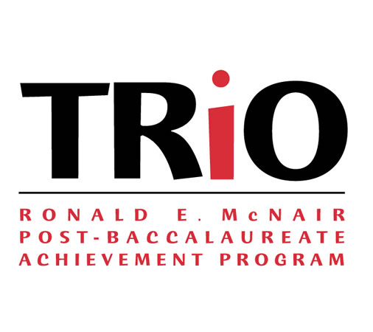

Spring 2021 ● McNair Scholars Program ● (361) 825-3835

McNair Faculty Mentors

*Thank you to the following Texas A&M University–Corpus Christi faculty members who support the program by mentoring and directing research. McNair would not be a successful program without their dedication.*

**College of Liberal Arts**

**College of Science and Engineering**

Dr. Isabel Araiza

Dr. Daniel Bartholomay

Dr. Pamela Brouillard

Dr. Lisa Comparini

Dr. Charles Etheridge

Dr. Gina Glanc

Dr. Mark Hartlaub

Dr. Sam Hill

Dr. Amy Houlihan

Dr. Melissa Jarrell

Dr. Susan Longley

Dr. Michelle Maresh-Fuehrer

Dr. Pamela Meyer

Dr. Miguel Moreno

Dr. Catherine Quick

Dr. Michael Ramirez

Dr. Phillip Rhoades

Dr. Carey Rote

Dr. Collin Scarince

Dr. Steve Seidel

Dr. Yuliana Zaikman

Dr. Anthony Zoccolillo

Dr. Dorina Murgulet

Dr. Valerie Murgulet

Dr. Cosmina Nicula

Dr. Dara Orbach

Dr. Frank Pezold

Dr. David Portnoy

Dr. Jai Prakash

Dr. Brandi Reese

Dr. Lee Smee

Dr.Greg Stunz

Dr. Jeffrey Turner

Dr. Dugan Um

Dr. Benjamin Walther

Dr. Kim Withers

Dr. Lin Zhang

Dr. Keisha Bahr

Dr. Eugene Billiot

Dr. Feri Billiot

Dr. Chris Bird

Dr. Gregory Buck

Dr. Kirk Cammarata

Dr. Patrick Fitzpatrick

Dr. Luis Garcia

Dr. Xavier Gonzales

Dr. James Hogan

Dr. Yuxia Huang

Dr. Scott King

Dr. Bruce Lee

Dr. Chuntao Liu

Dr. Ruby Mehrubeoglu

Dr. Paul Montagna

**College of Education**

Dr. Toyin Ajisafe

Dr. Randy Bonnette

Dr. Faye Bruun

Dr. Nikola Grafnetterova

Dr. Donald Melrose

Dr. Daniel Newmire

Dr. Bethanie Pletcher

Dr. Lon Seiger

Dr. Frank Spaniol

Dr. Corinne Valadez

Dr. Heather Webb

Dr. Doyeon Won

**College of Nursing**

Ms. Carmen Hernandez

Dr. Cathy Miller

Dr. Christina Murphey

**College of Business**

Dr. Mohan Rao

Dr. Lawrence Smith

McNair Scholars Research Presentations and Opportunities

**Katherine Lanoue**

**“Parental Analysis using ddRAD Sequencing looking for Evidence of Brood Parasitism and Plyandry in a Mouthbrooding Catfish*”***

**Faculty Mentor**: Heather Webb, Ph.D. Associate Professor; Department of Kinesiology

* American College of Sports Medicine Annual Meeting, San Francisco, CA; May 2020

**Brianna Hurst**

**“Healing Rates of Scars on Bottlenose Dolphins in Varying Natural Salinities*”***

**Faculty Mentor**: David Portnoy, Ph.D. Associate Professor; Department of Life Science

* 21st Annual University of Maryland National Conference for McNair Scholars; March 2020

**Krystal Garza**

**“A Methodology to Determine the Efficacy of Design Variations in Wearable Airbag Devices using Finite Element Analysis*”***

**Faculty Mentor**: Miguel Moreno, Ph.D. Associate Professor; Department of Psychology

* Southwestern Psychological Association Annual Conference, Frisco, TX; April 2020

**Meagan Pendleton**

**“Navigating Heteronormativity and Negotiating Allyship: A study of LGBT+ Allies in South Texas*”***

**Faculty Mentor**: Dorina Murgulet, Ph.D. Associate Professor; Department of Physical & Environmental Sciences

* 21st Annual University of Maryland National Conference for McNair Scholars; May 2020

**Anna Maree Longoria-Porterfield**

**“Cougars and Silver Foxes: Gender Perceptions, Relational Age Gaps and the Sexual Double Standard”**

**Faculty Mentor**: Miguel Moreno, Ph.D. Associate Professor; Department of Psychology

* Southwestern Psychological Association Annual Conference, Frisco, TX; April 2020

**Isaac Vargas**

**“Segmentation of Seagrass Blade Images using Deep Learning*”***

**Faculty Mentor**: Toyin Ajisafe, Ph.D. Assistant Professor; Department of Kinesiology

* 21st Annual University of Maryland National Conference for McNair Scholars; May 2020

Spring 2021● McNair Scholars Program ● (361) 825-3835

**Brianna Hurst**

**Major:** Dara Orbach, Ph.D.

**Faculty Mentor:** Daniel Newmire, Ph.D.

**Research Project: “Healing Rates of Scars on Bottlenose Dolphins in Varying Natural Salinities”**

**Esteban Guerrero-Ortiz**

**Major:** Psychology

**Faculty Mentor:** Raquel Botello, Ph.D.

**Research Project: “Study on the Ideologies of Rape Myth Acceptance Found in University Students and its Correlation to Date Rape Scenarios”**

**Krystal Garza**

**Major:** Engineering

**Faculty Mentor:** Bruce Lee, Ph.D.

**Research Project: “A Methodology to Determine the Efficacy of Design Variations in Wearable Airbag Devices Using Finite Element Analysis”**

**Alan Garduno**

**Major:** Engineering

**Faculty Mentor:** Ruby Mehrubeoglu, Ph.D.

**Research Project: “OpenCV Algorithms and Functions to Support Camera-Based Path-Planning and Navigation of an Unmanned Aerial Vehicle”**

**Valentina Campos**

**Major:** Kinesiology

**Faculty Mentor:** Nikola Grafnetterova, Ph.D. & Doyeon Won, Ph.D.

**Research Project: “Vegan Diet for Athletic Training and Performance: Myths and Reality”**

Spring 2020 ● McNair Scholars Program ● (361) 825-3835

Research Scholars Spring/Summer 2020

Researchers

**Isaac Vargas**

**Major:** Engineering

**Faculty Mentor:** Ruby Mehrubeoglu, Ph.D.

**Research Project: “Segmentation of Seagrass Blade Images Using Deep Learning”**

**Jesus Quintanilla**

**Major:** Psychology

**Faculty Mentor:** Steven Seidel, Ph.D.

**Research Project: “The Pandemic of In-Group Bias during the COVID-19 Crisis”**

**Megan Pendleton**

**Major:** Sociology

**Faculty Mentor:** Daniel Bartholomay, Ph.D.

**Research Project: “Navigating Heteronormativity and Negotiating Allyship: A Study of LGBT+ Allies in South Texas”**

**Amanda Moya**

**Major:** Communications

**Faculty Mentor:** Michelle Mareshfuehrer, Ph.D.

**Research Project: “How Wearing Face-Masks in COVID-19 Times Have Affection Communications for Deaf People”**

**Katherine Lanoue**

**Major:** Bio-Medical Science

**Faculty Mentor:** David Portnoy, Ph.D.

**Research Project: “Parental Analysis Using ddRAD Sequencing Looking for Evidence of Brood Parasitism and Plyandry in a Mouthbrooding Catfish”**

Spring 2020 ● McNair Scholars Program ● (361) 825-3835

**Scholar Graduates: Where are they Headed?**

We would like to congratulate the 2020-2021 cohort of graduate scholars. They have done many wonderful things during their time at TAMUCC and are representing the TAMUCC McNair Scholars Program well in their respective graduate programs.

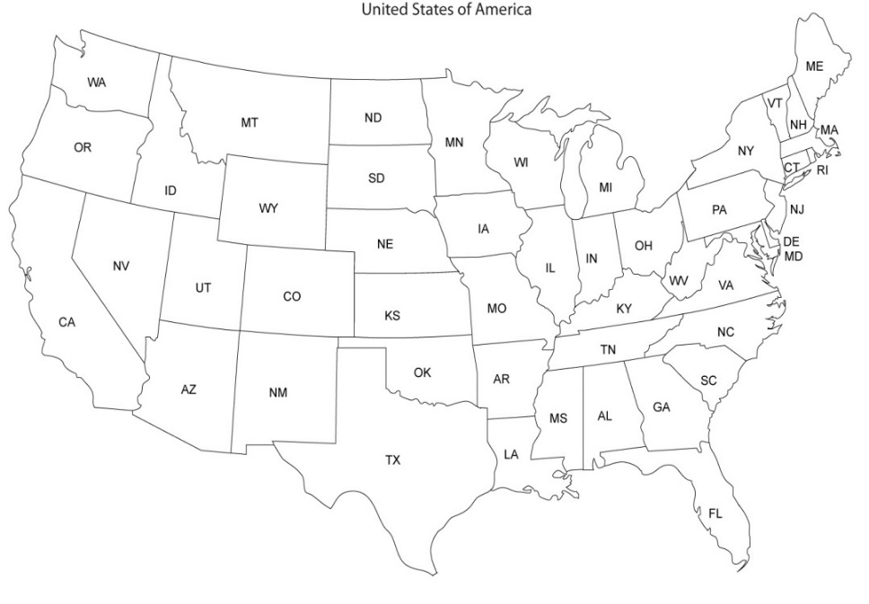

**Valentina Campos:** Applying to a Master’s of Business Administration at Texas A&M University – Corpus Christi for Fall 2021

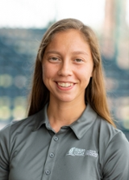

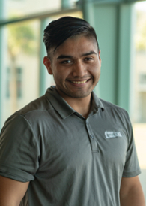

**Alan Garduno**: Accepted to an Electrical Engineering Program at the University of Texas at Austin for Fall 2021

**Esteban Guerrero-Ortiz**: Plans to attend Texas State University for the Professional Counseling master’s program

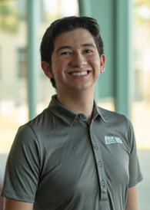

**Amanda Moya**: Applying to a Masters of Arts program in Communications at Texas A&M University – Corpus Christi for Fall 2021

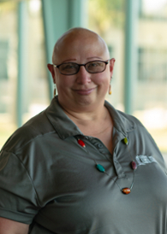

My McNair journey began when my professor recommended that I apply to gain more research experience. At the time, I wasn’t sure if research was something I wanted to do, and I was weary of additional commitments as I was working fulltime already. I decided to take the plunge anyways, and I knew after the first welcome luncheon that the McNair Scholars Program was truly something special. I always knew I wanted to attend graduate school, but I never realized how complex the application process was and the importance of research experience for applicants. The knowledge I gained from the McNair workshops and by working on my research were integral to my success as a student, researcher and graduate school applicant. McNair afforded me the opportunity to work on not only one, but two research projects. Before COVID, I was also given the opportunity to present my first project at a major national conference in New Orleans, and since then have presented at three additional conferences. I was also published in a national psychological research journal. With the support of McNair, I was able to apply to a wide variety of graduate programs without having to pay application fees. Eventually, I was accepted to a top-notch fully funded graduate program in Canada. When interviewing for the program, my future mentor even noted that he was impressed by my achievements with McNair and that it set my application apart from the rest. Every step of the McNair process, especially writing a journal article, working closely with a faculty mentor, and presenting my research, prepared me for success in grad school and in my future career. I am so grateful for the program because my involvement with McNair gave me the incredible opportunity to go to graduate school and work with one of the best researchers in my field. I would absolutely recommend this program to every student who has graduate school aspirations, because the support and dedication this program gives its students is life changing. Being a McNair scholar is something I will always be proud of, and hopefully one day I will be able to give back to the program that gave so much to me.

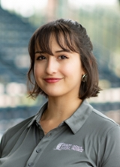

Scholar Spotlight: Anna Maree Longoria-Portfield

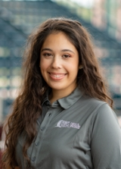

**McNair Alumni Spotlight: Abigail Champio****n**

***McNair Scholars Program***

Texas A&M University-Corpus Christi

6300 Ocean Drive, Unit 5791

Corpus Christi, Texas 78412

***Interim Director***

Dr. Steve Seidel

Ph: 361-825-

Email: [@tamucc.edu](mailto:pspaniolmathews@tamucc.edu)

***Assistant Director***

Anabel Hernandez

Ph: 361-825-3835

Email: [anabel.hernandez@tamucc.edu](mailto:anabel.hernandez@tamucc.edu)

***Administrative Associate***

Margarita Cooper

Ph: 361-825-3687

Email: [margarita.cooper@tamucc.edu](mailto:margarita.cooper@tamucc.edu)

**GIVE US AN UPDATE!**

The U.S. Department of Education requires all McNair programs to provide Annual Performance Reports and keep track of alumni until the attainment of a doctoral degree. Alumni can update their information by completing the form below and mailing the information to the McNair Scholars Program – or by contacting Anabel Hernandez at [anabel.hernandez@tamucc.edu](mailto:anabel.hernandez@tamucc.edu).

Name: ______________________________________________________________________________

Address: ____________________________________________________________________________

City & State: _____________________________________ Zip Code: ______________________

TAMUCC Cohort Year: _______________________________________________________________

Highest Degree Attained and When: __________________________________________________

Degree in Progress: Master’s _______ PhD __________ or Education Complete__________

Field of Study: ________________________________________________________________________

Expected Year of Completion: ________________________________________________________

School in Attendance: ________________________________________________________________

Email Address: ________________________________________________________________________

**Advisory Committee**

**Dr. Amy Aldridge Sanford**

Associate Provost

**Dr. Eugene Billiot**

Professor-Science & Engineering

**Ms. Shelley Dinkens**

Clinical Assistant Professor

**Ms. Penny Long**

Financial Aid Advisor

**Dr. Frank Lucido**

Interim Associate Dean

**Dr. Michelle Maresh-Fuehrer**

Associate Professor of Public Relations

**Dr. Gerardo Moreno**

Associate Vice President for Academic Affairs

**Dr. Frank Pezold**

Dean of College of Science & Engineering

**Ms. Nancy Salinas**

Student Development Specialist

**Dr. Steve Seidel**

Professor-Psychology

**Ms. Angela Walker**

Associate Dean of Students

**Alumni News**

**Anna Haga** (Nursing, 2017) obtained a master’s degree in Family Nurse Practitioner in May 2020 from Texas A&M University-Corpus Christi.

**Stephanie Tiet** (Interdisciplinary Studies, 2017) entered a master’s program in English in the Spring 2020 at Texas A&M University-Corpus Christi.

**Brenda Vela** (Sociology, 2010) entered a doctorate program in Social Work in the Spring 2020 at the University of Texas in Arlington.

**Doctorate Recipients**

**Meagan Bryand** (Communication, 2009) obtained her Doctor of Education in Educational Leadership in December 2015 from the University of Houston-Clear Lake.

**Samantha Hernandez** (Political Science, 2011) obtained her Ph.D. in Political Science in May 2018 from Arizona State University.

**Renae Hudak** (Kinesiology, 2013) obtained her Doctor of Physical Therapy in June 2017 from the University of Texas Health San Antonio.

**Jerahme Martinez** (Chemistry, 2009) obtained his Ph.D. in Biochemistry in May 2016 from Rice University

**Amanda Whitmill** (Bio-Medical Science, 2011) obtained her Ph.D. in Cell Biology in August 2016 from the University of North Texas.

**Justin Williams** (History, 2009) obtained his Ph.D. in Philosophy in August 2019 from the University of North Texas.

Spring 2020 ● McNair Scholars Program ● (361) 825-3835