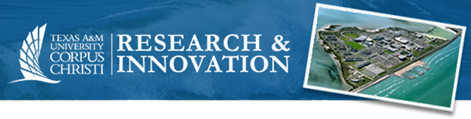

NSF Project Summary Template

NSF Project Summary Requirements
A Project Summary is required for every proposal submitted to NSF. The Project Summary provides an overview of the project, a statement of its intellectual merit, and a separate statement of its broader impacts. The documents must follow NSF Proposal & Award Policies & Procedures Guide formatting guidelines and is limited to no more than one page in length.
The PAPPG describes the Project Summary as (Chapter II.C.2.b):

Overview
The overview includes a description of the activity that would result if the proposal were funded and a statement of objectives and methods to be employed.

Intellectual Merit
The statement on intellectual merit should describe the potential of the proposed activity to advance knowledge in the discipline.

Broader Impacts
The statement on broader impacts should describe the potential of the proposed activity to benefit society and contribute to the achievement of specific, desired societal outcomes.

If your Project Summary includes special characters (for instance, math equations), then it must be uploaded as a Supplementary Documents. Project Summaries may only be uploaded as a Supplementary Document when they use special characters. These Project Summaries must also include separate headings for the Overview, Intellectual Merit, and Broader Impacts.
Some programs require the Project Summary to have specific headings and information. Always refer to the program solicitation for your project when preparing the Project Summary and any other part of the proposal. Any requirements in the solicitation such as page limitations, section headings, and other information will override requirements listed in the PAPPG.

If you would like assistance with your Project Summary or other parts of your proposal, please contact researchdevelopment@tamucc.edu.

Tip: Write your Project Summary AFTER you have written your Project Description.
The following template is only intended to be used as an example. Not all headings, sample questions, and materials will apply to your individual proposal. Please consult the program solicitation for specific requirements including page limitations, headings/sections, etc.
If you are interested in proposal development services or have questions about this template, please contact researchdevelopment@tamucc.edu.

NSF Project Summary Template
Describe the research and/or activities that will be conducted during your project. Base your Project Summary off your Project Description. Some samples
- What is the knowledge gap?
- What are the overall objectives, specific objectives and the proposed research approach?
- What is the research goal and how does it fit with the PI’s long-term research goals?
- How is your proposal creative & original?
- What is the education goal of the proposed project and how does this goal fit with the PI’s long-term educational goals?
- What is the educational approach?
- How are the research and education components integrated?

Intellectual Merit
Provide a statement of intellectual merit.
- What is the current state of knowledge in the field, and where is it headed?
- What will your research contribute to the state of knowledge and advance the field?
- Why will your contribution be transformative?
- What will your research do to enhance or enable other research in this field?
- Why is your research important for the advancement of the field?

Broader Impacts
Provide a statement of the broader impacts.
- What are the desired societal outcomes and how will those benefit the society at large?
- How will activities result in advancement?
- What are the possible applications of your research, why would the general public care?
  - Does it have any economic, environmental, social benefits?
  - Does it help with the involvement of underrepresented groups in research and education activities?
- How will your proposal benefit your organization?

