Research Regulatory Binder

PI: <add PI Name>
IRB #: <add IRB Number> Title: <add Research Title>

Introduction:
The following tabs are recommended for use in the Regulatory Binder. This document serves as a template and may be modified for study-specific requirements. It is the responsibility of the investigator to ensure compliance with GCP and applicable regulatory requirements. Good Clinical Practice (E6) Section 8.1, 8.2, 8.3, 8.4
Purpose: | To provide an organizational framework and guidance for filing paper versions of essential study documents (or referencing location of an electronically stored file) with a description of the required contents for each binder section.
Audience/User: | Study coordinators or individuals responsible for establishing the essential document binder (synonyms: Regulatory Binder, Investigator Binder, Investigational Site File (ISF), and Study Binder)
Details: | - This document clarifies the standard content of the binder.  - See also Regulatory Binder Checklist
Best Practice Recommendations: | - Store items in reverse chronological order, with the newest items within a section placed at the front of the section.  - Use the requirements note at the top of each binder tab to determine if that section is required for your study.  - Multisite studies: The lead site may choose to customize the binder tabs for the study and provide to all participating sites.  - Electronic documents: The recommendation is to store paper copies of documents in the binder. However, if you elect to use only electronic copies of documents, the following guidelines should be observed:  - Either a) place a paper placeholder in the relevant location of the binder that directs an individual to the electronic location, or b) place a paper placeholder in one location in the binder that includes a list of all documents that are stored only in electronic format, along with the specific electronic path for each item.  - Electronic-only documents should be limited to documents that a) are easily accessible by site staff; b) an inspector, auditor, or clinical monitor can be provided with easy access to the relevant electronic materials during a site visit; and c) the electronic location is controlled, regularly backed up, and is not in danger of disappearing or changing in the foreseeable future.  - For e-mail correspondence, sites may want to include clarification in the binder that e-mail will be archived to a permanent storage medium on a particular schedule (specify in documentation) and the media will be stored in the binder or an easily accessible location.
Section 1: Study Personnel

This section includes:

Delegation of Authority Log Delegation of Authority Log

Investigator Qualification Documentation
☐ Updated investigator and sub-investigator CVs (signed/dated within 2 years)
☐ A clinical (dental, medical, etc.) license for the PI and co-investigators, if licensed
Financial Disclosure Forms
☐ Signed Financial Disclosure Forms for the PI and co-investigators
Research and Study Training
Documentation of human subject protection training (for all staff members)
Documentation of Protocol training
Documentation of Occupational Health Program Enrollment (if applicable)
<Add other training required by study, i.e. blood pathogen training>

Section 1: Study Personnel

Delegation of Authority Log

Binder Instructional Page: Delegation Log In this section print and file:
☐ Documentation of the Delegation of Authority
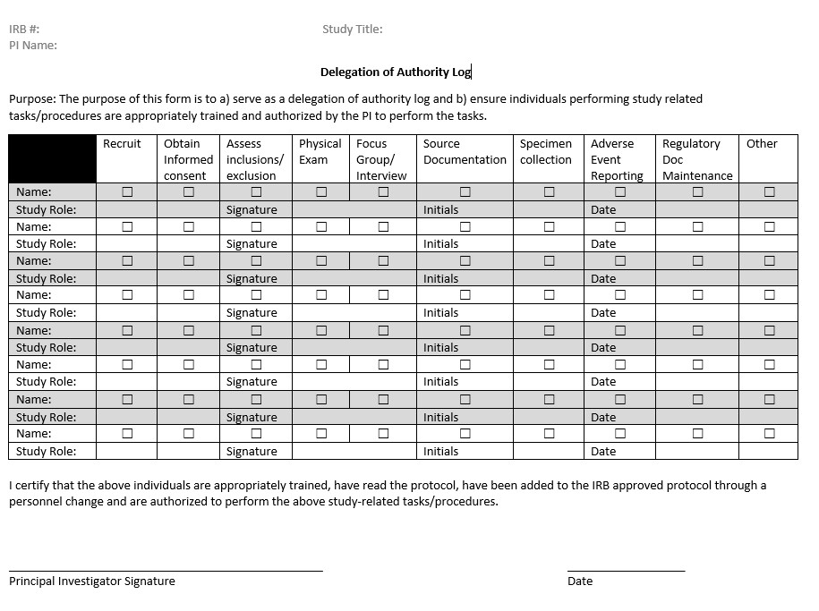

Any changes in site study personnel require an update to the DoA.
Click here for an electronic copy of the Delegation Log.

Section 1: Study Personnel

Investigator Qualification Documentation

Binder Instructional Page: Investigator Qualification Documentation In this section print and file:
☐ Updated investigator and sub-investigator CVs
Best practice: CVs are signed/dated within 2 years

☐ A clinical (dental, medical, etc.) license for the PI and co-investigators, if licensed. This is needed if the research procedure requires specific licensure to complete. For example, if you are taking a blood sample, only licensed professionals can perform this task.
CVs may be updated if an investigator’s qualifications increase or change during the course of the study.
Do not remove expired CVs as they demonstrate qualification for the entire duration of the study.
Licenses should be filed behind the corresponding investigator’s CV. Do not remove expired licenses.
The investigators must be actively licensed in the state in which the study is conducted.
The name on the license must correspond to the name on the investigator’s CV and Form FDA 1572 Statement of Investigator, if applicable.

Section 1: Study Personnel

Financial Disclosure Forms

Binder Instructional Page: Financial Disclosure Forms In this section print and file:
☐ Documentation that no financial conflicts of interest are present
☐ If a COI exist, a copy of the Conflict of Interest Management plan should be filed in this section.

Section 1: Study Personnel

Research and Study Training

Binder Instructional Page: Research and Study Training In this section print and file:
☐ Documentation of human subject protection training (for all staff members): Print Training CITI Certificates for All Research Personnel
☐ Document any internal training provided for the study
☐ Print a copy of enrollment in Occupational Health Program Enrollment (if applicable) Sample: Training Log for Internal Training.
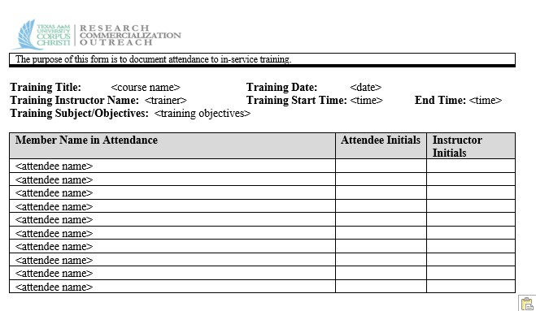

Click here for an electronic copy of the Training Log.

Section 2: Institutional Review Board

This section includes:

IRB Documentation
☐ IRB of Record
☐ IRB Reliance Agreement (if applicable)
☐ TAMU-CC IRB Federal Assurance Number: FWA00011281
☐ Updated IRB Roster

IRB Approvals and Correspondence
☐ IRB approval letters (e.g., protocol, protocol amendments, consent/assent documents, continuing review, advertisement or recruitment materials, investigator’s brochure, package insert)
☐ Original IRB application/submission
☐ Correspondence related to contingent approvals or stipulations
☐ IRB correspondence
☐ IRB annual renewals
☐ Interim/annual progress reports to the IRB

Section 2: Institutional Review Board
IRB Documentation

IRB Documentation
Binder Instructional Page: Fill out the following information and include in this section. This template has been filled out for you if using TAMU-CC IRB.
If you are using another IRB of Record, then fill in that IRB’s information.

Institutional IRB of Record: Texas A&M University-Corpus Christi
Institutional Review Board

FWA #: FWA00011281
IORG: IORG0000876

IRB Contact Info:
Website: http://research.tamucc.edu/compliance/human-
subjects-research.html
Email: irb@tamucc.edu
Phone: (361) 825-2497

Institutional Official
Name: Ahmed Mahdy, Ph.D.
Title: Interim Vice President for Research,
Commercialization and Outreach
Address: 6300 Ocean Drive, Unit 5843
City: Corpus Christi, TX 78412-5843
Email: ahmed.mahdy@tamucc.edu
Phone: (361) 825-3172

IRB Roster: http://academicaffairs.tamucc.edu/councils/insti_review_board.html
If using another IRB of Record, be sure to include your signed IRB reliance agreement with TAMU-CC in this section.
To Look up FWA for other IRBs: Link to the Office for Human Research Protections database (FWA and IRB registration): ohrp.cit.nih.gov/search/IrbDtl.aspx
Need an IRB reliance agreement? Click here to get a copy of the contract template.
Contact Sponsored Research Administration to negotiate and execute the contract.

Section 2: Institutional Review Board
IRB Approval Letters

Binder Instructional Page: IRB Approval Letters

☐ Initial IRB approval letter
☐ Continuing review approval letters
☐ Amendment approval letters
☐ Reportable Event approval letters

Best Practice Recommendation: Store items in reverse chronological order, with the newest items within a section placed at the front of the section.

Section 2: Institutional Review Board Original IRB Application

Binder Instructional Page: Original IRB Application

☐ Initial IRB application
☐ Any protocol feedback forms requesting changes
☐ All drafts created in response to requested changes
☐ Any IRB correspondence during initial review

Best Practice Recommendation: Store items in reverse chronological order, with the newest items within a section placed at the front of the section.

Section 2: Institutional Review Board IRB Correspondence

Binder Instructional Page: IRB Correspondence

☐ Any IRB correspondence during initial review

Best Practice Recommendation: Store items in reverse chronological order, with the newest items within a section placed at the front of the section.

Section 2: Institutional Review Board
IRB Annual Renewals and Progress Reports

Binder Instructional Page: Annual Reviews and Progress Reports
In this section print and file:
☐ Continuing Review Reminders Received
☐ Continuing Review Applications Sent to the IRB ☐ Any protocol feedback forms requesting changes
☐ All drafts created in response to requested changes
☐ Any IRB correspondence during continuing review

Section 2: Institutional Review Board
Serious Adverse Events (SAE)/Unanticipated Problems

Binder Instructional Page: Annual Reviews and Progress Reports
In this section print and file:
☐ Adverse Event Log
Click here for an electronic template for AE Log
☐ Reportable event forms submitted to IRB
☐ Any protocol feedback forms requesting changes
☐ All drafts created in response to requested changes
☐ Any IRB correspondence during Reportable Event Review
☐ Any corrective action plans

Section 3: Study Documents
This section includes:

Protocol and Amendments
☐ Institutional Review Board (IRB)-approved protocol
☐ Log of protocol changes
☐ IRB-approved protocol amendments

Study Communication
☐ Letter of Understanding/Confidentiality Agreement
☐ Data Sharing Agreement
☐ Material Transfer Agreement
☐ Signed agreements between parties (i.e., sponsors/investigators)
☐ Important decisions regarding study conduct, such as notes to the Study File
☐ Notes to File

Recruitment Documents and Screening/Enrollment Log
☐ IRB-approved advertisements
☐ Recruitment Flyers
☐ Recruitment Emails

☐ Screening/Enrollment Log
☐ A log without identifying information that lists all screened subjects
☐ Subject Identification Code list (aka Master List, which should be kept separately)

Informed Consent Documents
☐ Log of Informed Consent versions
☐ IRB-approved Informed Consents (blank)
☐ Signed Consent Forms (may be kept in a separate binder)

Serious Adverse Events (SAE)/Unanticipated Problem Documents
☐ Reportable Event Forms
☐ Corrective Action Plans
☐ Correspondence

Section 3: Study Documents Protocol and Amendments

Binder Instructional Page: Protocol and Amendments In this section print and file:
☐ Most recently IRB-approved protocol
☐ Log of protocol changes
Click here for electronic template for a Protocol Change Log
☐ All IRB-approved protocols

Best Practice Recommendation: Store items in reverse chronological order, with the newest items within a section placed at the front of the section.

Section 3: Study Documents Study Communication

Binder Instructional Page: Protocol and Amendments In this section print and file:
☐ All copies of agreements (Data Sharing Agreements, Material Transfer agreements)
☐ All copies of grants or research awards or contracts
☐ Important documents (Notes to File) showing important decisions regarding study conduct

Best Practice Recommendation: Store items in reverse chronological order, with the newest items within a section placed at the front of the section.

All printed communication (e.g., e-mail) needs to be signed and dated by the individual printing and storing the document.
Communication about subject treatment/clinical care, protocol deviations, and study drug dosing should immediately be printed and stored in this tab.
E-mail correspondence may be saved to a compact disc (CD) for electronic storage and noted in this section.
Electronic media must be permanent media and must be appropriately secured and approved (e.g., password protected).
If saved to a CD or other electronic storage media, a note to the Study File needs to be generated describing the types of e-mail on the electronic media, the start and stop dates of the e-mail correspondence, and the signature and date of the individual creating the CD and writing the note to file.
If a study team member receives a new computer or if a newer version of the email provider is used, it is highly recommended to create the CD and the note to file at the time of the transfer to prevent any important study communication from being lost in the transition.

Section 3: Study Documents Recruitment Documents Binder Instructional Page: Protocol and Amendments In this section print and file:
☐ Most recent IRB-approved recruitment material

Need to develop a recruitment plan?

- 800.01 Worksheet, Investigator Recruitment Plan
- 1100.01 Guidance for Enrolling Participants with Institutional or Deferential Vulnerability
- 1100.01 Guidance for Enrollment of Economically Disadvantaged Persons
- 1100.01 Guidance for Enrollment of Educationally Disadvantaged
- 1100.01 Guidance for Enrollment of Illiterate or Physically Impaired Subjects

Need recruitment material templates?

- 800.01, Frequently Asked Questions, Recruitment Materials
- Recruitment Samples o 800.01 Template, Advertisement - Flyer o 800.01 Template, Advertisement.Survey Study o 800.01 Template, Classroom Recruitment Script o 800.01 Template, Dear Subject Letter o 800.01 Template, Facebook Recruitment Script

☐ Letter of Support from other Recruitment Sites
- 800.01 Template, Letter of Support for Non-TAMUCC Sites

☐ Screening/Enrollment Logs

A log without identifying information that lists subjects who were screened (including screen failures) and enrolled in the study.
- Note: Subjects may be tracked separately on logs, such as a coded list with a key.
Note: If screening and enrollment information is entered into an electronic data capture (EDC) system, please include a memo explaining this process.
- 600.01 Template, Data Collection Sheet

Section 3: Study Documents
Informed Consent Documents
Binder Instructional Page: Protocol and Amendments In this section print and file:
☐ Log of Informed Consent Versions
☐ IRB approved consent form (Blank)
☐ Signed consent forms (may be kept in separate binder)

Informed Consent Templates

Best Practice Recommendation: Store items in reverse chronological order, with the newest items within a section placed at the front of the section.
A version number and date should be on each consent document.
An expiration date of the consent document on the actual document is preferable, but cross-reference to the IRB approval letter of the protocol may be required.
This section should include:
- A copy of all signed consent documents
- Alternatively, consent documents may also be kept in a separate binder or in the subject’s medical record.
If signed consent documents are kept in a separate binder, a note to the Study File explaining where they are stored and the reason needs to be generated, signed, and dated.
If a subject withdraws consent, this should be documented. The signed consent document must be retained even if a subject withdraws consent.

Section 4: Study Monitoring
Monitoring Forms

Section 4: Study Monitoring

Monitoring Forms

This section includes:

Monitoring Documents
☐ <List documents used to monitor compliance for the study>

Section 4: Study Monitoring
Monitoring Forms
Binder Instructional Page: Monitoring Forms
This section should include:
- A copy of any monitoring form templates
- Filled in monitoring forms showing compliance is being evaluated
- Any documentation of findings of non-compliance
- Documentation non-compliance has been reported to the IRB ◼ Documentation of corrective action plans

Monitoring form templates:
1500.03 Checklist, Investigator Compliance with Good Clinical Practices
1500.03 Monitoring Form, Training and Credentialing
1500.03 Monitoring Form, Regulatory Binder Quality Assessment

Section 5: Other Documents

Section 5: Other Documents
This section includes:

Other Documents
☐ <List Other Documents included in this section based on your study>

