What training is required for IRB staff and members?

CITI course: IRB Members – Basic/Refresher.

When does training expire?

Courses expire every 3 years.

How can I check if my training is still good?

Login at: https://www.citiprogram.org

Under the Main Menu/My Courses, courses will be listed that require your attention. Or you can go under My Records to access course completion data and print completion certificates.

Where do I go to take the training?

Training is managed through CITI.
Login at: https://www.citiprogram.org

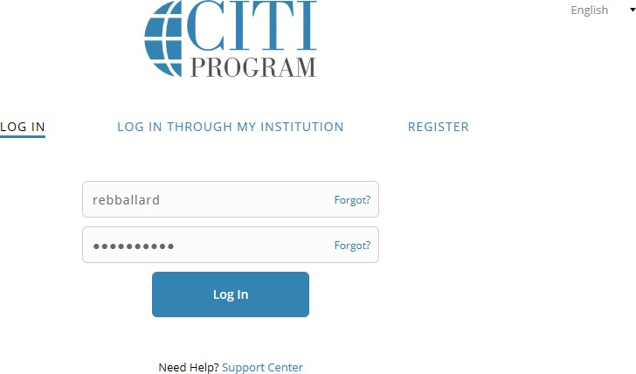
If new to CITI, click Register to create an account.

Be sure to check “Texas A&M University-Corpus Christi,” not Texas A&M University.
Select the Course you want to take: IRB Members

What if I don’t see the course in the Main Menu/My Courses that I need to take?

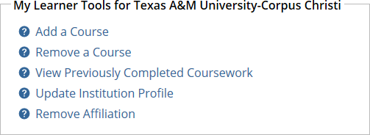
At the bottom of the page you can Add a Course.
A list will be presented of courses based on roles that you can select and have added to your Courses.

Under Question 2, Human Subjects Research, select “IRB Members”.
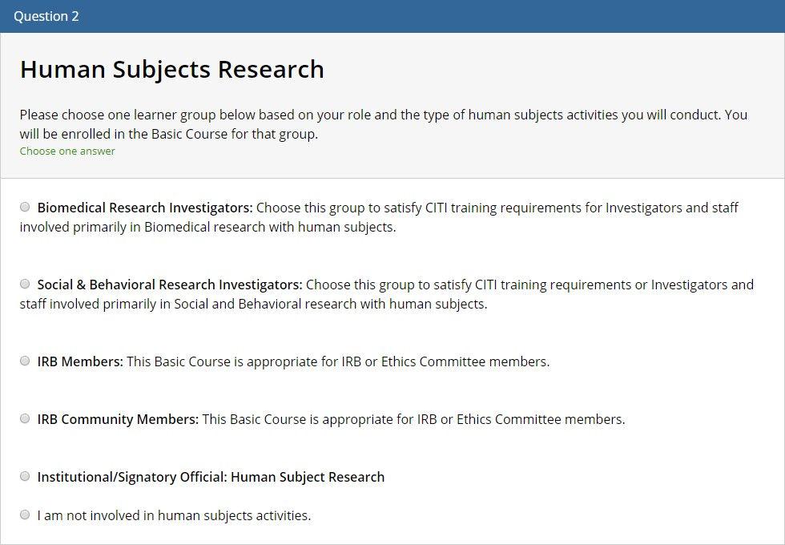

Where do I send my completion certificate?

No. There is no need to email or send in the CITI certificate if you are under the TAMU-CC CITI account (see below on how to affiliate with TAMU-CC). We can look up individuals’ training records directly within CITI.

If I’ve taken the course at another institution, do I have to retake the course?

No. Another option is to affiliate within CITI to Texas A&M University-Corpus Christi. This allows us as admins to verify training directly within CITI.
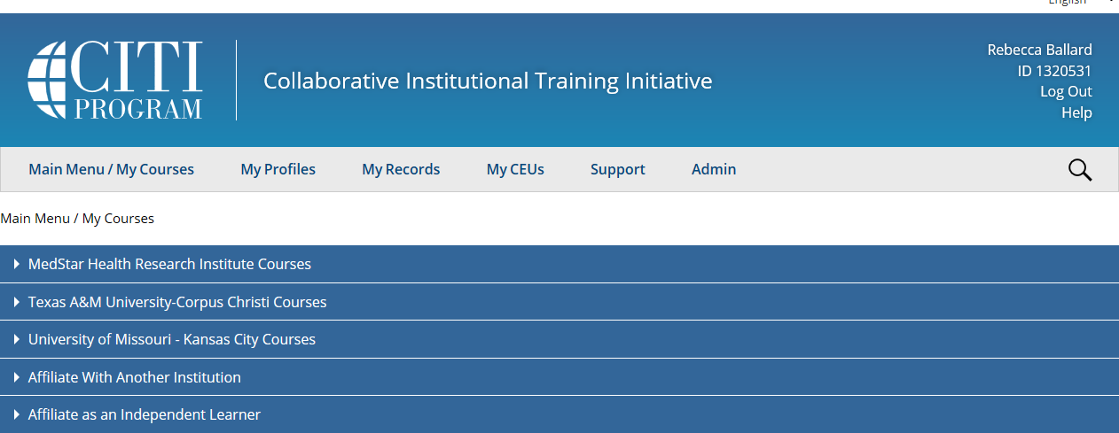

Click on Affiliate with Another Institution, type in “Texas A&M University-Corpus Christi”, and follow prompts.

