Scheduling in Navigate Student Desktop View
Overview
Students can schedule appointments through the Appointments tab of their Navigate Student mobile app or desktop site.
Select the appropriate button to start scheduling an appointment. The New Appointment page opens.
- Students choose their Care Unit (the Office or area of Support).
- Student chooses the Service (Meeting Reason for the appointment).
- Student chooses a date.
- Once all required fields are filled out the student clicks Find Available Time.
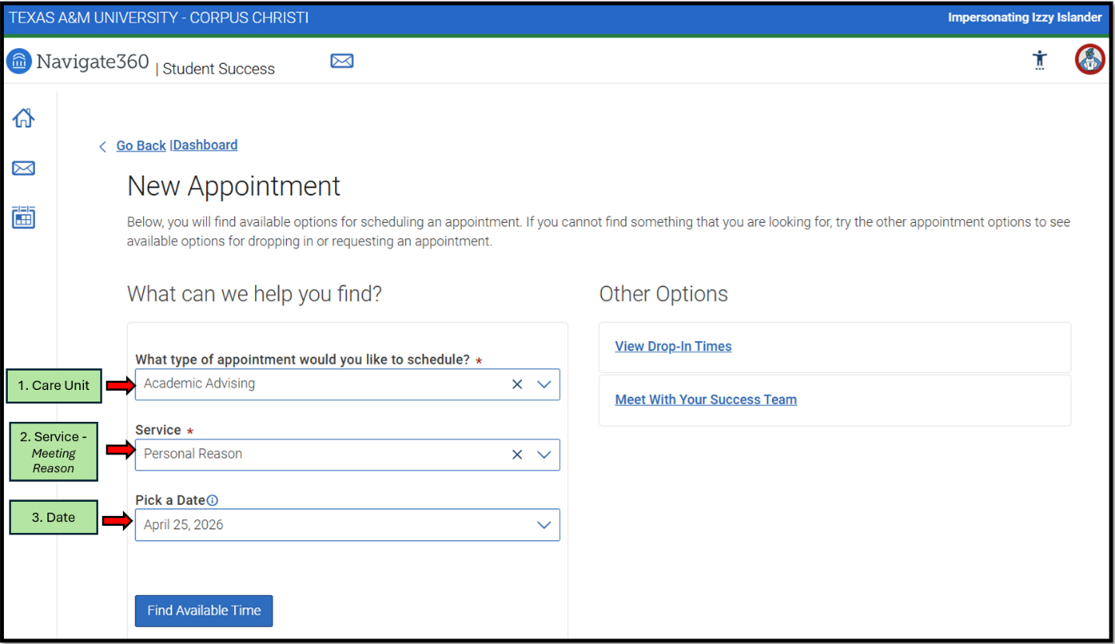

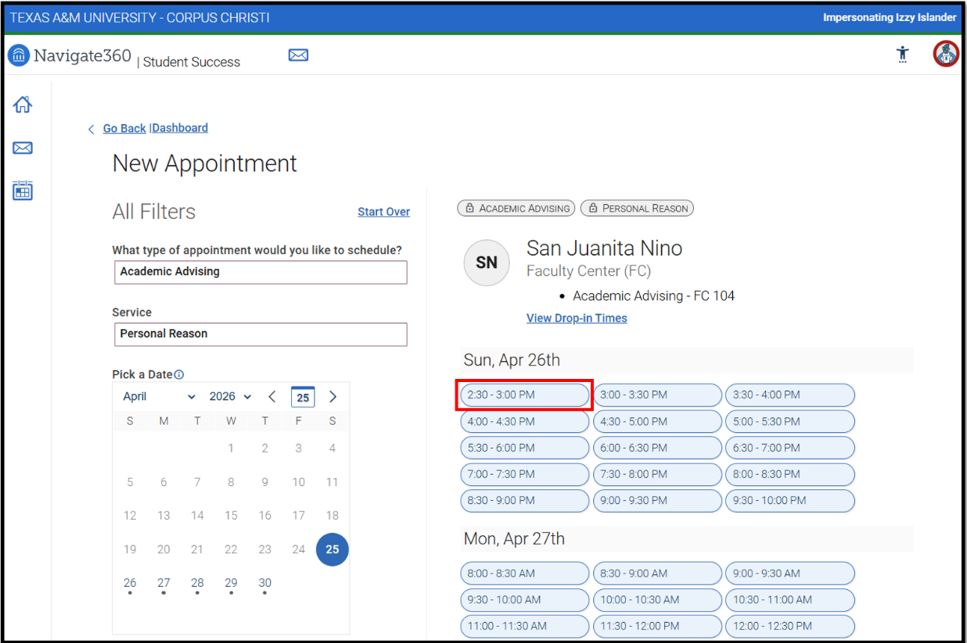
Students can select one of the time slots from the list.

When a student chooses an appointment time, regardless of filters chosen, the Review Detail page opens.
- Students choose meeting type, How you would like to Meet (In-Person, Virtual, Phone, etc).
- [OPTIONAL] Student add additional notes (Not a required field).
- [OPTIONAL] Student chooses if they would like email or text reminders.
- Once all required fields are filled out the student clicks Schedule.
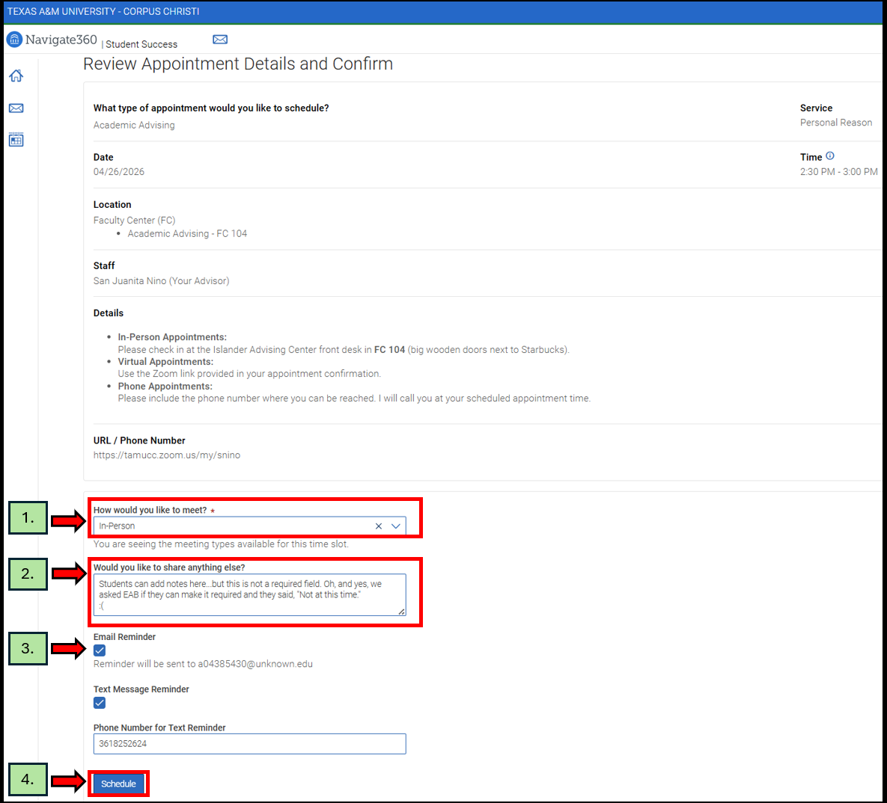

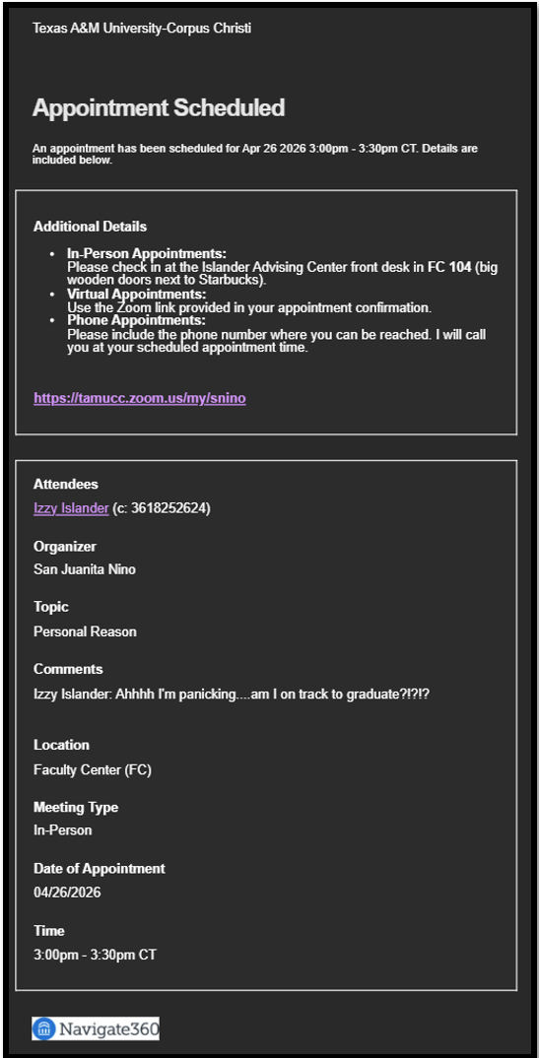
The student will receive a confirmation email that includes the appointment details and any instructions the staff member provided when creating their availability.

