How to View a Student Profile
Viewing a student profile is essential for understanding their academic journey and providing effective support. Accessing the correct student profile allows you to review key details such as GPA, major, and class standing, as well as see their current courses, success team (advisor and support staff), and academic history and activity. This workflow is designed to help staff, faculty, and administrators efficiently navigate to a student’s profile and quickly find the information they need to guide and support student success.
Video Demo: https://player.vimeo.com/video/1017330289?h=5ba94edecc
Student Profile View
After selecting a student, you will be taken to their profile, where you can view their academic details and support information.
The top gray box, also known as the 30-Second Overview, offers faculty and staff the opportunity to gather a basic understanding or “gut check” on the student’s academic performance to date. Sections can be expanded or collapsed by using the arrow on each section title.
The data includes course performance (number of Ds and Fs, number of repeated courses, and number of withdrawn courses), number of success marker notifications, GPA (GPA type depends on institution configurations), credit performance (number of credits earned, percentage of credits completed vs. attempted), and the student’s Predicted Support Level (calculated by the institution’s predictive model). Note that when you click on a number in the 30-Second Overview, only the first ten examples will appear.
The 30-Second Overview is intended to surface critical details regarding the student’s performance, but the full details related to each datapoint are available in other Student Profile tabs, such as the Success Progress and Class Info tabs.
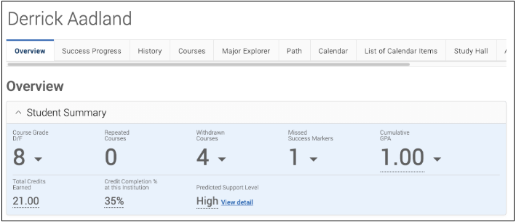

Beneath the 30-Second Overview is another Overview section. Basic information such as the student’s IDs, classification year, most recent enrollment, and declared major are listed here.
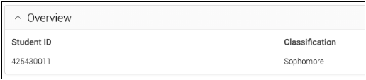
Additionally, this section displays Student Minors.
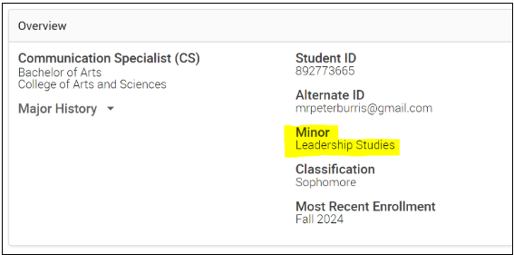
The Categories section includes a list of all categories associated with the student, depending on the institution’s available data. Categories are used to further understand the student’s attributes and potential needs, and often includes academic as well as non-academic information. For example, the Overview tab may show that the student participates on an athletics team, has a merit scholarship, is a member of the Drama club, or is an International student.
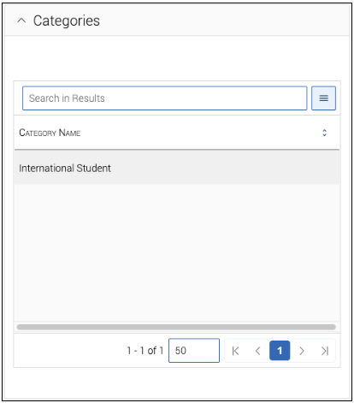
The Tags section includes any information that has been manually tagged to the student’s Navigate profile. Note that even if you have the ability to view student tags, you may not have permission to assign or remove tags from a student profile. Tags can help provide additional information about students that is not typically stored in the Student Information System. For example, a tag may indicate that the student attended orientation, or that they have completed their degree plan.
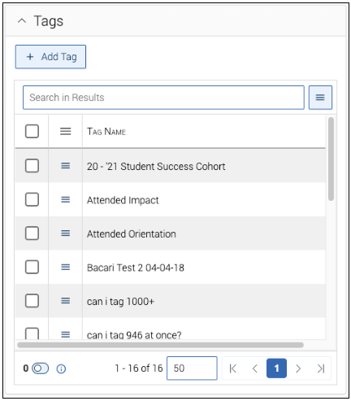
If your institution has Navigate Student, there may be an additional section outlining the student’s Goals & Interests, based on the information the student has supplied through the mobile application. This section includes items that the student has favorited within the mobile app (majors, fields, resources, subjects, and activities).
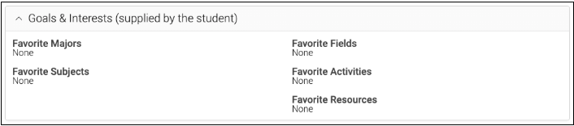
Your institution may also manually add custom attributes to the Student Profile. Custom attributes can be one of two types: Attributes without Any Term, or Attributes Specific to a Term. Custom Attributes will appear in their own section on the Overview tab and can be searched as of the 24.21 release.
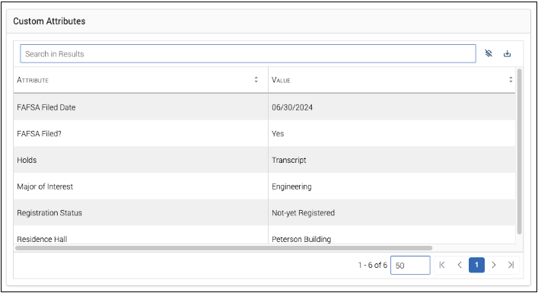
On the right side of the Student Profile, staff and faculty can find additional general information about the student (such as their age and contact information) and take action within the platform. For example, if there is a phone number for the student, the staff member can click on it and open a call via Zoom or other internet telephone program.
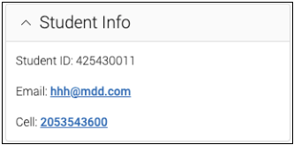
Below the Student Info section, staff and faculty can view the “Your Success Team,” which displays the student’s professors, advisors, and other connected support staff.
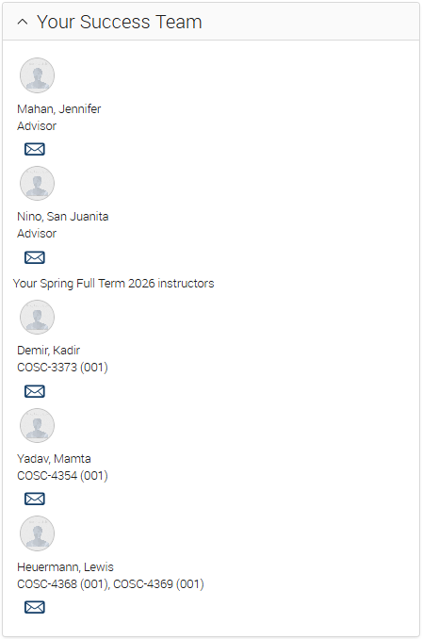
Additionally, you can view the courses a student is currently taking by selecting the Courses section. This area provides detailed information such as course names and numbers, scheduled meeting times, assigned instructors, and available performance data like midterm and final grades, giving you a more complete picture of the student’s academic progress.
