How to Setup Availability in Navigate
Feature Overview:
Availability lets staff indicate the days, times, locations, and services they offer when they meet with students.
There is significant flexibility when you create availabilities. Staff can choose the length of the availability’s duration, which can range from a specific set of dates to forever. Availability can be set for appointments, drop-in visits, and/or appointment campaigns. Staff can create course-specific availability such as course-based tutoring. For group appointments, staff can set the maximum number of students for a single appointment slot.
Creating Availabilities for Yourself
To have the ability to schedule appointments with students in Navigate360 and have students schedule appointments with you, you must have at least one availability set up. The following instructions are meant for a staff user creating their own availabilities.

Table of Contents
- Feature Video
- Creating Availabilities
- Managing Existing Availabilities
- Using Personal Availability Links (PAL)

Creating Availabilities:
Go to Staff Home > My Availability. You should see a table of existing Availabilities, if any, and your Personal Availability Link.
- From your Home tab
- Select My Availability tab
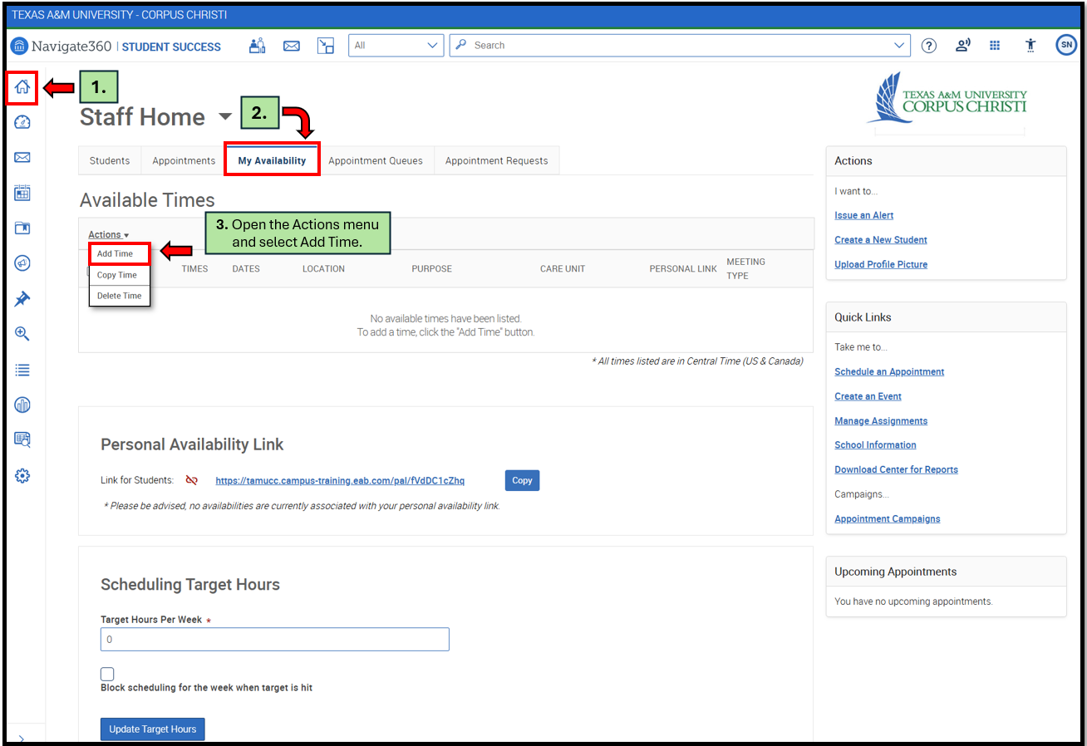
- Open the Actions menu and select Add Time.

The Add Availability dialog opens.
- Choose days of the week for the availability.
- Select the start and end time for the availability in the From and To fields.
- How Long Is this Availability Active - Set the length of the availability.
- PAL - If you want this availability added to your personal availability link, select Add This Availability to Your Personal Availability Link
- You can put the personal availability link in an email or text or on a website. Students are taken to a scheduling workflow that has the staff member's chosen availabilities pre-filled, including on Navigate360 Student's mobile app.
- Availability types - You can choose more than one at a time. For example, an availability can be for both Drop-In and Appointments. (Not recommended if you have dedicated time for drop-ins).
- Meeting Types - You can choose more than one at a time. For example, an availability can be In-Person, Phone, or Virtual.
- Care Unit - This determines which location and services can be added to the availability.
- Select a Location.
- Services - You must choose at least one service, but can pick more. These are the reasons why students would be meeting with you.
- Course - If any service you select is tied to a course, a Course field appears. Select the courses you are available for. (not included in image below).
- Enter a phone number or URL in the URL / Phone Number field.
  - Anything included in this field stamped at the time of appointment creation, and is not expected to retroactively apply to appointment notification/reminder emails sent before or after it was added/edited. A clickable version of this link appears for students who create an appointment during the availability on the Appointment Confirmation page.
- Special Instructions - These notes will be included in the notification students receive once the appointment is scheduled. We recommend including general instructions, like your office location or how to check-in for the appointment upon arrival.
- Determine how many students can be in one appointment. If you do not select a Max Number of Students per Appointment, the maximum number stays 1.
- Click Save to create the availability.
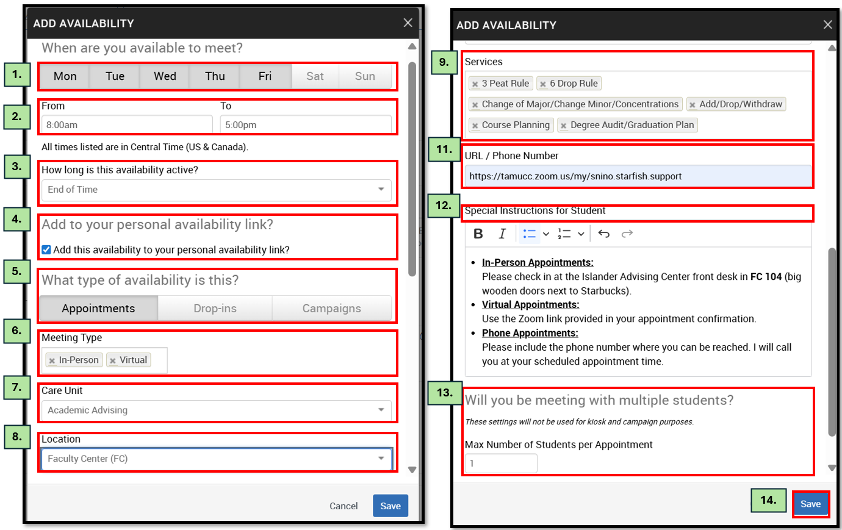
Repeat this process any time you want to add another availability.

Managing Existing Availabilities
When you create availabilities, you can edit, copy, or delete availabilities.
      - To edit - an existing availability, click the Edit link next to the entry you want to change.
- Editing an availability is very similar to adding an availability, so refer to the instructions above for information. Please note: editing or deleting an existing availability DOES NOT edit or change already scheduled appointments. In addition, changes made to availability will be immediately reflected in the Student Scheduler.
      - To copy - an existing availability,
- Select the time you would like to copy
- Open the Actions menu
- Click Copy Time. The availabilities are copied and a Modify Availability dialog opens, allowing you to make edits or to save your newly created availability.
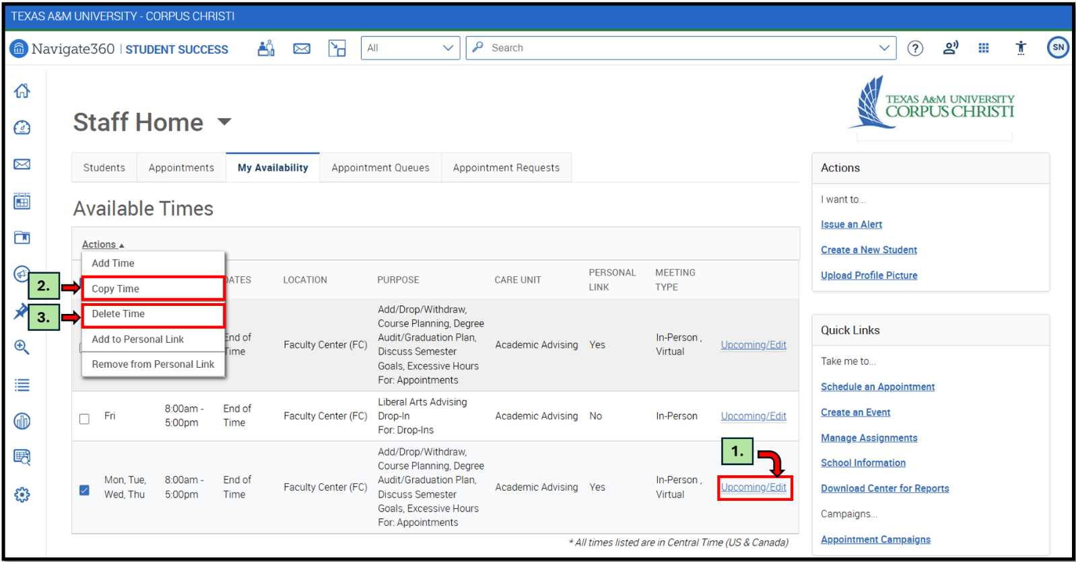
      - To delete - an availability, simply select the time, open the Actions menu and click Delete Time.

Using Personal Availability Links (PAL)
Personal Availability Links (PAL) are a useful tool for scheduling. Each PAL is unique to a staff member in Navigate360. The link does not change over time.
When you include a PAL in a URL field, website, email, or SMS and students click the link, they are taken to the New Appointment page in student scheduling. The link redirects to the scheduling page in the student’s browser and asks if they want to continue in the browser or open Navigate360 Student app. If the student chooses the Navigate360 Student app, they will still see the filtered appointment scheduler view outlined below
Mobile redirect from a PAL
The staff user and their Care Units and Support Services are pre-selected. Students then see the available times staff have to meet. The student will only see the Care Unit, Services, and Locations and times the staff user has selected to be part of their PAL. All configurations, limitations, and permissions for the availabilities remain in effect.
