How to Send Messages to Students
Overview
Sending messages through Navigate starts with finding the right student. Using the student search feature ensures you’re contacting the correct individual, which is essential for clear and effective communication. Once you’ve located the student’s record, you can quickly send messages, share important information, and follow up as needed to support their success.

Sending Message to Individual Student
Sending a message to an individual student in Navigate allows you to provide personalized guidance, share important updates, or follow up on specific needs. Once you’ve located the correct student record, you can initiate a direct message to ensure your communication is targeted and relevant.
To do so:
- Go to Home and look for your Student list under “Students In My Courses”.
- Select a Student that you want to send a message to.
- Click Actions.
- Select Send Message.

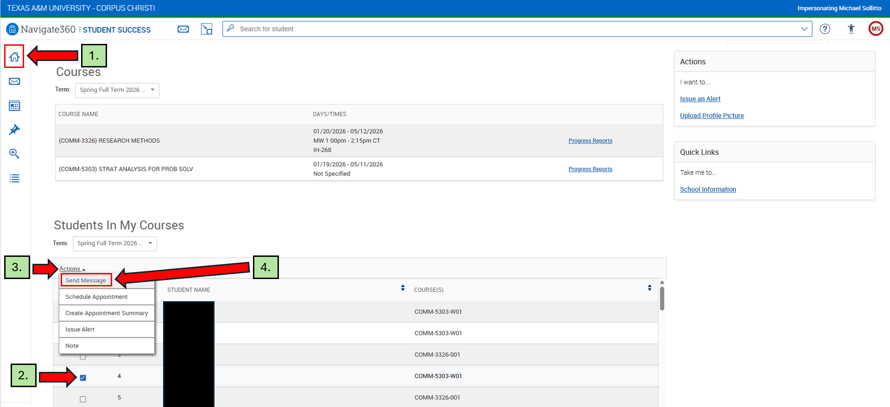

A pop-up window will appear where you can enter a subject, write your message, and attach any relevant files before sending the email to the selected student.
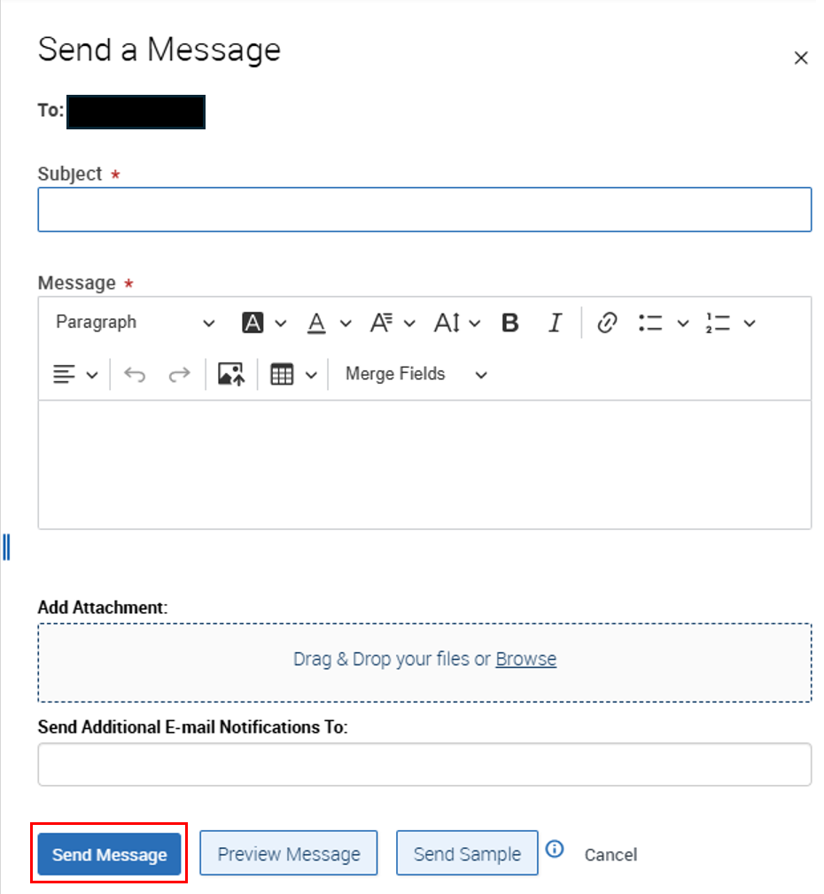

Sending Message to Students or Courses
Sending messages to students or entire courses in Navigate allows you to share important updates, provide guidance, or communicate with multiple recipients at once. Once you’ve identified the appropriate students or selected a course, you can initiate a message to ensure your communication is efficient, targeted, and relevant.
To do so:
- Go to Home and look for your Student list under “Students In My Courses”.
- Filter the Course by clicking on the arrow (in case the professor has more than 1 course).
- Select some/all Students in the same course that you’d like to send a message to.
- Click Actions.
- Select Send Message.

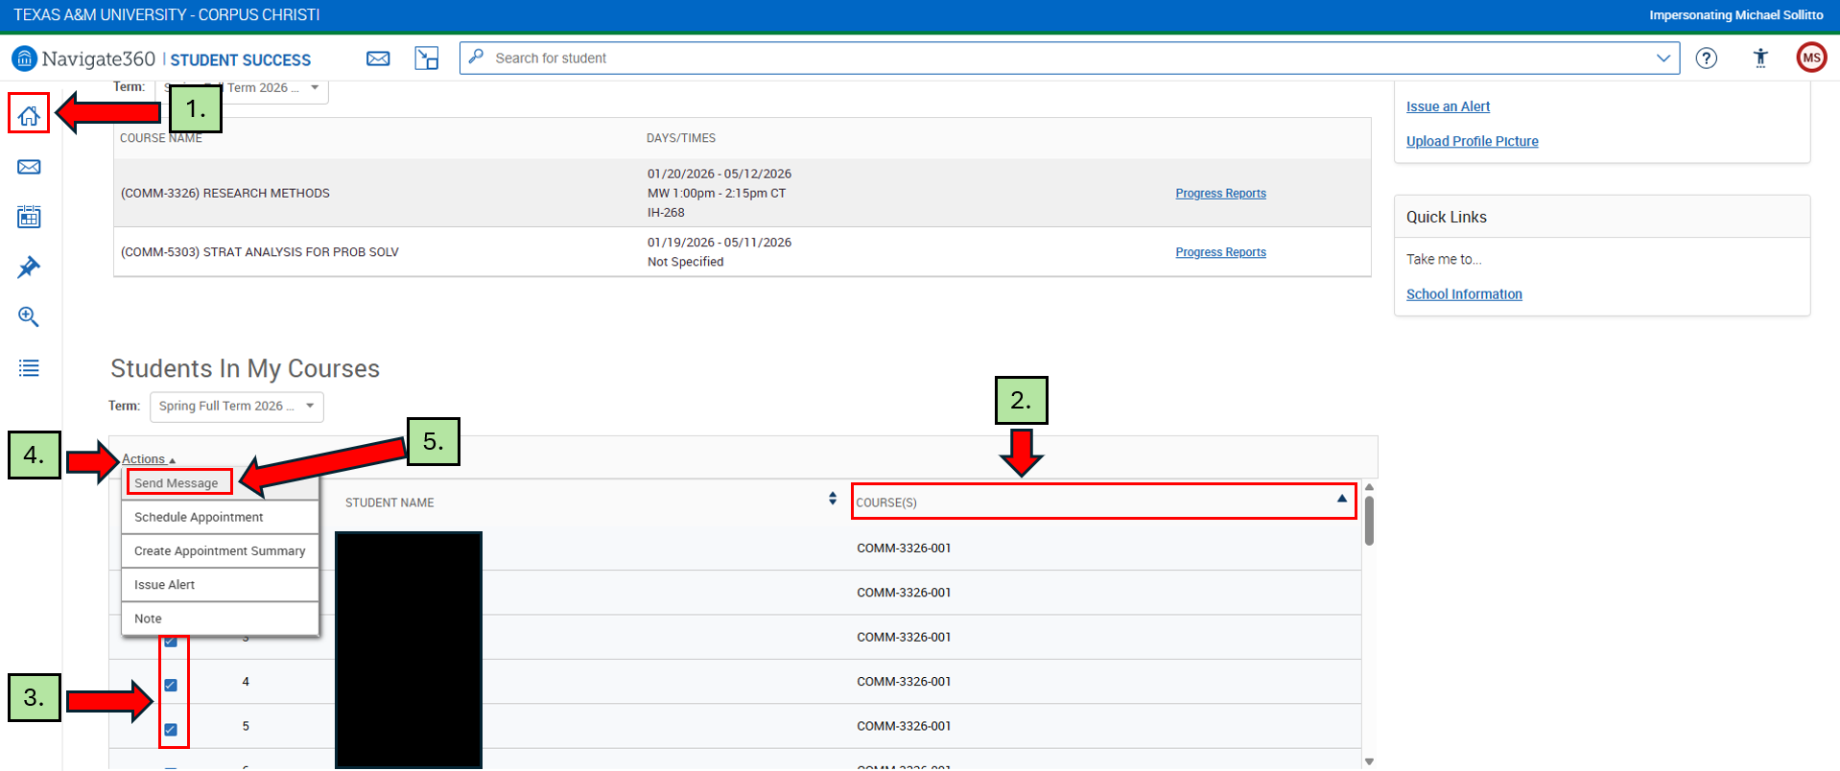

A pop-up window will appear where you can enter a subject, write your message, and attach any relevant files before sending the email to the selected student.

