How to Search a Student
Using Navigate to search for a student is critical to many other actions in the platform. Finding the correct student record allows you to view academic details, review history, schedule appointments, add notes, and take further actions that support student success. This workflow is designed to help staff, faculty, and administrators start from the student search feature and efficiently locate and access the information they need.
Student Search Instructions
Go to Staff Home > Search Bar. You should see a search bar located at the top of the page.
- From your Home tab
- Select Search Bar
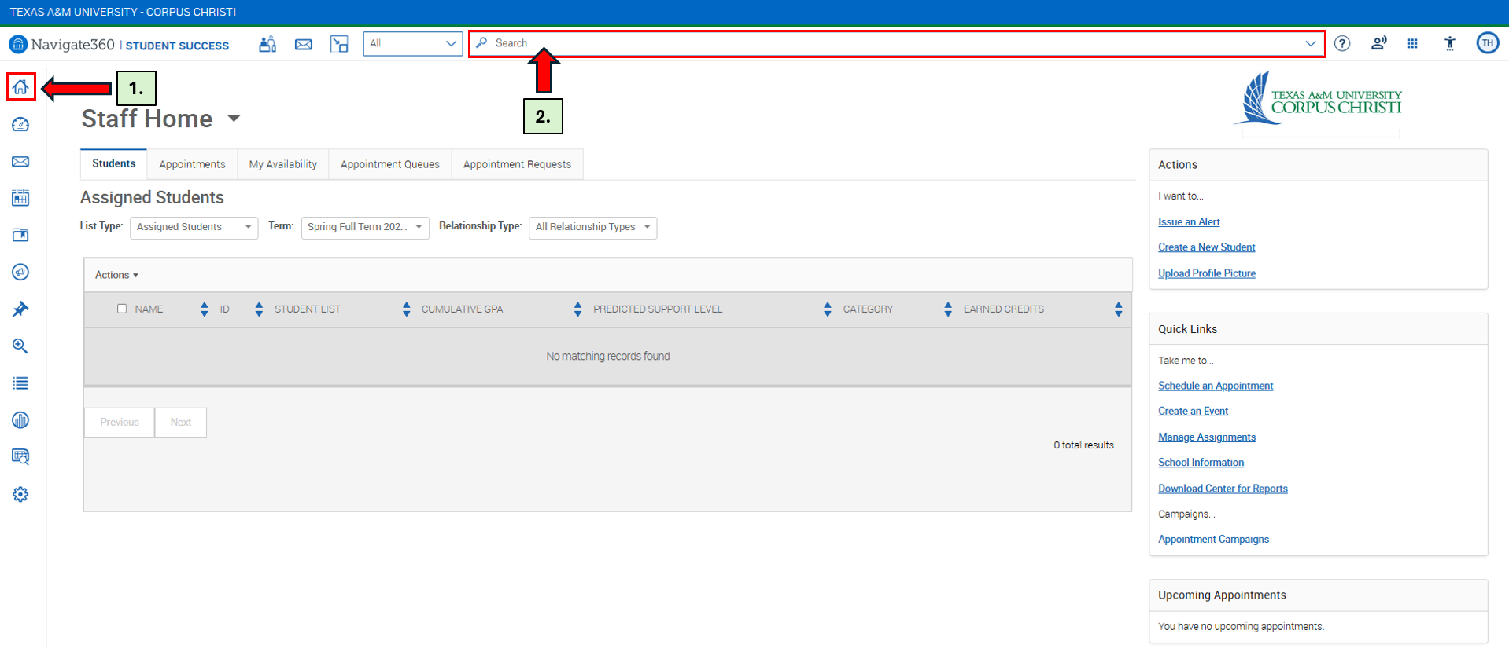
After selecting the Search Bar, you can search for a Student by using:
- Name
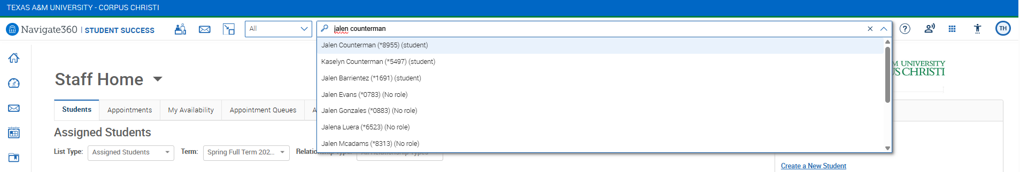

- Student ID
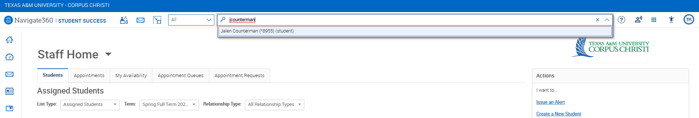

- Email
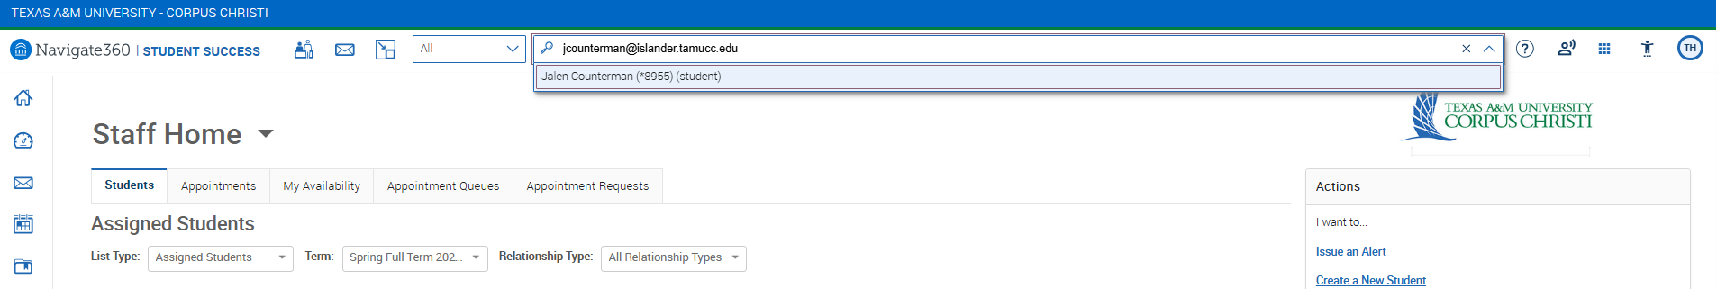

Student Profile View
Choosing a student will open their profile and let you view academic and support information.
