How to Manage Appointments
Overview
The Appointments section provides staff with a centralized place to manage and track all student meetings. From here, staff can view upcoming appointments, reschedule or cancel meetings as needed, and communicate directly with students by sending messages. It also allows staff to record attendance, mark no-shows, and document key details by adding appointment summaries or notes. This ensures all interactions are organized and supports consistent, informed follow-up with students.
You can get to the Appointments section by selecting Appointments.
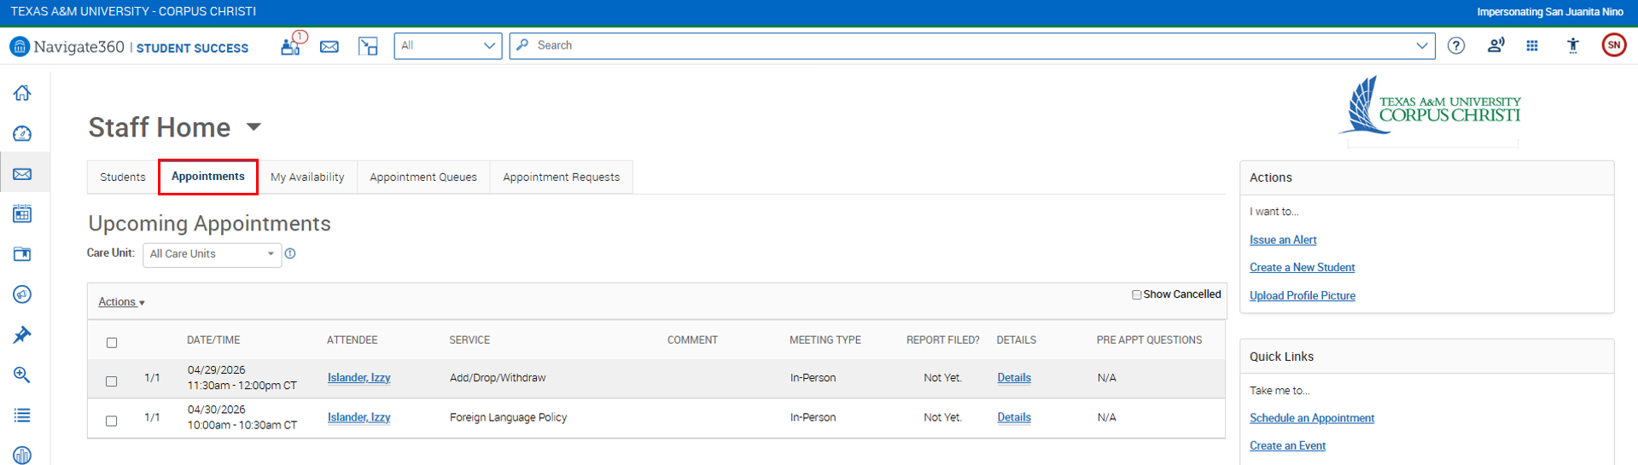

View Upcoming Appointments
Here, you can view any upcoming appointments in the Upcoming Appointments.
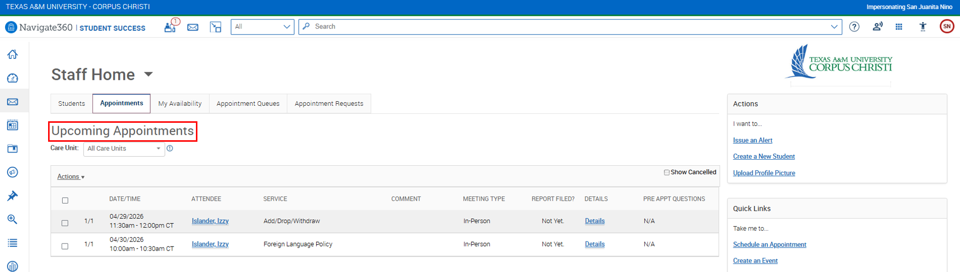
Or, if you want additional visibility, you can also find that through the section located below Quick Links.
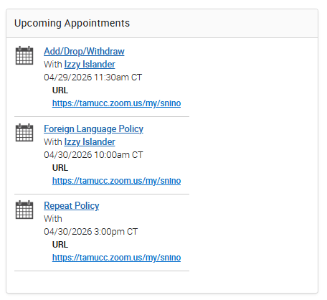
Cancel or Reschedule Appointments
You can cancel any appointment by:
- Select an appointment you want to cancel by clicking on the checkbox.
- Click on Actions.
- Choose Cancel Appointment.
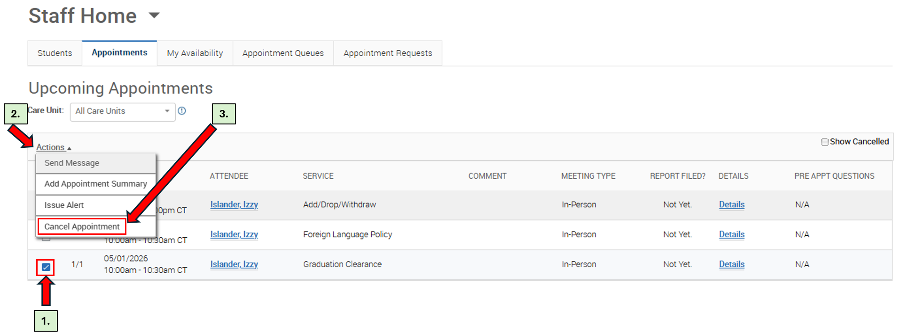
Or, you can click on Details on the appointment that you want to cancel.
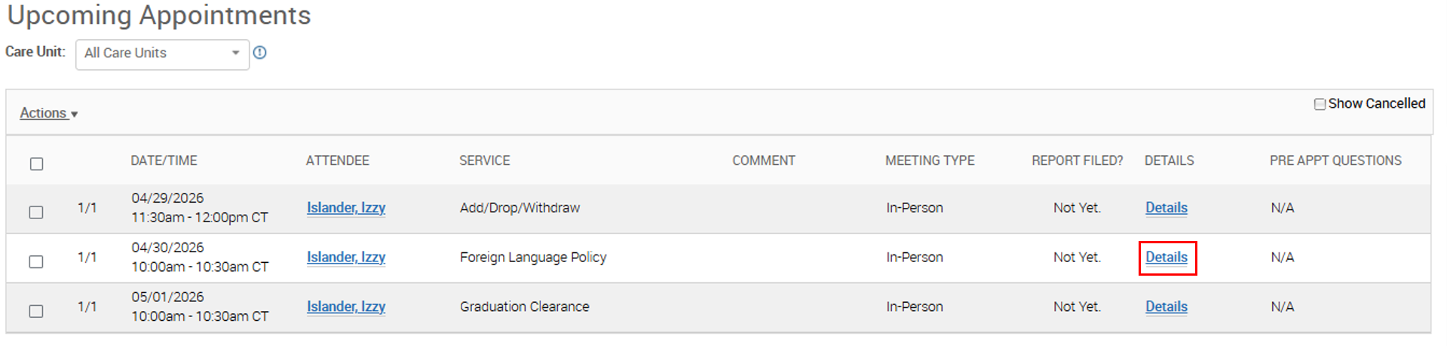
Then, select Cancel Appointment.
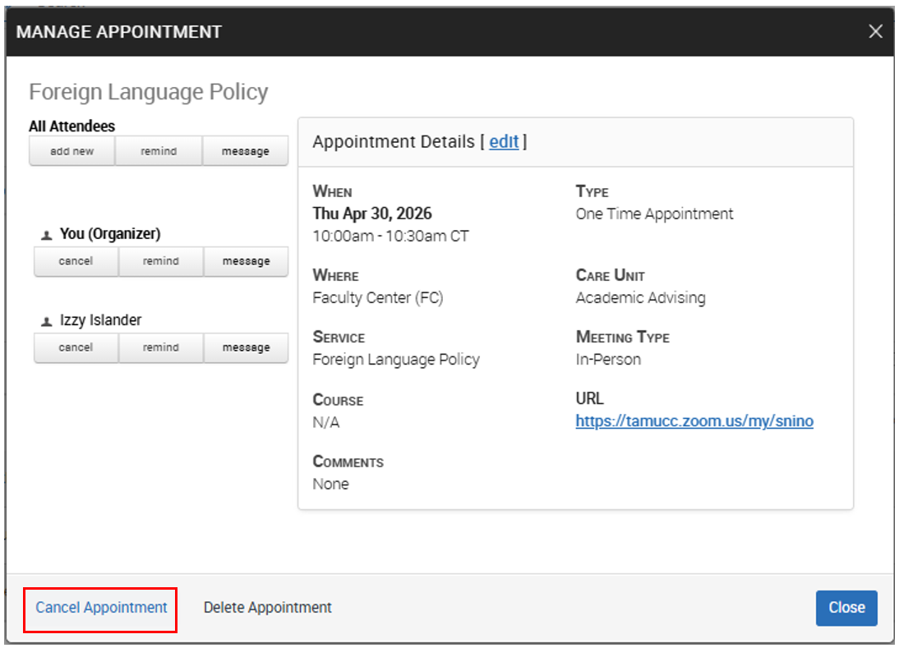

As for how to reschedule an appointment, click Details on the appointment that you want to change.
Then, select edit located next to “Appointment Details”.
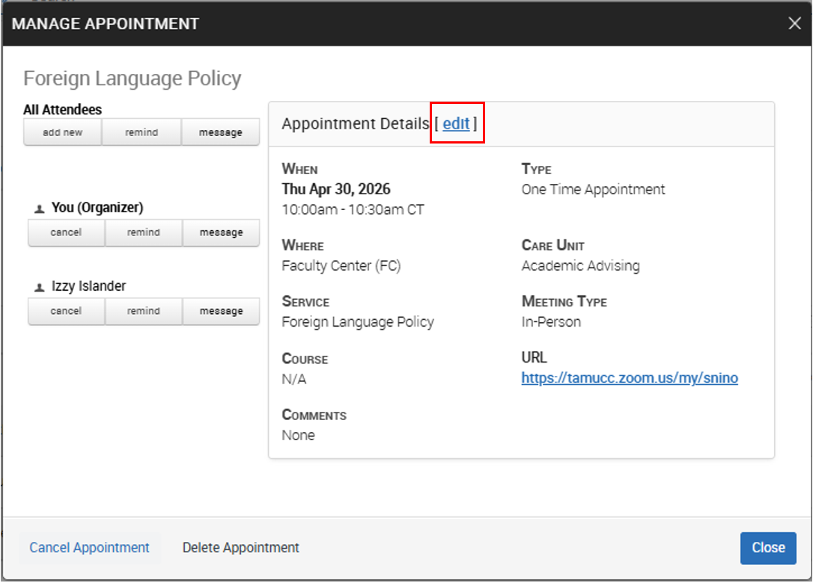
Scroll down a bit until you see Choose A Time To Meet:
- Uncheck the time slot the appointment is currently scheduled for (you can see the gray box).
- Select a new available time by checking the corresponding box.
- Click Save Appointment.
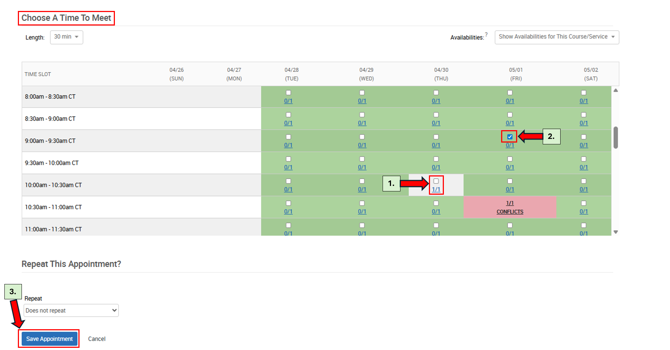
Send Messages to Students
You can send message to a student by first clicking on the Student’s name in your Appointments or you can simply look them up.
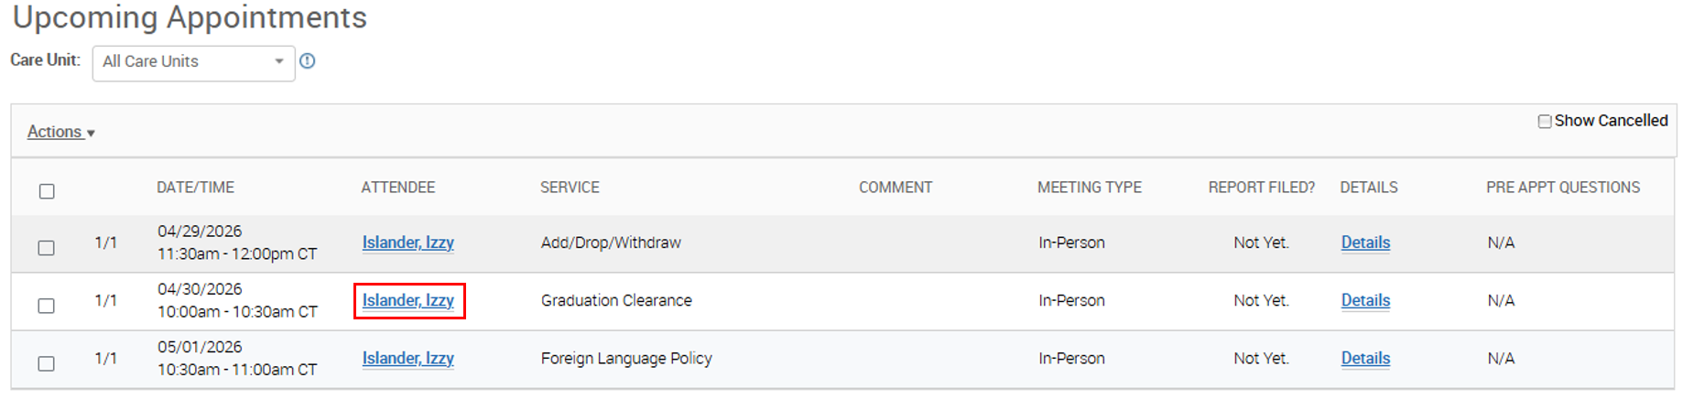
Then, choose Message Student located on the right side of the Student’s Overview. 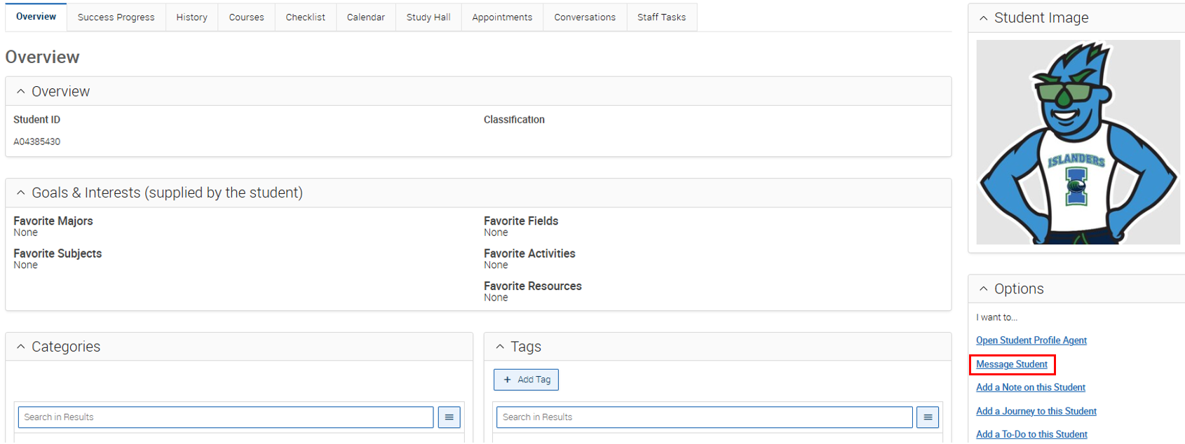
A prompt will appear where you can enter the required detials, such as the subject, message, attachments, and any other nececssary information.
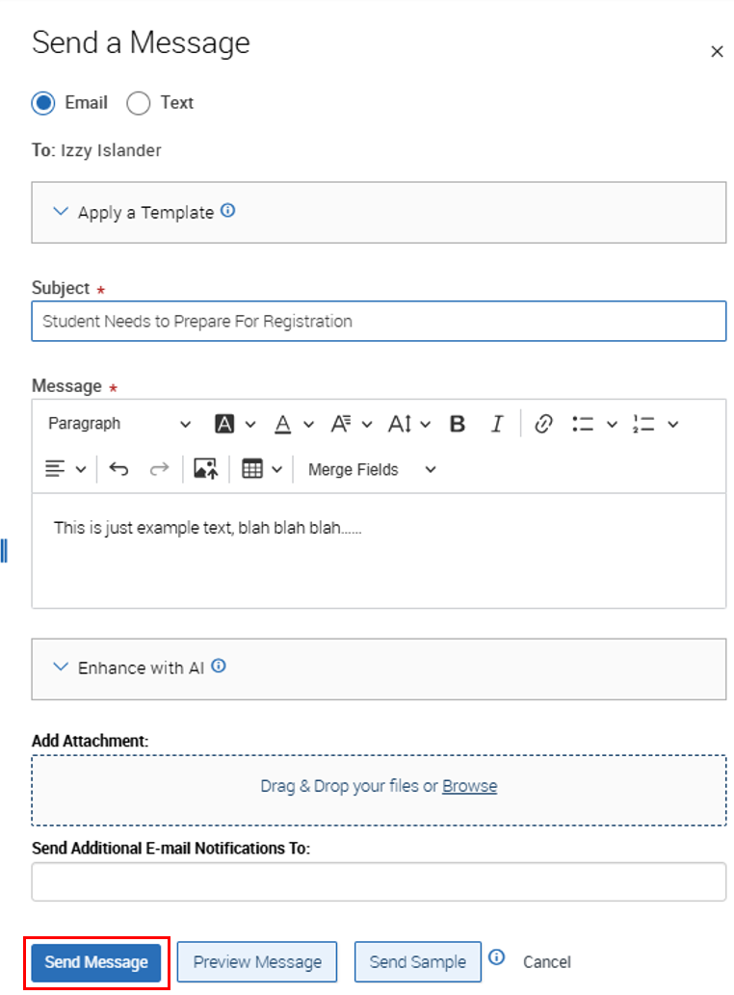
FYI: there’s a template option located at the top that you can use to save time if your template has set one up.
Mark Attendance or No-Shows
There’s not an explicit option to mark an appointment as “Attended” but adding an Appointment Summary is the equivalent of an attended appointment in Navigate. To do that:
- Select an appointment that you want to add Notes/Summary
- Click Actions.
- Choose Add Appointment Summary.
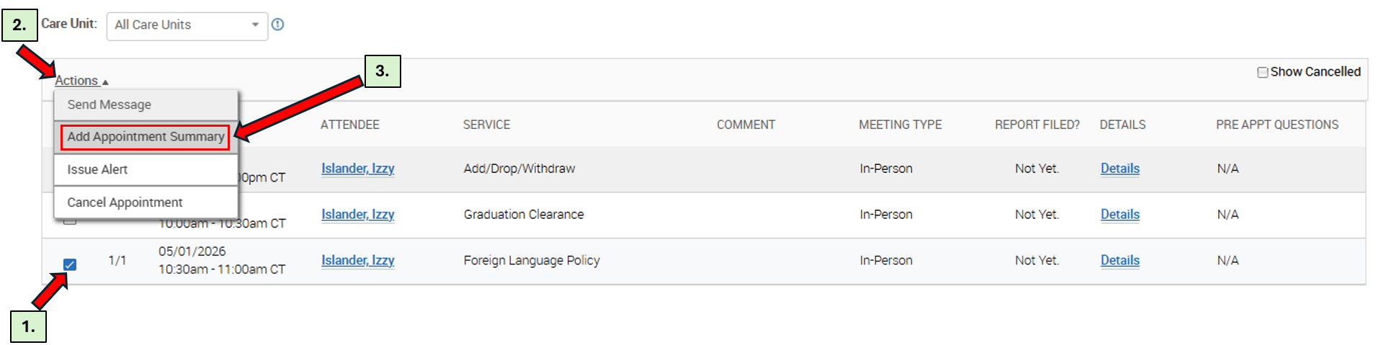
A pop up will appear and that will let you enter any relevant information regarding the meeting you just had with the student; Fill in as much information as you can then click Save this Report.
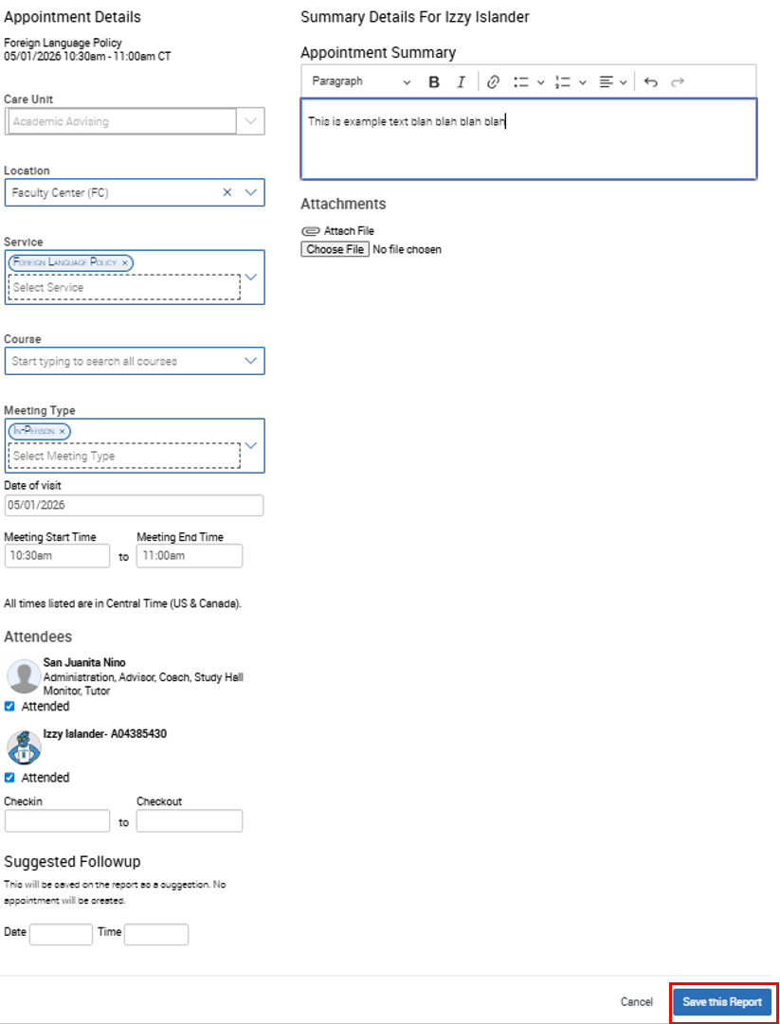
In case a student doesn’t show up for the appointment, you mark that appointment as No-Show by:
- Select an appointment that the student missed or didn’t show up for.
- Click Actions.
- Choose Mark No-Show.

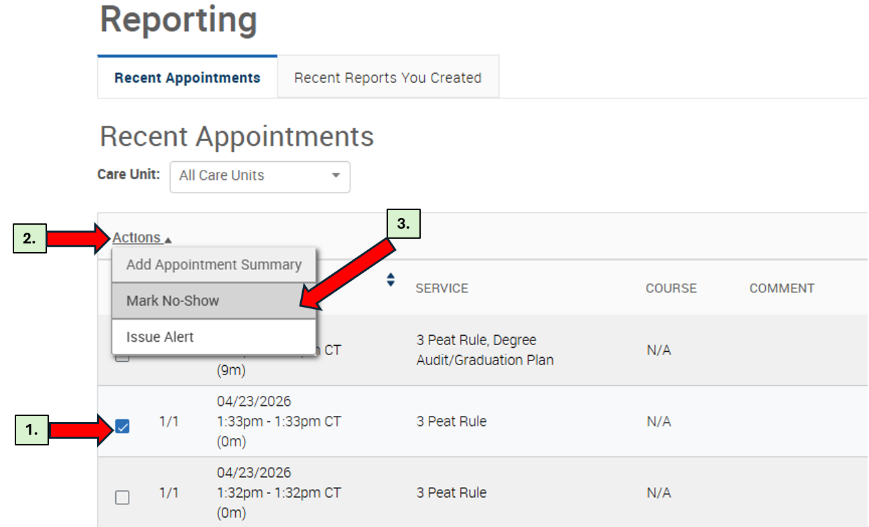
A similar pop-up (like the one for Appointment Summary) will appear, fill in any information, and click Save this Report.

Add Appointment Summaries or Notes
In order to add Summary/Note to any appointments (upcoming or past), you have to:
- Select an appointment that you want to add Notes/Summary
- Click Actions.
- Choose Add Appointment Summary.
A pop up will appear and that will let you enter any relevant information regarding the meeting you just had with the student; Fill in as much information as you can then click Save this Report.

