How to Create & Resolve a Case
Feature Overview
Important. Cases can only be opened automatically as a result of an Alert. It is not possible to manually open a Case on behalf of a student.
Alerts can be configured to automatically open a Case. A Case is an electronic case file where staff across departments (e.g., financial aid, bursar, tutoring, counseling) can coordinate and collaborate on the follow up with the student. Cases create a formalized next step for action or intervention on the issued Alert, should that be needed. The decision to automatically open Cases for certain Alerts is entirely up to the institution and will differ based on configurations in your platform. Contact your Application Administrator if you have questions about which of your Alerts open Cases. Only faculty or staff with appropriate permissions have access to view or manage Cases.

Viewing and Managing Cases
There are three ways to view and manage cases through the Navigate360 platform: the Cases page, a Student Profile, or through V2 and V3 reports.
Note: You cannot view your assigned or owned cases from your Staff Home page.

Cases Page
With the correct permissions, you can view and manage all open and closed cases on the Cases page. It is a streamlined view where users can access and search all cases they have permission to view in one place.
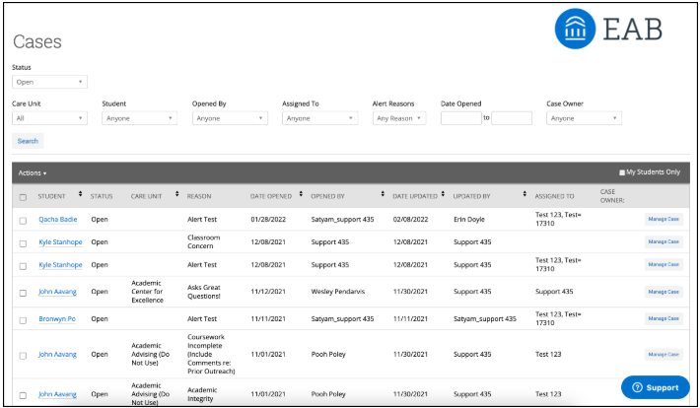

The table of student cases has the following column headers.
Student
Student name associated with the case.
Status
The status of the Case, which can be open or closed.
Care Unit
Care Unit the Case is associated with. Cases can only be associated with ONE Care Unit.
Reason
The Alert Reason that triggered opening the Case.
Date Opened
Date the Case was originally opened.
Opened By
Staff member who issued the Alert.
Date Updated
Date the Case was last updated. This could also be the date of closing the Case.
Updated By
Staff member who last updated the Case.
Assigned To
The staff members assigned to follow through on the opened Case. For example, if the alert reason is Needs Tutoring, a Case could be automatically assigned to the head of tutoring. A Financial Aid alert reason could be assigned to a financial aid services employee. These assignments are configured on the Alert Reasons page and depend on your institution’s user roles and configurations.
Case Owner
The Case owner is someone who has been assigned to and is managing the Case. For example, if a Case is assigned to a group in Financial Aid, the Case owner is responsible for triaging the Case by assigning it to the specific financial aid counselor who will be working with the student. You can only manually assign the Case owner within the case.
From this page, you can also manage the Case from this section by selecting Manage Case.
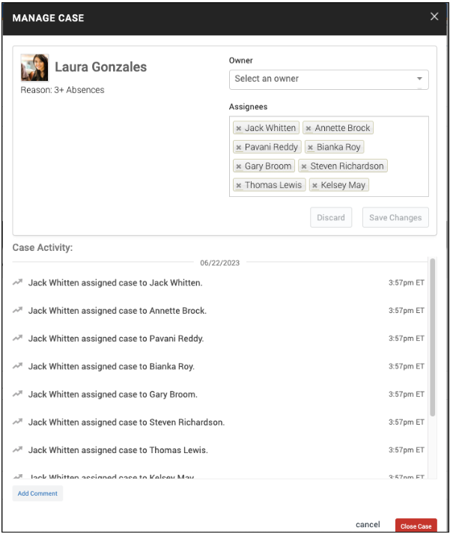
The following list is information and actions in the Manage Case dialog.
Student Name
Name of the student for whom the Case is opened.
Class
The course associated with the issued Alert.
Reasons
The Alert reasons.
Case Owner
The Case owner is someone who has been assigned to and is managing the Case. For example, if a Case is assigned to a group in Financial Aid, the Case owner would be responsible for triaging the Case by assigning it to the specific financial aid counselor who will be working with the student.
Assignees
The staff members assigned to follow through on the opened Case. For example, if the alert reason is Needs Tutoring a Case could be automatically assigned to the head of tutoring. A Financial Aid alert reason could be assigned to a financial aid services employee. These assignments are configured in alert reasons and depend on your institution’s user roles and configurations.
Close Case
Select this option if the Case should be closed. You are directed to the next page, prompting you to choose a required Case outcome and add comments to provide context to closing the Case. Please note that if a case was opened from an alert that was issued by a student using Hand Raise, that student would receive the closure comments since they were the original alert issuer.
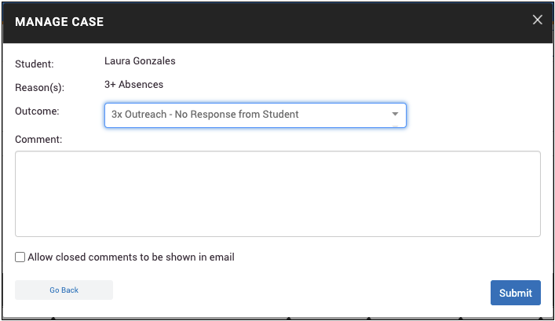

Student Profile
To view and manage Cases on the student profile, navigate to the student profile. On the right side of the profile are all current Alerts for a student. This count includes all Alerts, Cases, and Progress Reports issued for the student. Based on your institution’s configurations, this count may include all issued Alerts in the platform, or it may only include Alerts issued in the current term. Contact your Application Administrator if you have questions about your institution’s configuration for this count. The example below shows when Alert language has been changed; in this case to Referral.
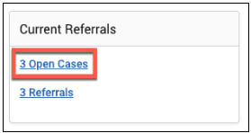
Important: Because the total count includes all Alerts, Cases, and Progress Reports, you may find duplicate information. For example, if one Progress Report issues one Alert, which in turn opens a Case, the total count is three to include each of those actions, even though they all originated from the same Progress Report. Be mindful of what the total count means when using that information to inform student interactions or follow up.
You can view all open and closed Cases that you have permissions to see for the student either in the Cases section of the Reports/Notes tab or on the History feed.
In the Cases section:
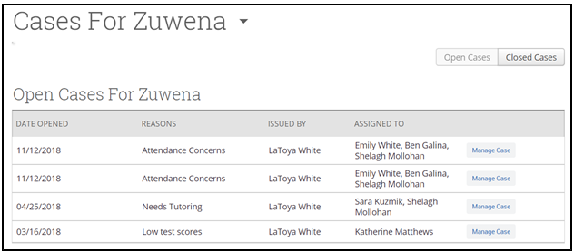
In the History Feed:
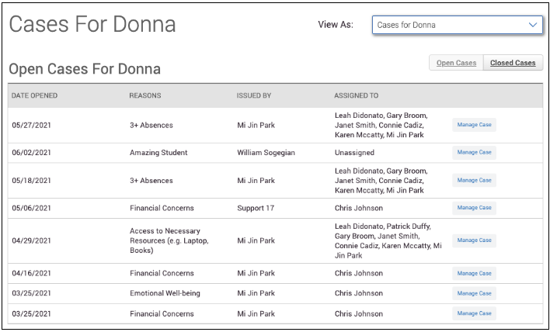
Important: If you are viewing the History feed but would instead like to view all Cases together like in the example above or the Reports/Notes tab, select the dropdown menu at the top of the History feed, and choose Cases for [Student’s Name]. This shows the Cases section view only.

Information provided in the Cases section includes:
Date Opened
Date the Case was originally opened.
Date Updated
Date the Case was last updated. This could also be the date of closing the Case.
Reasons
The Alert reason that triggered opening the Case.
Issued By
Staff member who issued the Alert.
Assigned To
The staff members assigned to follow through on the opened Case. For example, if the alert reason is Needs Tutoring, a Case could be automatically assigned to the head of tutoring. A Financial Aid alert reason could be assigned to a financial aid services employee. These assignments are configured on the Alert Reasons page and depend on your institution’s user roles and configurations.
You can also manage the Case from this section by selecting Manage Case. Information and actions in the Manage Cases dialog on the Student Profile are the same as on the Cases page.

V2 and V3 Reports
To view Case information for many students at once, open the Cases Report on the Standard Reports page.
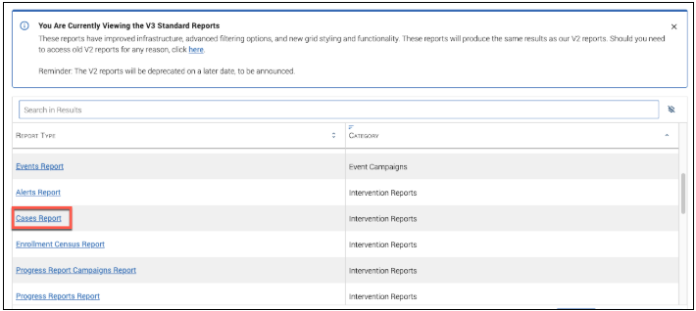
The Cases report shows any Case created by a user in the platform and associated details regarding that Case. Each row represents a single Case in the date range.
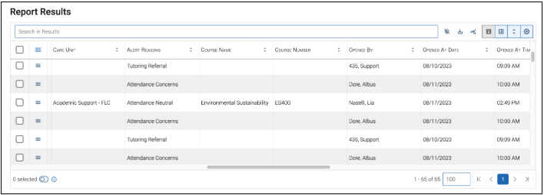
The fields included in the Cases report are explained in the Cases Report Data Fields article.
The following actions can be taken from the Actions menu on the Cases report:
- Send a Message
- Create Ad hoc Appointment Summary
- Create an Appointment Campaign
- Schedule Appointment
- Tag
- Note
- Issue Alert
- Delete Case: this action allows the user to delete the selected Cases.
- Add to Student List
- Add To-Do
- Add Journey (for institutions with this feature active)

Case Notifications
Depending on your institution’s configurations, the Case assignee/owner or original alert issuer may receive notifications about the Case opening and closing. Your institution may choose to send all, one, or none of these notification emails, configured globally. If you have questions about what notification emails are being sent for your institution’s Cases, contact your Application Administrator.

Case Assignee or Owner
When a Case is opened, a message is sent to all staff assigned to the Case, notifying them of the new Case. The message informs the recipient if they have been assigned to the Case or marked as the owner of the Case. The message below is an example and may look different for your institution.
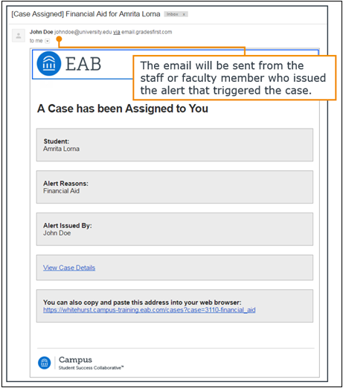

Original Alert Issuer
When the Case is closed, a message is sent to the original Alert issuer, notifying them that the Case has been closed. This message is simply an example and may look different for your institution.
