How to Cancel Appointments (Student View)
There are several ways to cancel an appointment in Navigate. Follow the steps below for the most direct method.
Before You Begin
- Go to navigate.tamucc.edu
- Sign in using your university credentials.
- After signing in, you will be taken to the Navigate home page.

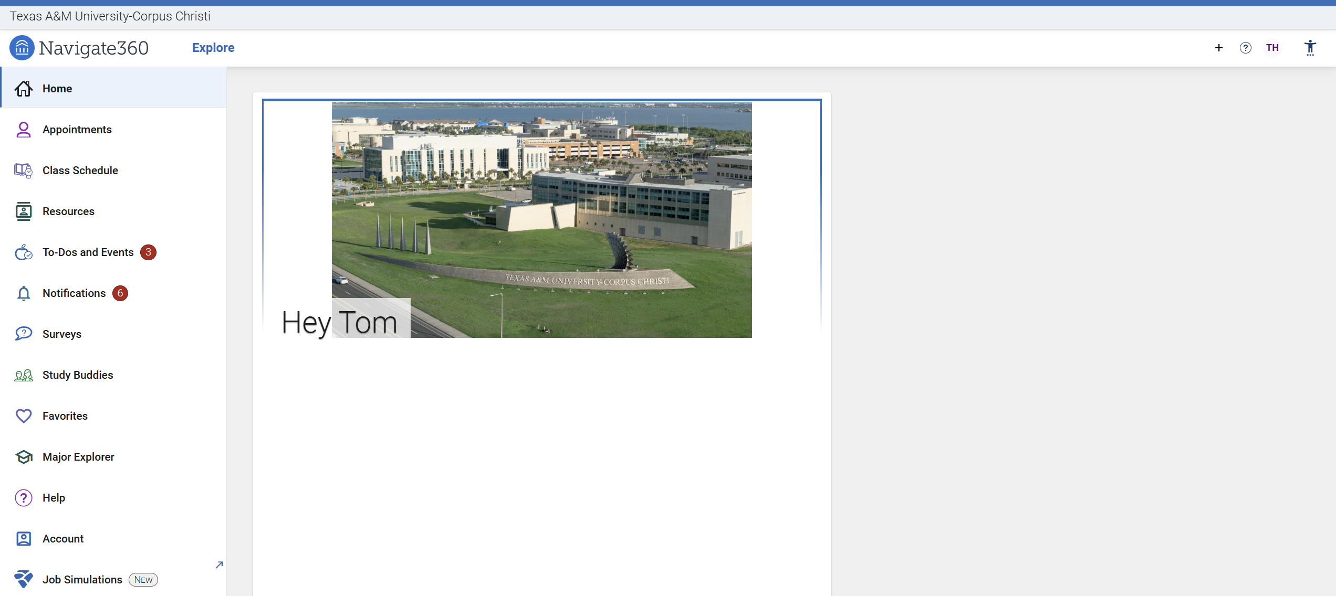

Method 1: Cancel Through To-Dos and Events
Select “To-Dos and Events”
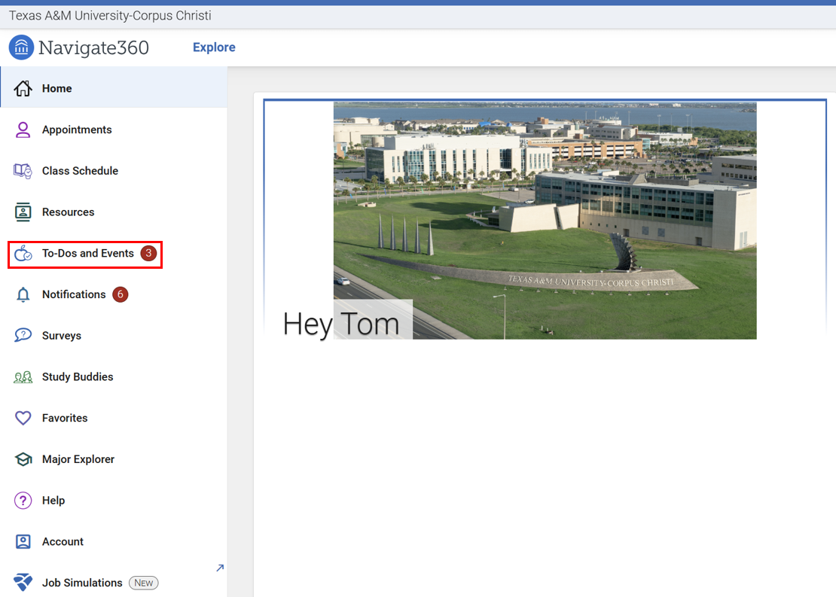

You will be directed to a page displaying your upcoming events, including scheduled appointments and any required tasks. Locate the appointment you wish to cancel and click “View Details”.
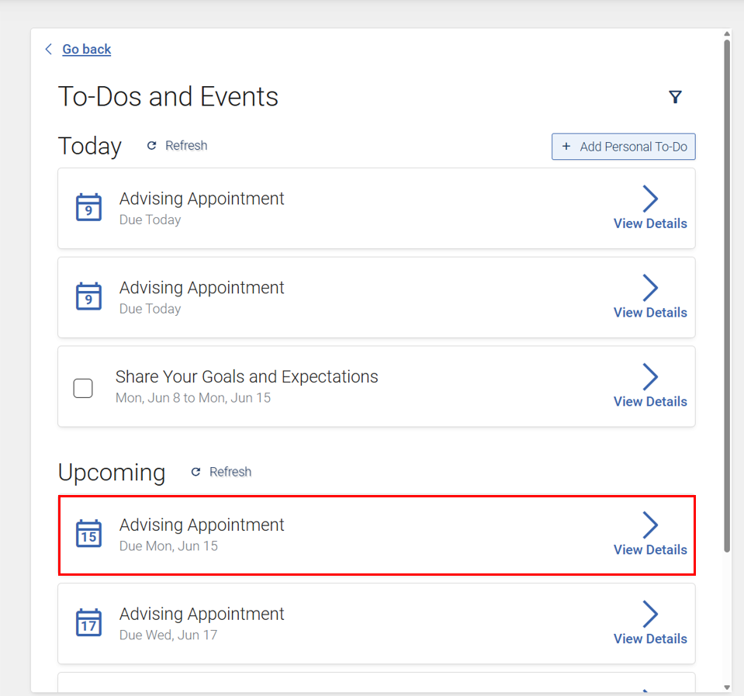

After clicking that, you will see the details of the appointment. At the bottom, there’s the Cancel Appointment button:
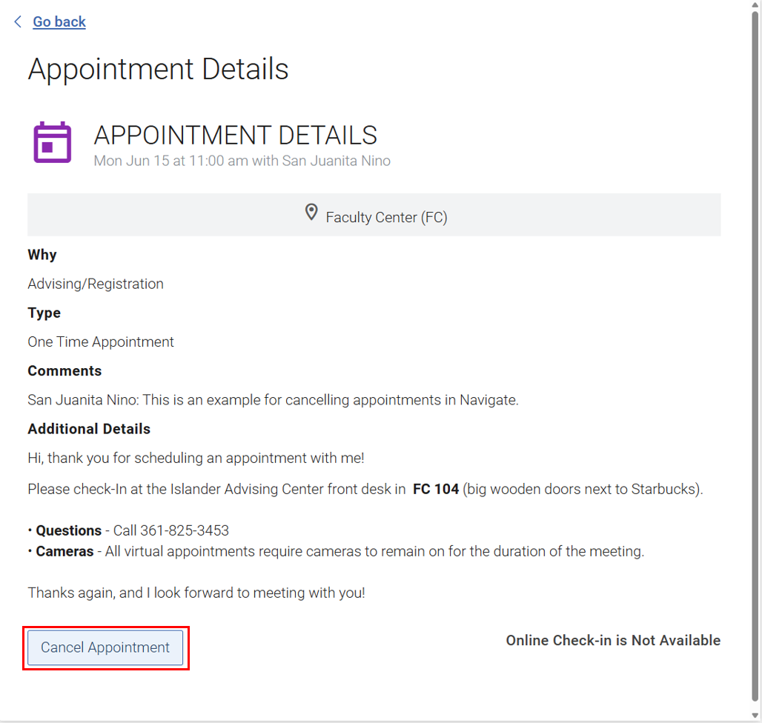
Clicking the “Cancel Appointment” button will display another prompt:
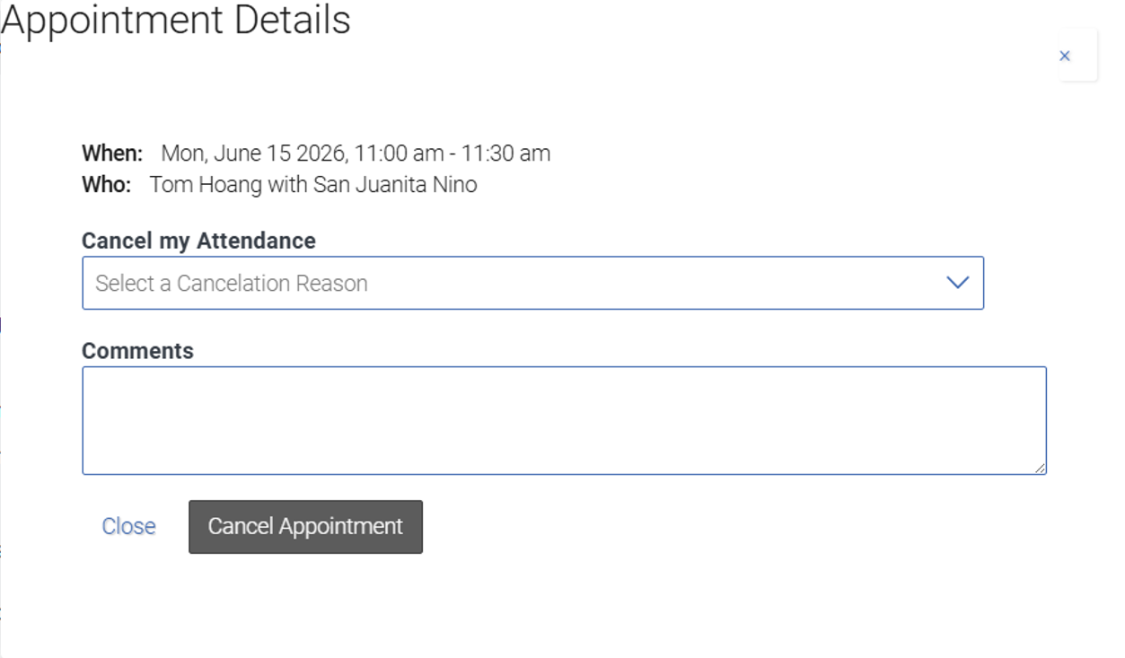
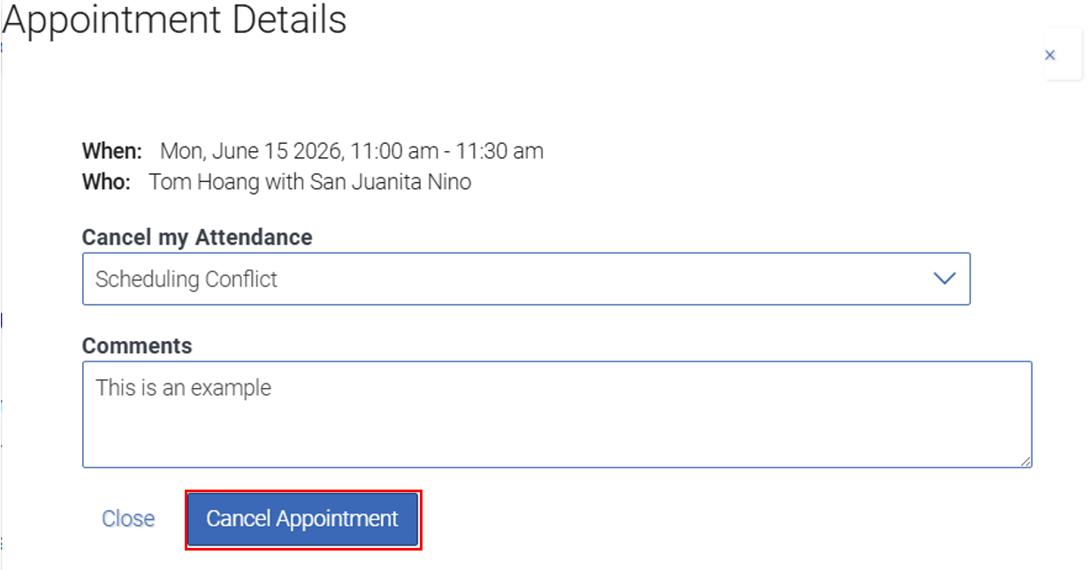

Select your reason for cancelation by clicking the drop-down then pick a reason that fits the best and add in any comment if you’d like. After that, click “Cancel Appointment”.

Method 2: Cancel Through Appointments
Select “Appointments”
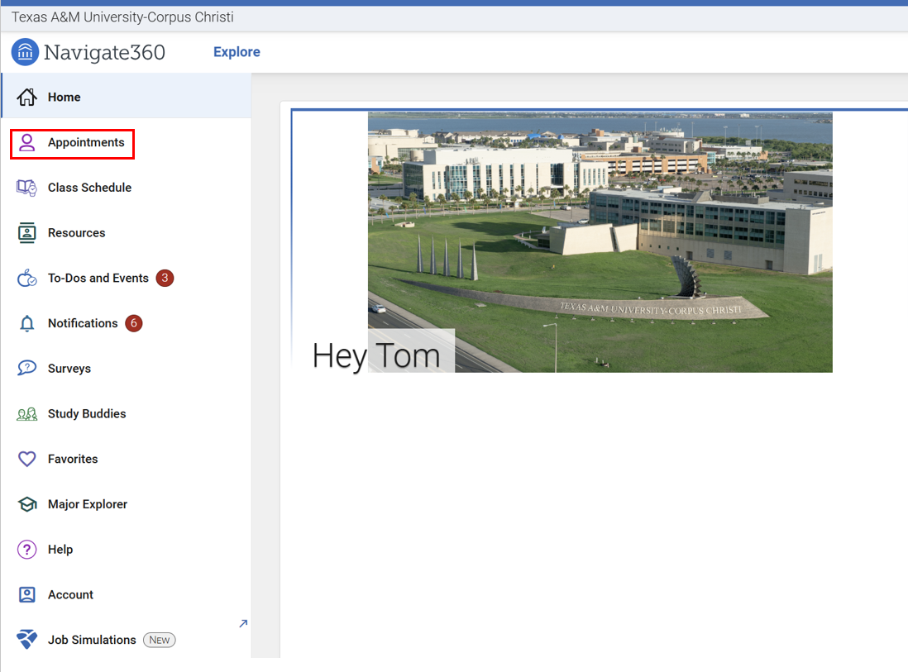
You will be directed to a page displaying your upcoming appointments or any invites you might receive. Locate the appointment you’d like to cancel by clicking on the Highlighted and Underlined Appointment or click on the Drop-Down Arrow.
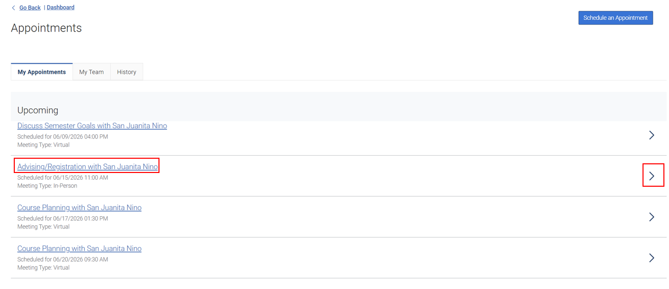
After choosing the appointment, you will see the details of that appointment
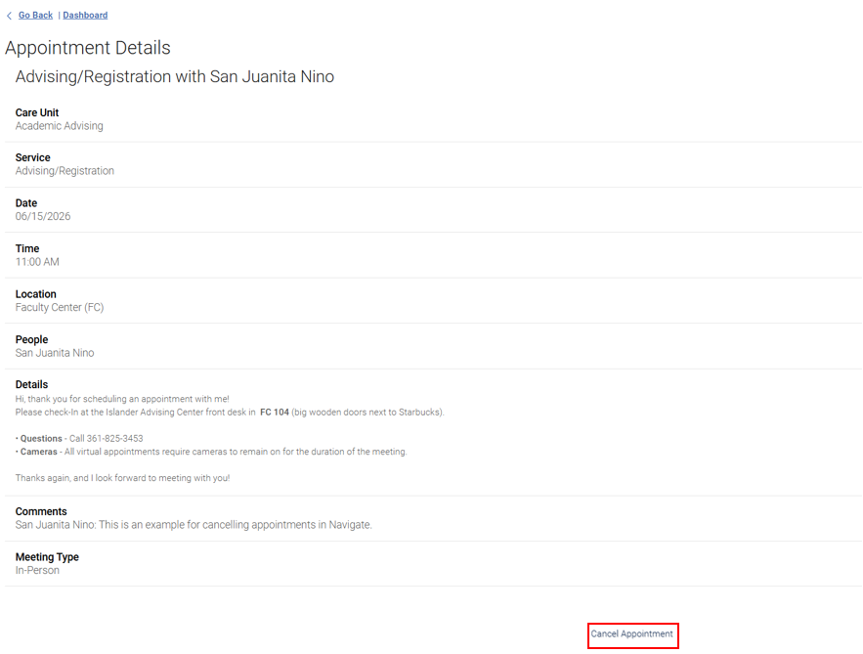
Clicking Cancel Appoint will display the following pop-up:
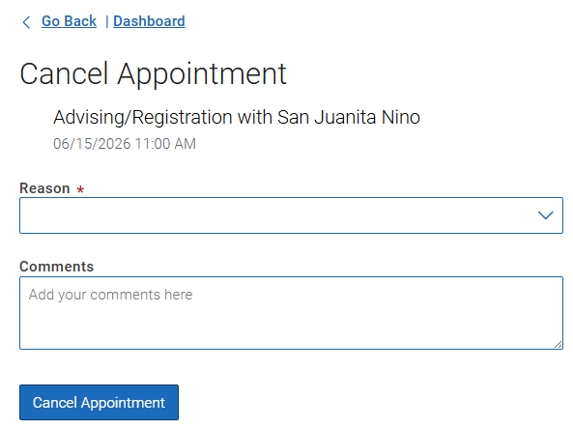
Select your reason for cancelation by clicking the drop-down then pick a reason that fits the best and add in any comment if you’d like. After that, click “Cancel Appointment”.
