How to Cancel Appointments (Student View in the Mobile App)
Before You Begin
- Go to navigate.tamucc.edu
- Download the Mobile App through either App Store or Google Play.
- Sign in with your Islander credentials and you will be directed to app’s homepage.

First thing you will see when you launch the app is your class schedule if you have any during the Semester.
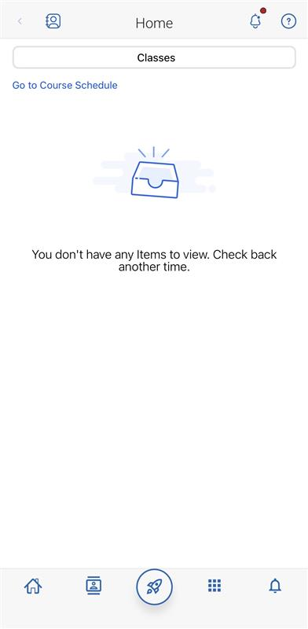

Locate the Rocket icon at the bottom of the home page.
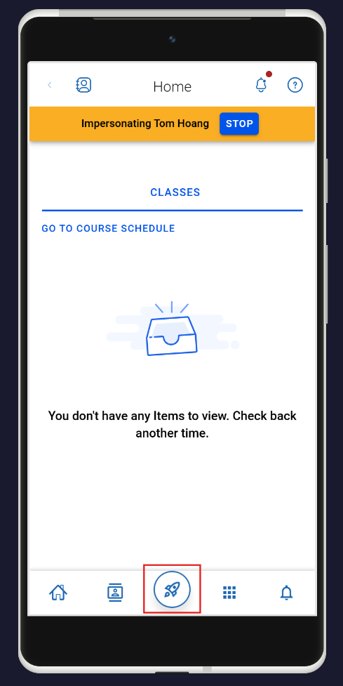
Then, you will see a few pop-ups. Select Appointments.
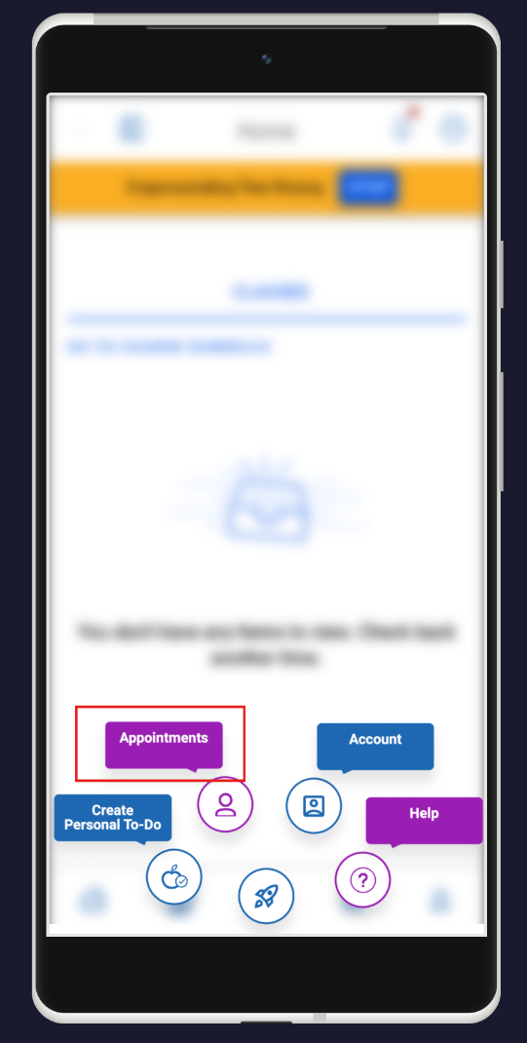
You will be redirected to a page where it shows any upcoming appointments you have. Select the appointment you want to cancel by clicking on the Highlighted & Underlined Part of the appointment or the Drop-Down Arrow.
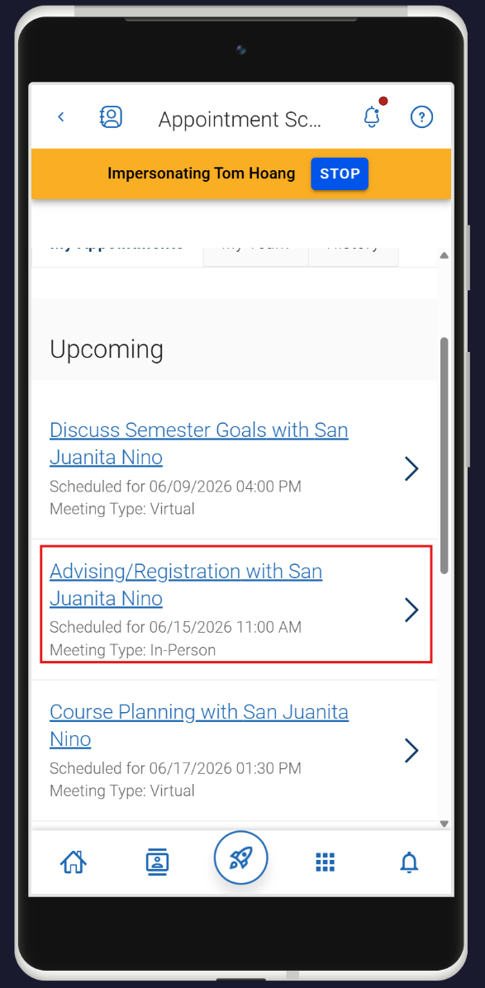

After that, you can see more details of that appointment. To cancel your appointment, scroll down all the way to the bottom of that page and select Cancel Appointment.

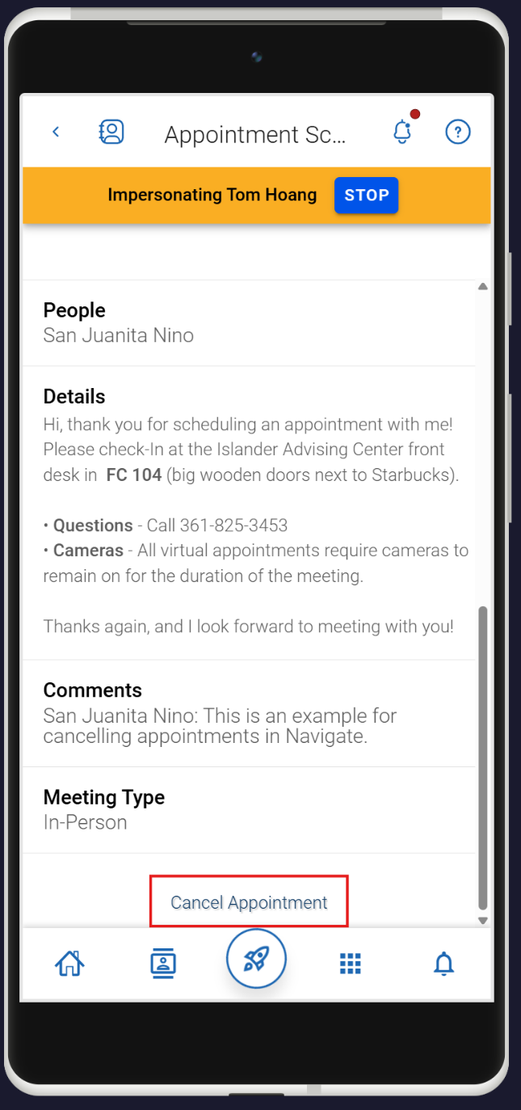

Clicking the “Cancel Appointment” button will display another prompt:

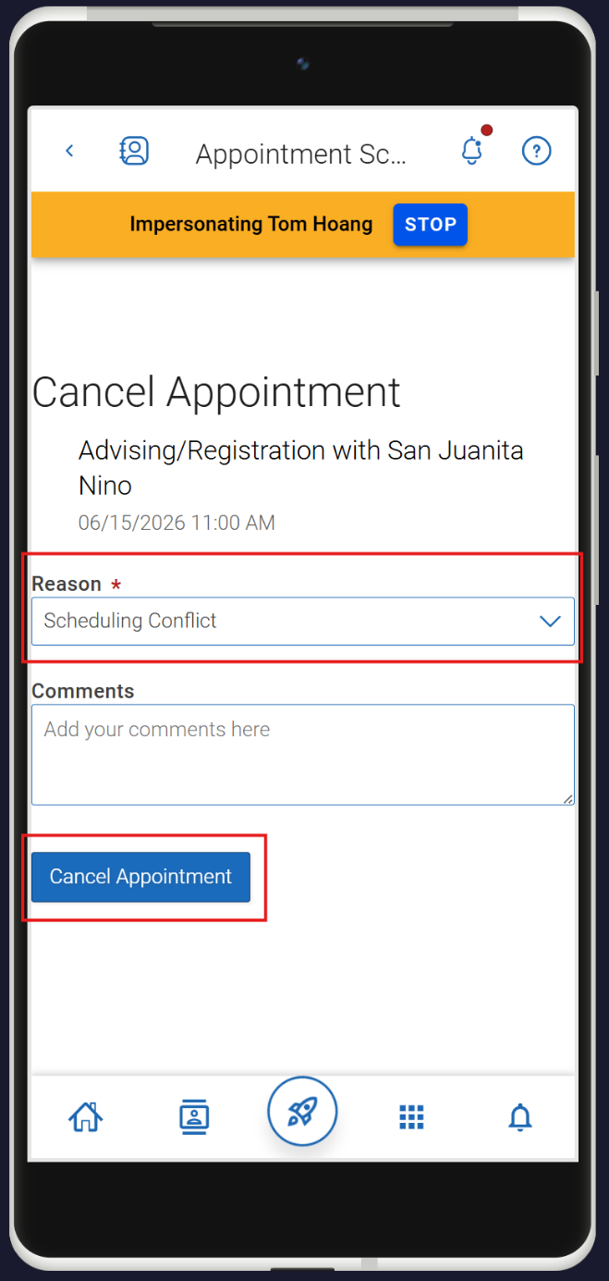

Select your reason for cancelation by clicking the drop-down then pick a reason that fits the best and add in any comment if you’d like. After that, click “Cancel Appointment”.

