How to Add Notes to a Student Record
Feature Overview
Notes offer an additional mechanism to jot down information about a student, collaborate across Care Units, and create a record of information provided directly to the student. Unlike Appointment Summary reports, notes are not tied to specific appointments, nor are they formatted specifically for specific Care Units.
Because of their flexibility, institutions take advantage of notes in a variety of ways. Some institutions view the capability as a sticky note, and allow faculty and staff to document any important information that should be visible to anyone working with the student.
Notes can be added to more than one student at the same time. There is a cap of 100 students for whom notes can be added to at once. This can be done by selecting students in your queue (e.g. Advanced Search or report) and opening the Actions menu. If they have permission, users can select Note to add a note to anywhere from 1 to 100 students. If more than one student is selected, the same note scripting will apply to each student record. If more than 100 students are in your queue and selected, the Note option no longer appears in the Actions menu.
Another Note capability that can be configured for your institution is Private Notes. If your institution has private notes, only you and other users with the permission to see private notes can see notes marked as private about a student. This capability can be turned on and off, so if your institution disables private notes, your old private notes remain private; however, you will no longer be able to create private notes.
Some institutions use Notes to track very specific information about students, such as their degree plans. In these scenarios, faculty and staff can attach the student’s degree plan directly to the Note, make the note visible to the student, and label the note with a searchable Note Reason, such as Academic Planning. Note reasons vary depending on configurations. Administrators can then report on degree plans by generating a Notes Report, as shown below. Administrators can also use the Notes Report search for text included in notes.
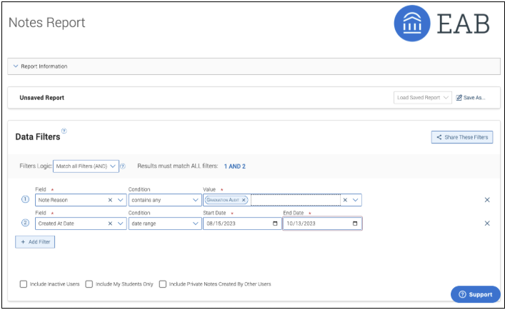
The Notes report can also be used to delete notes.

On the student profile, Notes can be found on the History tab along with other documentation, such as Appointment Summaries or Progress Reports. To view only Notes, you have two options:
1. Select Note Added in the History filter, as shown below.
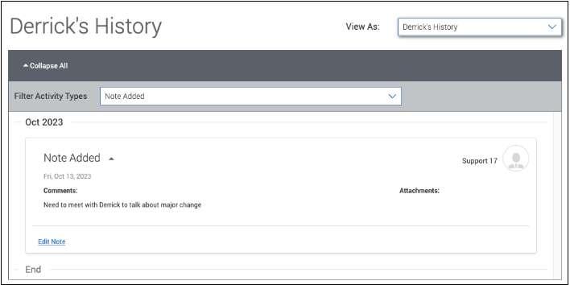
2. Click on (Student Name)'s History and filter to view only Notes. This view is helpful if you have the right permissions, as this is where you are able to delete Notes. To delete a Note, select that Note, open the Actions menu and then click Delete Note.
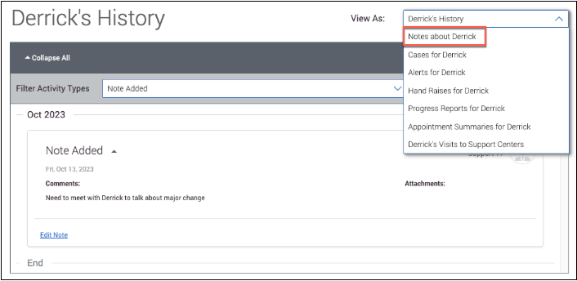
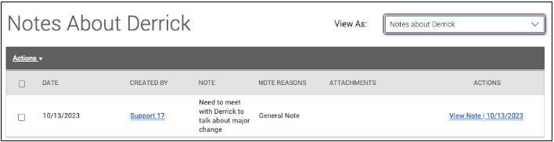
Note visibility is based on configurations and permissions. For example, if you don't mark a note as private, users with the permission to view student notes will be able to see your note, regardless of Care Unit. However, even if you mark a note as private, if your administrator gives another user permission to see private notes, that user will be able to see a private note.
Users with the permission to edit notes that were created by others can edit your note.
To show a Note to a student, check the box next to their name in the Visibility field. If you choose to make a Note visible to the student, it appears on the Reports page in Navigate360 Student or the Reports tab on the Student Home.
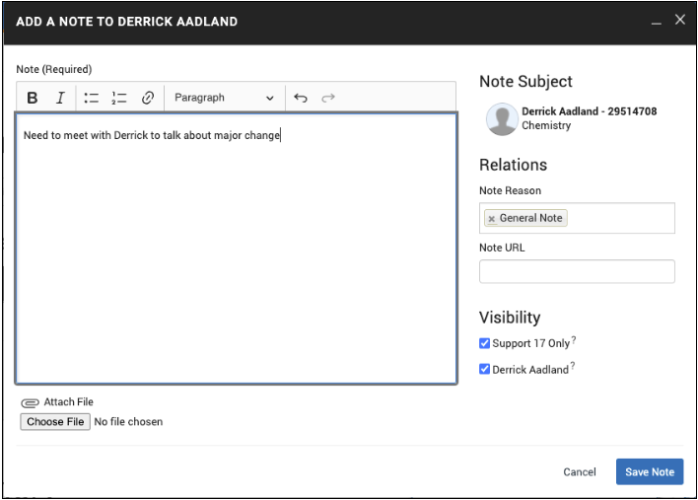
The fields on an Add Note window depends on what your institution has configured. For example, attachments may be turned off and if they are, you will not see the ability to choose file to add an attachment. Private notes may be turned off.
Use the Note URL field to copy and paste a URL. For example, if you spoke with the student about the FAFSA, you can copy and paste in a URL to the FAFSA website to share with a student.

