Ad Hoc Alerts
There are several locations to issue ad hoc alerts in Navigate. They include the Staff Home or Professor Home pages, in Advanced Search results, or from a student profile.
To issue an alert from Staff Home or Professor Home, select Issue an Alert from the Actions pane. A dialog then prompts you to search for the student you want to issue the alert for, as in the following screenshot.
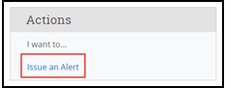
To issue an alert from a list of students, such as Advanced Search results or your My Assigned Students pane on your home page, select a student from the list. Next, select Actions > Issue Alert.
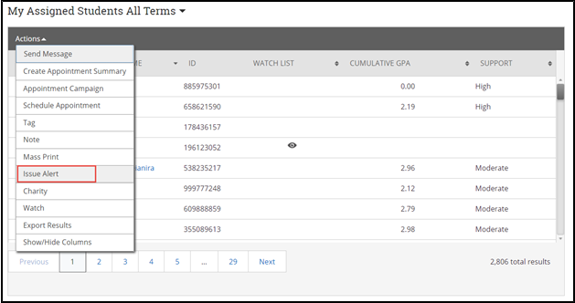
To issue an alert from a student profile, select Issue an Alert from the Action pane as in the following screenshot.
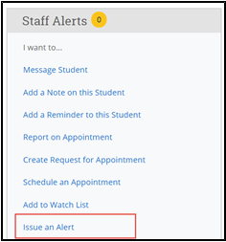
Selecting Issue an Alert opens the Alerts dialog. Text boxes in the dialog are in the list that follows the screenshot.
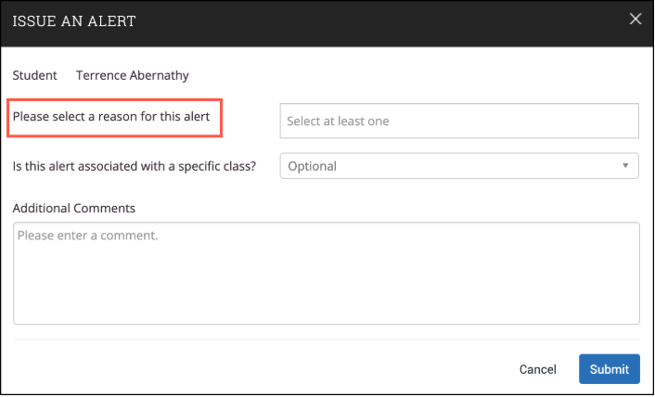
- Alert Reason: Select at least one reason for issuing this alert. Alert reasons are configured by your institution. They should be sorted by Care Units and then alphabetically within the Care Unit. If your role does not include any Care Unit assignments, you only see Alert Reasons not associated with a Care Unit. Contact your Application Administrator if you have questions about your institution’s alert reasons.
Important. Alert Reasons are tied to Care Units. If your institution uses case management workflow, each Alert Reason chosen may open a separate case for the student.
- Association with Specific Course (Optional): Select a course from the list if the alert is associated with a specific course the student is currently enrolled in.
- Additional Comments: Enter comments in this box. Staff and faculty with permission can view the alert and its comments. There is no character limit to this field.
When you select an Alert Reason when issuing an ad-hoc Alert, details and the actions that will take place are shown. If you select more than one Alert Reason, each reason's details will show beneath Additional Comments. This also shows if the alert opens a case.

