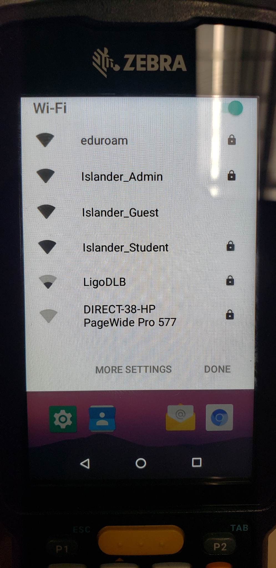
Step 1:
Locate the Wifi drop down at the top of the home screen (Similar to a cellphone). Select Islander_Admin.
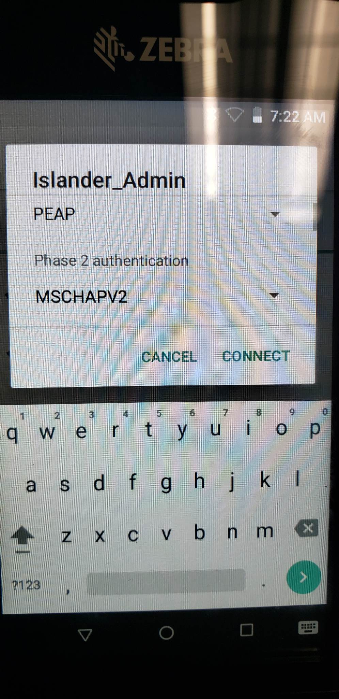
Step 2:
Make sure the settings reflect the above. PEAP, MSCHAPV2. You should not have to change these.
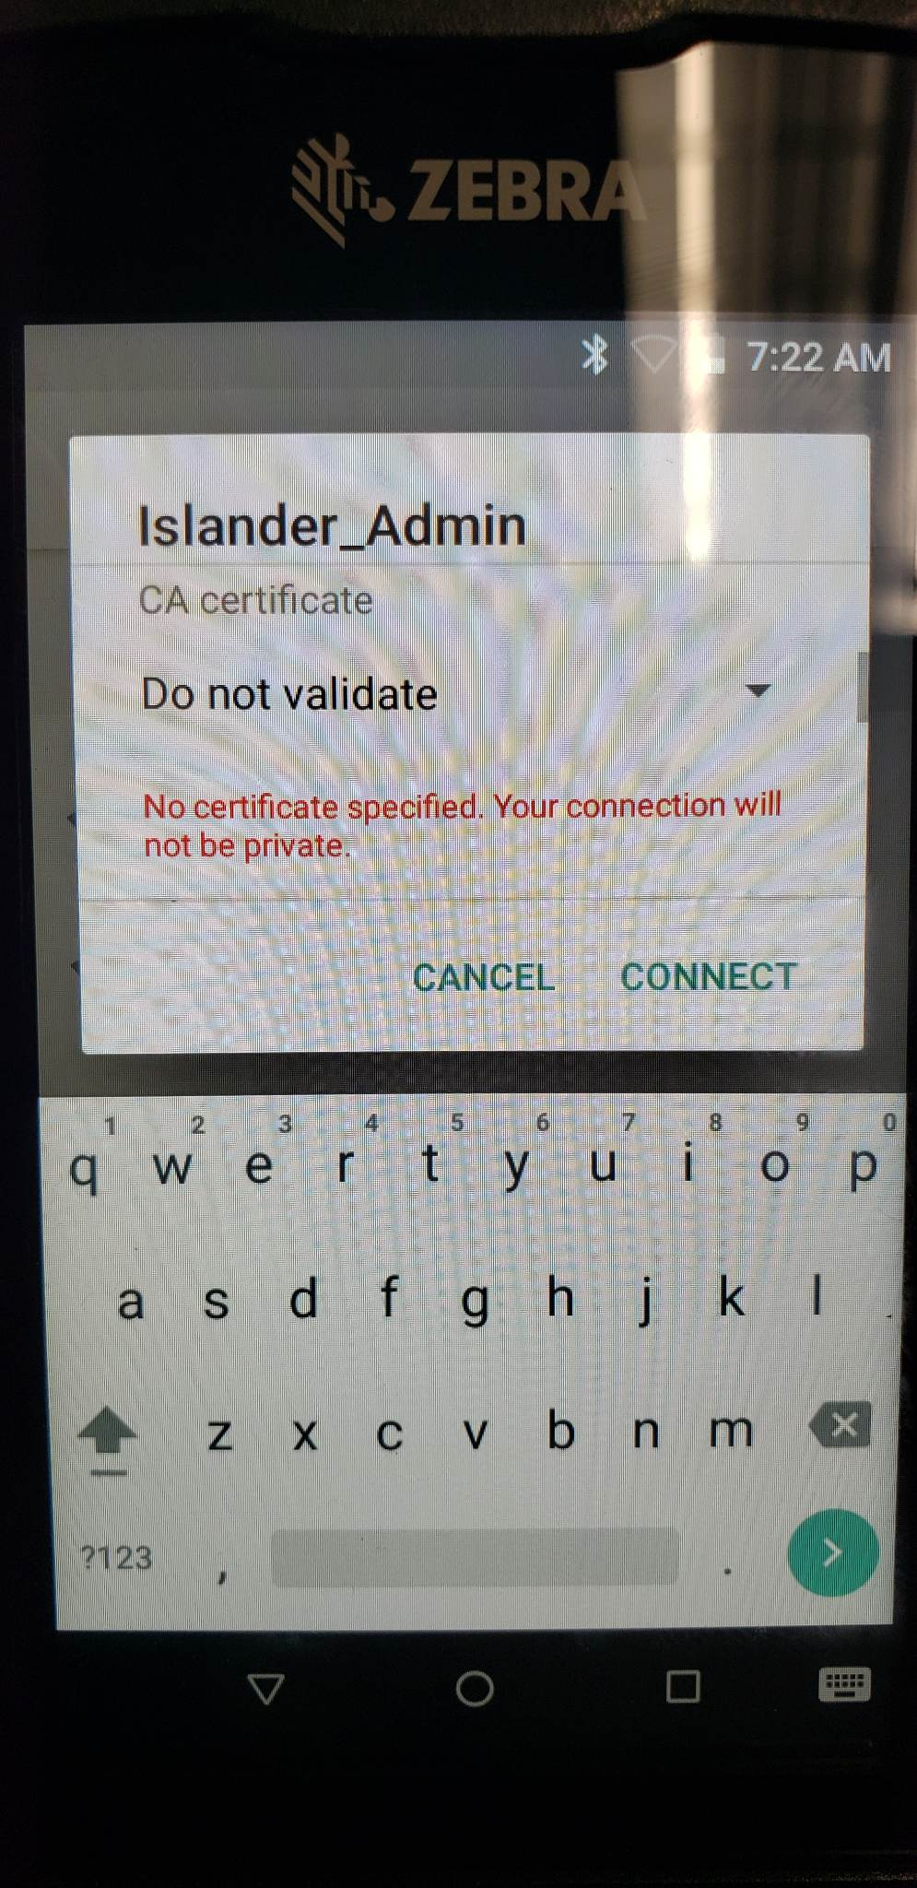
Step 3:
Under CA Certificate click the drop-down arrow and select “Do not validate”.
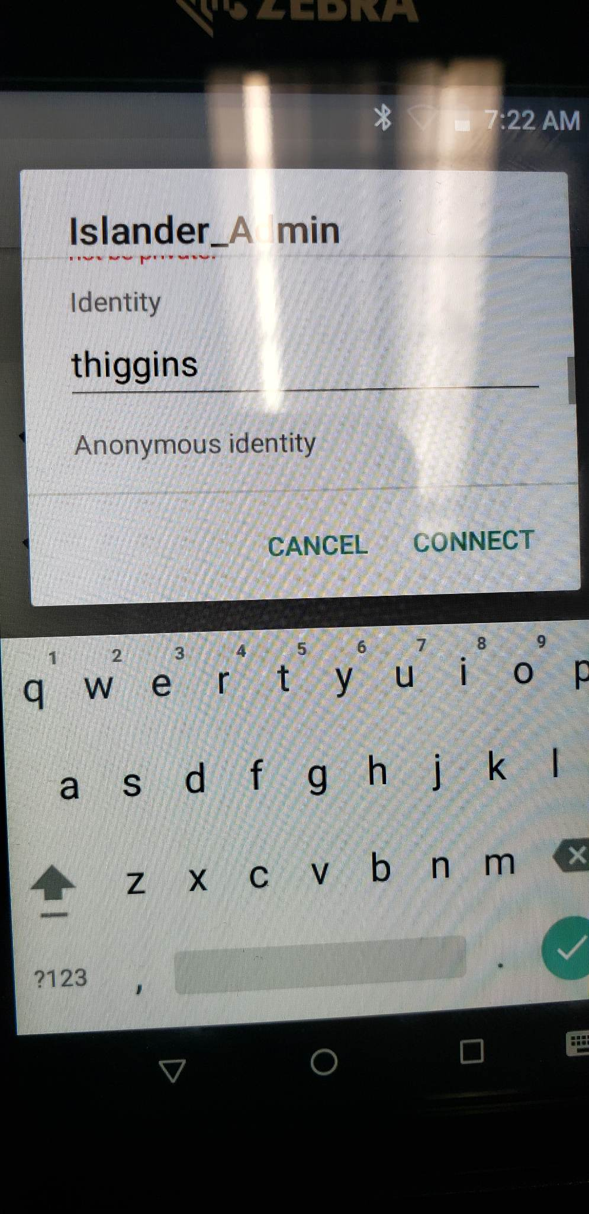
Step 4:
Scroll down further to identity and put the same login you use to sign into your work PC. It’s your first initial of first name followed by your last name. My login is thiggins.
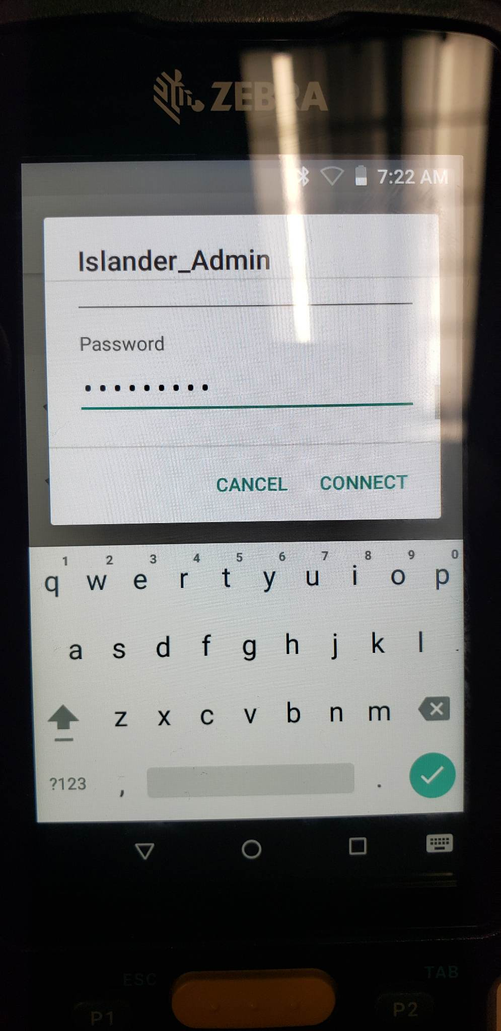
Step 5:
Your password is the same password you log into your work PC. My password is… .
After you enter your password, hit connect. If it does not connect right away, verify you have everything entered correctly. If it still does not work, restart the scanner, and try again. If it still does not work, contact Inventory@tamucc.edu and we will assist you.

