Amazon Business Access Request - MyIslandID

All TAMUCC Faculty and Staff may request access for themselves or others in their department through MyIslandID Self-Service Portal.
Request Access to an Application through MyIslandID

- Open a web browser and navigate to MyIslandID, and login using your IslandID and password. Please update recovery and emergency contact information if prompted.
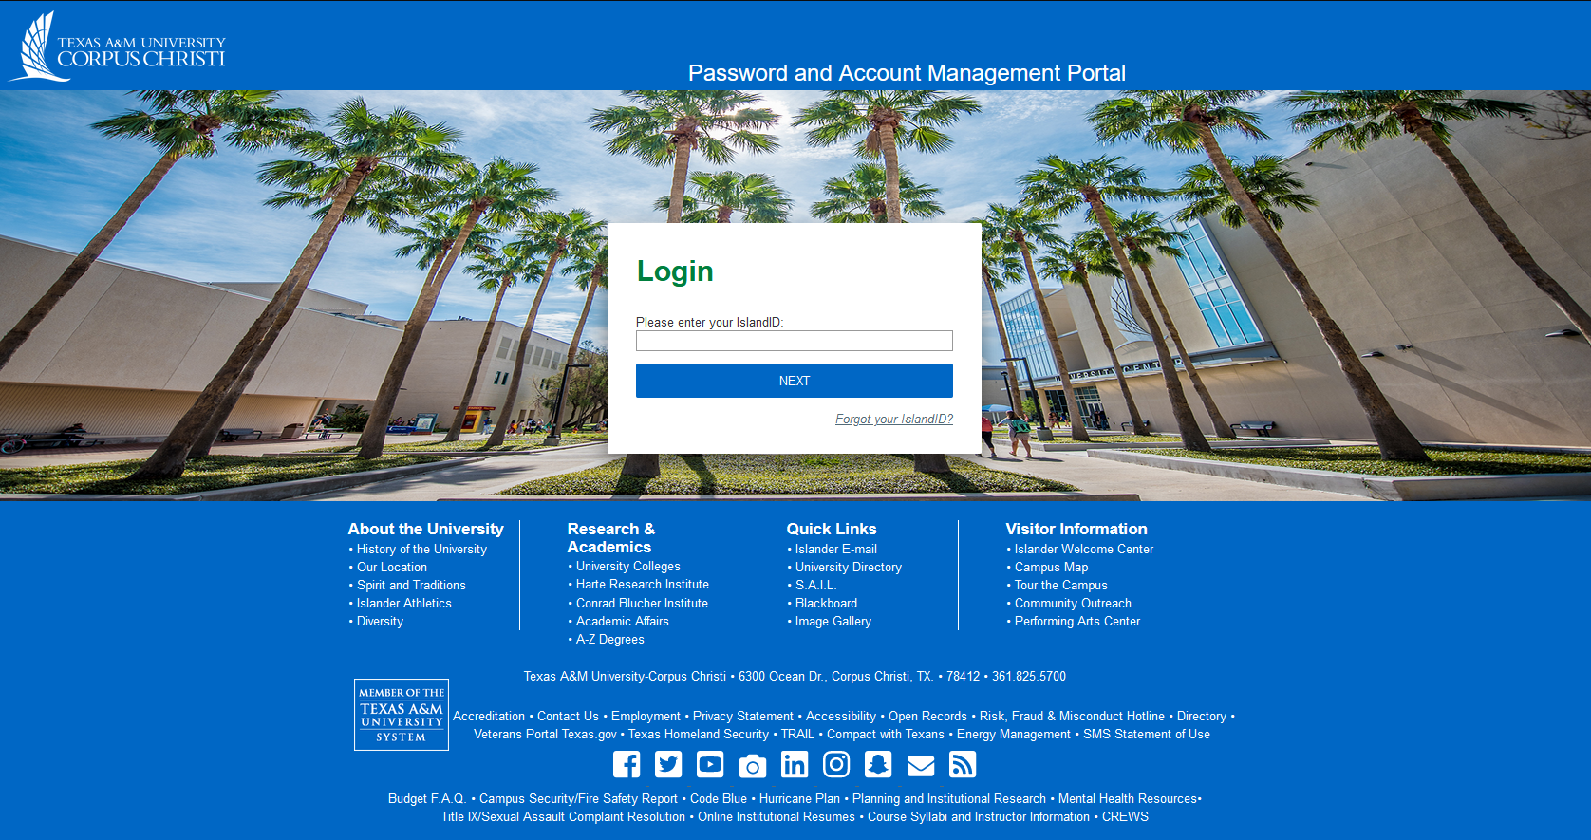
- Next, click the Requests tab at the top left of the screen, then click on the inner "Request Access" tab.

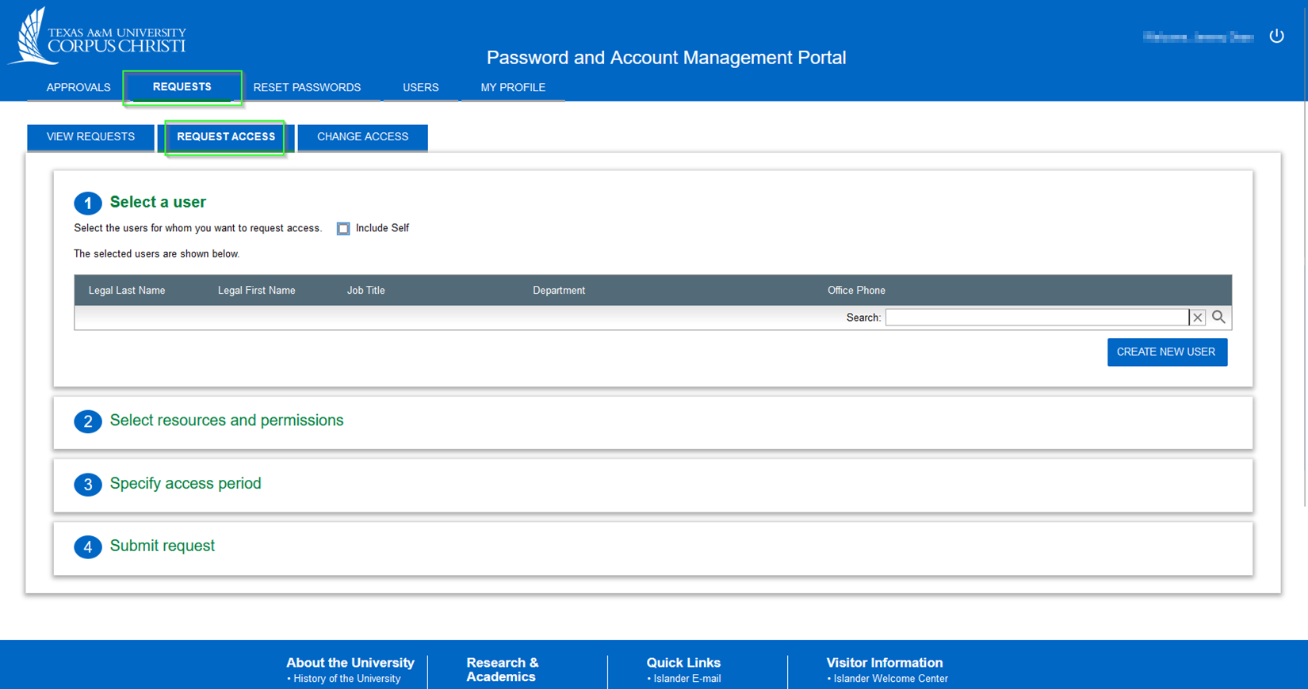

- Now tick the "include self" box to request access for your own account or if requesting access for another individual you’ll go to the “search” bar and start typing in last name, first name.
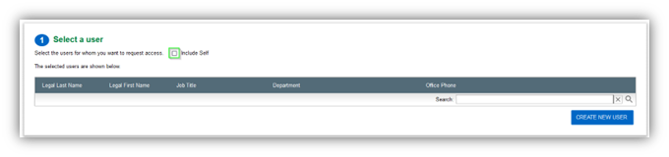
- Using the drop-down menus, select Entitlements > Access Groups > Application Access Group, Amazon Business. Check the box and then click the “done” button.
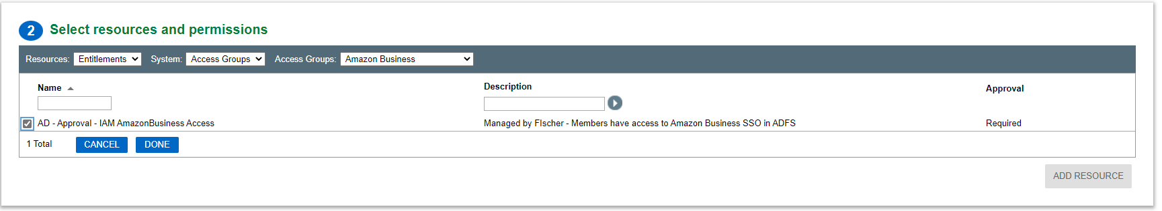

- Please select the “permanent box,” and enter a brief justification for your request, then click “submit request.”
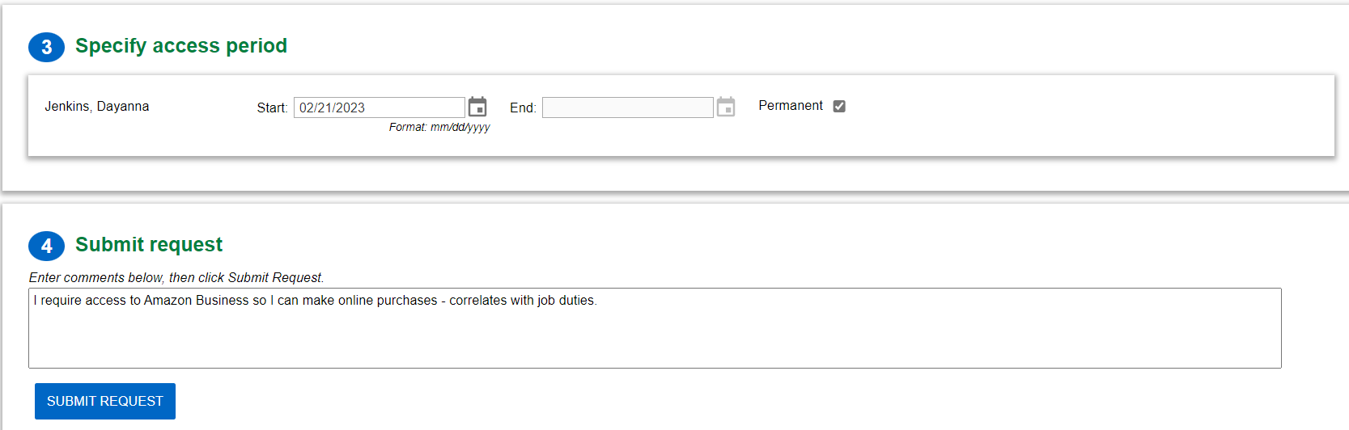

- Your request will be routed to the proper resource for approval, and you will receive an email upon completion! Any questions or requests for additional information will also be sent via email with instructions.

