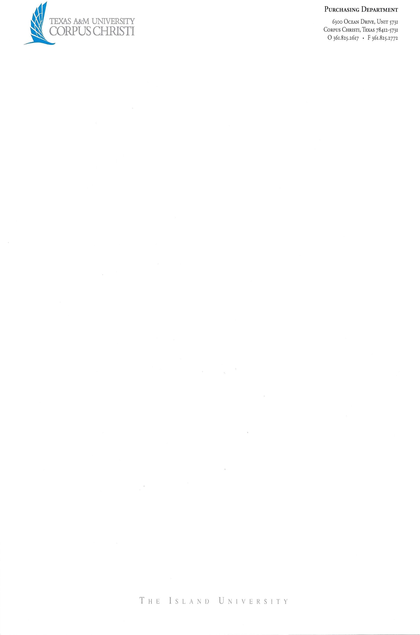

**PROJECT PARTICIPATION AS UNPAID VOLUNTEER AND LIABILITY RELEASE**

**1.** I am volunteering to participate in certain educational and research activities associated with the **Texas A&M University – Corpus Christi** (“TAMU-CC”) project described as: _________________________________________________ (the “Project”).

I volunteer without promise, expectation, or receipt of consideration, employment, benefits, or other privileges for my participation and without contemplation of future employment, benefit, or other tangible benefit. I understand that I am not eligible for workers’ compensation benefits if I am injured or become ill as a result of my volunteer participation, and I am not eligible for unemployment compensation benefits when my volunteer participation ends. I am not currently employed by TAMU-CC, The Texas A&M University System (“TAMUS”), any other member of TAMUS, or the State of Texas in a position requiring me to perform the same type of activities as contemplated by this Project Participation as Unpaid Volunteer and Liability Release (this “Agreement”).

**2.** In consideration for permission to board the research vessel _______________ (“Vessel”), which is owned by ___________________, and to participate in activities aboard the Vessel related to the Project, I hereby ***RELEASE, WAIVE, DISCHARGE, AND COVENANT NOT TO SUE*** TAMU-CC, TAMUS, and their respective officers, regents, agents, volunteers, and employees (the “Releasees”) ***FROM ALL LIABILITIES, CLAIMS, DEMANDS, AND INJURIES, INCLUDING DEATH***, that I may sustain as a result of my boarding the Vessel and/or my participation in any activities aboard the Vessel, ***INCLUDING INJURIES CAUSED BY THE SOLE, JOINT, OR CONCURRENT NEGLIGENCE, NEGLIGENCE PER SE, STATUTORY FAULT, OR STRICT LIABILITY OF THE RELEASEES***. I understand this waiver does not apply to injuries caused by intentional or grossly negligent conduct.

**3.** I am aware that there are inherent risks involved in boarding the Vessel and/or participating in any activities aboard the Vessel, including but not limited to loss of balance, falling (onboard or overboard), nausea, drowning, heatstroke, cuts, broken bones, and death, and I choose to voluntarily participate in these activities with full knowledge that these activities may be hazardous to me and my property, and to the person and property of others. I acknowledge there may be physically strenuous activities and I know of no medical reason why I should not participate. ***I AGREE TO INDEMNIFY THE RELEASEES from all losses, liabilities, claims, demands, and damages, including court costs and attorneys’ fees that may occur as a result of my boarding the Vessel and/or participation in any activities aboard the Vessel,*** ***including injuries resulting from the sole, joint, or concurrent negligence, negligence per se, statutory fault, or strict liability of the Releasees.***

**4.** I understand that TAMU-CC does not maintain insurance covering my participation in activities related to the Project. As such, I am aware that I should review my personal insurance coverage. TAMU-CC seeks these waivers of claims so that TAMU-CC can provide access to educational, research, and public service activities to more participants and at the lowest possible costs rather than expending its limited resources on liability insurance.

**5.** I understand the Releasees cannot be expected to anticipate or control all of the risks associated with the Project and that Releasees may need to respond to accidents and potential emergency situations***. Therefore, I hereby consent to any medical treatment, rescue, or evacuation services that may be required (as determined by TAMU-CC staff, medics, emergency personnel, or medical professionals) as a result of boarding the Vessel and/or participating in any activities aboard the Vessel with the understanding that the cost of any such treatment will be my responsibility.***  ***I agree to indemnify the Releasees for any costs incurred to treat me, even if a Releasee has signed medical care facility documentation promising to pay for the treatment due to my inability to sign the documentation. I further agree to release, waive, covenant not to sue, and indemnify the Releasees from liabilities, claims, demands, injuries (including death), and damages, including court costs and attorneys’ fees and expenses, that I may sustain while receiving medical care or in deciding to seek medical care, including while traveling to and from a medical care facility, including injuries sustained as a result of the sole, joint, or concurrent negligence, negligence per se, statutory fault, or strict liability of the Releasees***. I understand this waiver does not apply to injuries caused by intentional or grossly negligent conduct.

**6.** I intend that this Agreement bind my family and spouse if I am alive, and my heirs, assigns and personal representatives if I am deceased, and be governed by Texas law.

**7.** I intend that this Agreement be as broad and inclusive as is permitted by Texas law. If any portion of this Agreement is held invalid or unenforceable, I intend that the remaining provisions continue in full legal force and effect.

**8.** I acknowledge and represent that I have read this Agreement, understand it, and sign it voluntarily and intending to be bound by it, now and in the future. TAMU-CC has not made, and I am not relying upon, any oral representations, statements, or inducements apart from this Agreement. I understand I can choose not to sign this Agreement and avoid its terms and the risks of the Project by not participating in the Project and choosing some other activity that has a lower level of risk to me. I further understand that this voluntary, extracurricular activity is not required for me to obtain TAMU-CC credits and not participating in the Project will not hinder my ability to obtain a degree from TAMU-CC.

**Participant**

Signature: _____________________________________

Print Name: _____________________________________

Dated: _____________________________________

Address: _____________________________________

_____________________________________

Telephone: _____________________________________

Email: _____________________________________

Date of Birth: _____________________________________

If Participant is under 18 years old:

**Parent or Legal Guardian**

Signature: _____________________________________

Print Name: _____________________________________

Dated: _____________________________________

Address: _____________________________________

_____________________________________

Telephone: _____________________________________

Email: _____________________________________

Date of Birth: _____________________________________