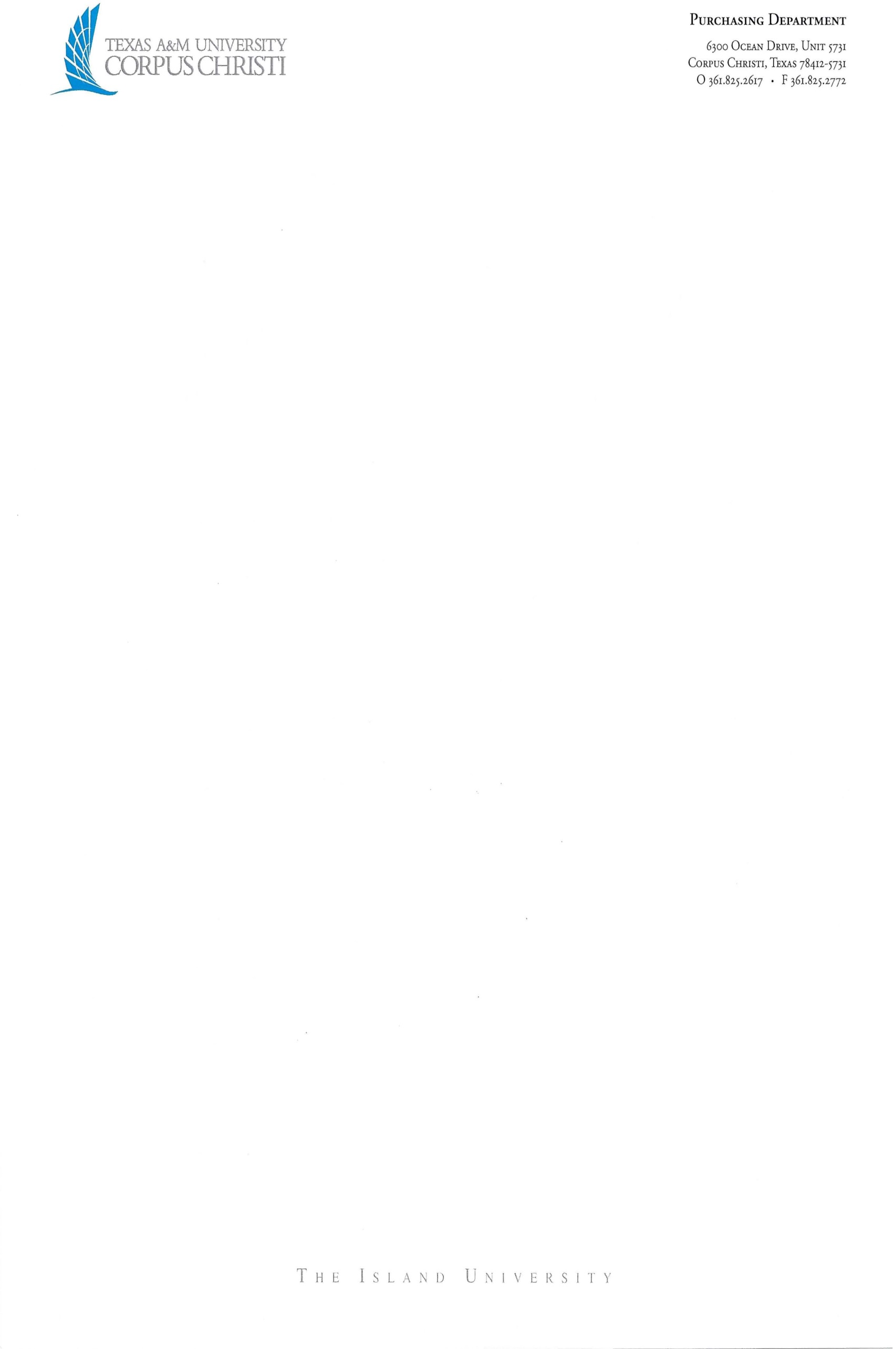
Contracts Administration
6300 Ocean Drive, Unit 5731
Corpus Christi, Texas 78412-5731

FACILITY USE ADDENDUM
between TEXAS A&M UNIVERSITY – CORPUS CHRISTI
and ___________________________

The following terms and conditions are incorporated into and form a part of the [Insert Name of Agreement] (the "Agreement") to which this Addendum is attached. “TAMU-CC” means Texas A&M University–Corpus Christi, a member of The Texas A&M University System, an agency of the State of Texas and “FACILITY” means __________________________.

For clarification, the [Insert Name of Agreement] is being entered into by Texas A&M University–Corpus Christi, a member of The Texas A&M University System, an agency of the State of Texas. TAMU-CC requires the following changes to be made to FACILITY’S standard [Insert Name of Agreement].

(Choose option 1 or 2 by marking x in the space below)

- DIRECT BILL ACCOUNT:
______ If there are any charges which accrue and are payable by TAMU-CC, they will be applied to a master account and direct billed. If an existing direct bill account is not already established and on file, TAMU-CC will submit information required to establish a direct bill account prior to the Agreement start date. Under this Agreement, the TAMU-CC credit card shall only be used to secure the room block. All room charges will be paid by each individual reserving a room.

- PAYMENT OF MASTER ACCOUNT:
______ The outstanding balance of TAMU-CC’s direct bill account, if any and excluding disputed charges, will be due following the event and payable within thirty (30) days from receipt of invoice. Upon resolution of any disputed charges, FACILITY shall invoice such remaining charges to TAMU-CC. Payment of the revised charges shall be payable within thirty (30) days of receipt of invoice. All past due amounts will be subject to a finance charge in accordance with the Texas Prompt Payment Act, Chapter 2251, Texas Government Code.

- PAYMENTS: Payments shall be made to Facility by TAMU-CC via procurement and/or travel credit card.

- TAX EXEMPT STATUS: As an agency of the State of Texas, TAMU-CC is tax exempt. Tax exemption certification will be furnished upon request.

- INSURANCE: The liability of The Texas A&M University System and its members (“System”) for personal injury and property damage is controlled by the Texas Tort Claims Act, Texas Civil Practice and Remedies Code, Chapter 101, Section 101.021. The limits of liability are $250,000 for each person, $500,000 for each single occurrence for bodily injury or death and $100,000 for each single occurrence for injury to or destruction of property. Following this limited exposure, System, as a state agency, is protected by the doctrine of sovereign immunity, and as such, is self-insured up to the aforementioned limits.
To expand on this limited liability, the following language defines instances when sovereign immunity may be waived:
A governmental unit in the State is liable for:
(1) Property damage, personal injury, and death proximately caused by the wrongful act or omission or the negligence of an employee acting within his scope of employment if:
- the property damage, personal injury, or death arises from the operation or use of a motor-driven vehicle or motor-driven equipment; and
- the employee would be personally liable to the claimant according to Texas law.
(2) Personal injury and death so caused by a condition or use of tangible personal or real property if the governmental unit would, were it a private person, be liable to the claimant according to Texas law.

- CANCELLATION: In the event TAMU-CC must cancel the Agreement, FACILITY will make every effort to resell the space reserved by TAMU-CC in order to reduce TAMU-CC’s cancellation/attrition fees. Resold space will be credited to reducing any obligations that TAMU-CC may have incurred. TAMU-CC will not pay any cancellation/attrition fees until after the event date. A copy of FACILITY’s occupancy report, concerning the space reserved by TAMU-CC for the date cancelled by TAMU-CC, shall be delivered to TAMU-CC within ten (10) business days of departure date.

TAMU-CC, at any time prior to the event date with written notice, may cancel the Agreement with FACILITY without liability or penalty, in the event one or more of the following occur:

a) A force majeure event as described below, renders either party’s performance inadvisable, impossible, or is materially affected. In the event of cancellation under this Item 1, FACILITY agrees to return any deposits paid by TAMU-CC. In the event TAMU-CC decides to continue with its reserved use of the FACILITY despite such circumstances, FACILITY will waive any fees related to a reduced-sized program or event including, but not limited to, any food and beverage attrition fees and space rental.

b) A Loss of funding event as described below.

c) There is a change in ownership or management of the FACILITY prior to the scheduled arrival date.

d) FACILITY enters into bankruptcy proceedings, becomes insolvent or subject to foreclosure, or takes any other like action for the benefit of creditors or debtors prior to the scheduled arrival date.
- MANDATORY STATE AGENCY CERTIFICATIONS AND PROVISIONS:

a) Franchise Tax Certification. FACILITY certifies that it is not delinquent in the payment of Texas Franchise Tax.

b) Eligibility Certification. Under Section 2155.004, Texas Government Code, FACILITY certifies that the individual or business entity named in this bid or Agreement is not ineligible to receive the specified Agreement and acknowledges that this Agreement may be terminated and payment withheld if this certification is inaccurate.

c) Debts or Delinquencies. Pursuant to Section 2252.903, Texas Government Code, FACILITY agrees that any payments owing to FACILITY under the Agreement may be applied directly toward certain debts or delinquencies that FACILITY owes the State of Texas or any agency of the State of Texas regardless of when it arises, until such debt or delinquency is paid in full.

d) Child Support Certification. Under Section 231.006, Texas Family Code, the FACILITY certifies that the individual or business entity named in this Agreement, bid, or application is not ineligible to receive the specified grant, loan, or payment and acknowledges that this Agreement may be terminated and payment may be withheld if this certification is inaccurate.

- GOVERNING LAW AND VENUE: The validity of the Agreement and all matters pertaining thereto shall be governed and determined by the Constitution and the laws of the State of Texas. Venue for any suit filed against TAMU-CC shall be Nueces County, Texas.

- INAPPLICABLE PROVISIONS: None of the following provisions, if they appear in the Agreement, shall have any effect or be enforceable against TAMU-CC: (i) requiring TAMU-CC to maintain any type of insurance either for TAMU-CC’s benefit or for FACILITY’s benefit; (ii) renewing or extending the initial Agreement term or automatically continuing or renewing the original Agreement term; and (iii) binding TAMU-CC to any arbitration, to the decision of any arbitration board, commission, panel or other entity, or to any other alternative dispute resolution other than is provided below.

- DISPUTE RESOLUTION: The dispute resolution process provided in Chapter 2260, Texas Government Code, and the related rules adopted by the Texas Attorney General pursuant to Chapter 2260, shall be used by TAMU-CC and FACILITY to attempt to resolve any claim for breach of contract made by FACILITY that cannot be resolved in the ordinary course of business. FACILITY shall submit written notice of a claim of breach of contract under this Chapter to TAMU-CC Contracts Administration, who shall examine FACILITY’s claim and any counterclaim and negotiate with FACILITY in an effort to resolve the claim.

- PUBLIC INFORMATION:
a) FACILITY acknowledges that TAMU-CC is obligated to strictly comply with the Public Information Act, Chapter 552, Texas Government Code, in responding to any request for public information pertaining to this Agreement, as well as any other disclosure of information required by applicable Texas law.

b) Upon TAMU-CC’s written request, FACILITY will promptly provide specified contracting information exchanged or created under this Agreement for or on behalf of TAMU-CC.

c) FACILITY acknowledges that TAMU-CC may be required to post a copy of the fully executed Agreement on its Internet website in compliance with Section 2261.253(a)(1), Texas Government Code.

d)The requirements of Subchapter J, Chapter 552, Texas Government Code, may apply to this Agreement and FACILITY agrees that the Agreement can be terminated if FACILITY knowingly or intentionally fails to comply with a requirement of that subchapter.

- LOSS OF FUNDING: Performance by TAMU-CC under the Agreement may be dependent upon the appropriation and allotment of funds by the Texas State Legislature (the "Legislature"). If the Legislature fails to appropriate or allot the necessary funds then TAMU-CC will issue written notice to FACILITY and TAMU-CC may terminate the Agreement without further duty or obligation hereunder. FACILITY acknowledges that appropriation of funds is beyond the control of TAMU-CC.

- FORCE MAJEURE: Neither party will be in breach of its obligations under this Agreement or incur any liability to the other party for any losses or damages of any nature whatsoever incurred or suffered by that other party if and to the extent that it is prevented from carrying out those obligations by, or such losses or damages are caused by, a Force Majeure event (as defined below), except to the extent that the relevant breach of its obligations would have occurred, or the relevant losses or damages would have arisen, even if the Force Majeure event had not occurred. “Force Majeure event” is defined as: 1) acts of God; 2) war; 3) act(s) of terrorism; 4) fires; 5) explosions; 6) natural disasters, to include without limitation, hurricanes, floods, and tornadoes; 7) failure of transportation; 8) strike(s); 9) loss or shortage of transportation facilities; 10) lockout, or commandeering of materials, products, plants or facilities by the government or other order (both federal and state); 11) interruptions by government or court orders (both federal and state); 12) present and future orders of any regulatory body having proper jurisdiction; 13) civil disturbances, to include without limitation, riots, rebellions, and insurrections; 14) epidemic(s), pandemic(s), or other national, state, or regional emergency(ies); and 15) any other cause not enumerated in this provision, but which is beyond the reasonable control of the party whose performance is affected and which by the exercise of all reasonable due diligence, such party is unable to overcome. Such excuse from performance will be effective only to the extent and duration of the Force Majeure event(s) causing the failure or delay in performance and provided that the affected party has not caused such Force Majeure event(s) to occur and continues to use diligent, good faith efforts to avoid the effects of such Force Majeure event(s) and to perform its obligation(s). Written notice of a party’s failure or delay in performance due to Force Majeure must be given within a reasonable time after its occurrence and must describe the Force Majeure event(s) and the actions taken to minimize the impact of such Force Majeure event(s). For the avoidance of doubt, the COVID-19 pandemic and any governmental changes or closures related thereto shall be deemed Force Majeure events, even to the extent reasonably foreseeable by either party as of the effective date of this Agreement.

- PROHIBITION ON CONTRACTS/AGREEMENTS WITH COMPANIES BOYCOTTING ISRAEL: To the extent that Texas Government Code, Chapter 2271 applies to the Agreement, FACILITY certifies that (a) it does not currently boycott Israel; and (b) it will not boycott Israel during the term of the Agreement. FACILITY acknowledges the Agreement may be terminated and payment withheld if this certification is inaccurate.
- CERTIFICATION REGARDING BUSINESS WITH CERTAIN COUNTRIES AND ORGANIZATIONS: Pursuant to Subchapter F, Chapter 2252, Texas Government Code, FACILITY certifies it is not engaged in business with Iran, Sudan, or a foreign terrorist organization. FACILITY acknowledges this Agreement may be terminated if this certification is inaccurate

- RECORDS RETENTION: FACILITY will preserve all contracting information, as defined under Texas Government Code, Section 552.003 (7), related to the Agreement for the duration of the Agreement and for seven years after the conclusion of the Agreement.

- PROHIBITION ON CONTRACTS/AGREEMENTS RELATED TO PERSONS INVOLVED IN HUMAN TRAFFICKING: Under Section 2155.0061, Government Code, the FACILITY certifies that the individual or business entity named in the Agreement is not ineligible to receive the specified Agreement and acknowledges that the Agreement may be terminated and payment withheld if this certification is inaccurate.

- LIMITATIONS: The parties are aware that there are constitutional and statutory limitations on the authority of TAMU-CC (a state entity) to enter into certain terms and conditions of the Agreement, including, but not limited to, authorizations of the placement of liens on TAMU-CC’s property; disclaimers and limitations of warranties; disclaimers and limitations of liability for damages; waivers, disclaimers and limitations of legal rights, remedies, requirements and processes; limitations of periods to bring legal action; granting control of litigation or settlement to another party; liability for acts or omissions of third parties; payment of attorneys’ fees; dispute resolution; indemnities; and confidentiality (collectively, the “Limitations”). Any Agreement terms and conditions related to the Limitations will not be binding on TAMU-CC except to the extent authorized by the laws and Constitution of the State of Texas. Neither the execution of the Agreement by TAMU-CC nor any other conduct, action, or inaction of any representative of TAMU-CC relating to the Agreement constitutes or is intended to constitute a waiver of TAMU-CC’s or the State’s sovereign immunity to suit.

- CONFLICT OF INTEREST: By executing the Agreement, FACILITY and each person signing on behalf of FACILITY certifies, and in the case of a sole proprietorship, partnership or corporation, each party thereto certifies as to its own organization, that to the best of their knowledge and belief, no member of The Texas A&M University System or The Texas A&M University System Board of Regents, nor any employee, or person, whose salary is payable in whole or in part by The Texas A&M University System or its members, has direct or indirect financial interest in the award of the Agreement, or in the services to which the Agreement relates, or in any of the profits, real or potential, thereof.

- ADDENDUM CONTROLLING: In the event there is a conflict between the terms and conditions of the Agreement and this Addendum, this Addendum will control.

In WITNESS WHEREOF, the parties have caused this Addendum to be duly executed intending to be bound thereby.

FACILITY: TEXAS A&M UNIVERSITY
– CORPUS CHRISTI:

By: By:
Name: Name:
Title: Title:
Date: Date:

