Setting up Smartsheet for New User
Step #1 Open the Smartsheet Invite received by Allison Lewis via Smartsheet.
Note: Emails via Smartsheet may be found in the junk mail for initial invites. Once your profile is set up then any notifications will go into your Inbox.
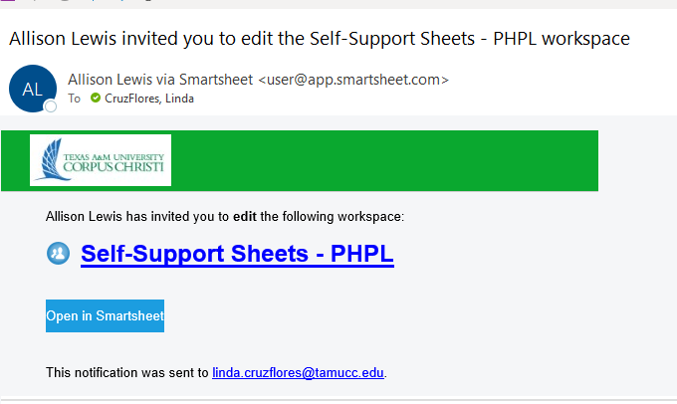
Clicking in this box will open the link

2. Once you click on the “Open in Smartsheet” button and it will guide you to set up your Smartsheet Profile.
Note: Please ignore the UPGRADE button at the top of your sheets. Our Enterprise plan will convert your profile to a “Free User”. NO need to upgrade.
Ignore!
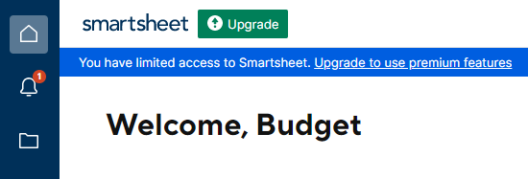
3. Access the Profile Settings and enter your basic profile information.

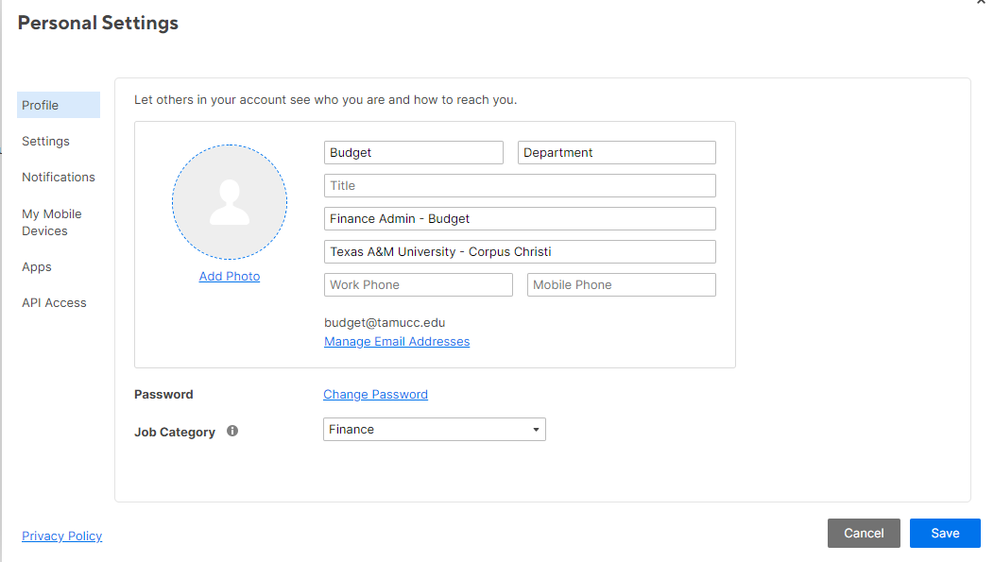

4. Access the Self-Support Smartsheet assigned to you for the Account Numbers you will be preparing or approving.

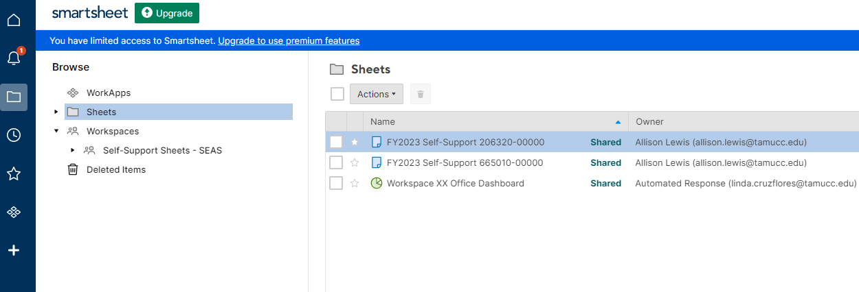
Click here.

