Course Copy Process to Support Accessibility and Remove Unused Files

Use the process below to copy your previously taught course(s) and avoid copying unused files.
- In Canvas, go to the course where you would like to import/copy content.
- In Course Navigation, click the Settings link.
- Click the Import Course Content link.
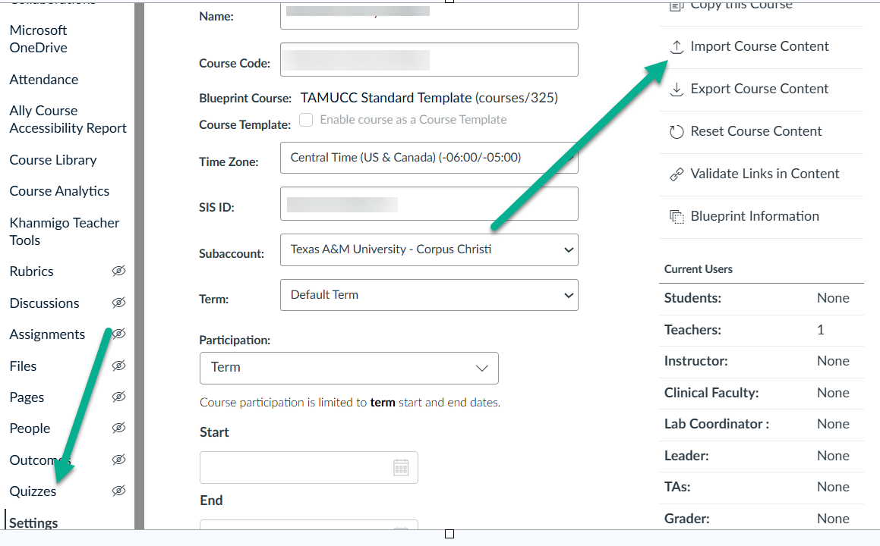
- In the Select Content Type drop-down menu, select the Copy a Canvas Course option.
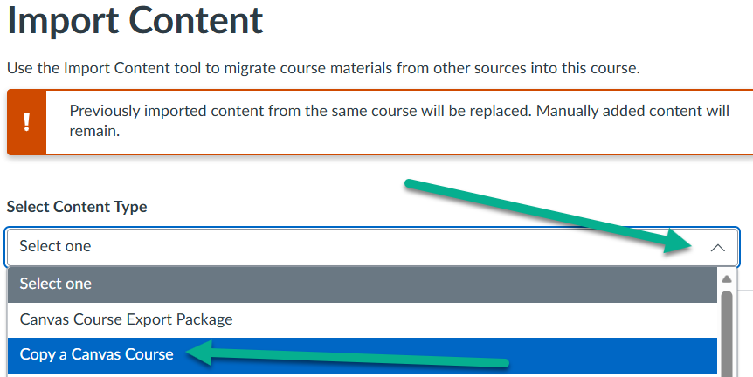
- In the Select a course drop-down menu, select the course you would like to access. Courses are ordered alphabetically by most recent term. To search for a course by name, enter the name or SIS ID in the Search for a course field. Click the course name when it appears. Click the Select specific content radio button.
- DO THIS STEP to avoid bringing previous due dates into your grade book: Click the Adjust Events and Due Dates checkbox and select the option to Shift dates or remove dates altogether.
- Click the blue button to Add to Import Queue.
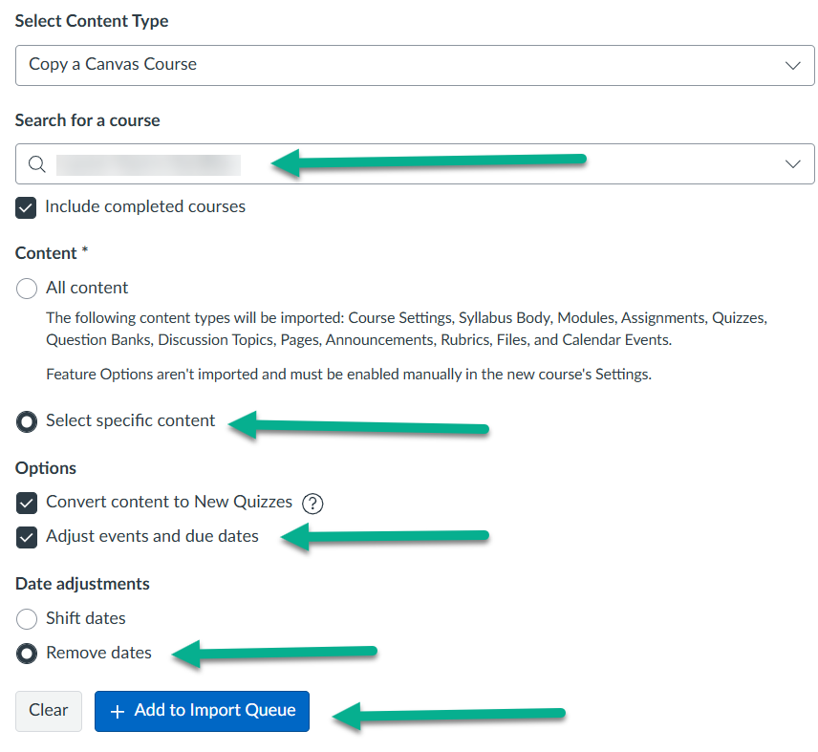
- On the Import Content page, click Select Content.
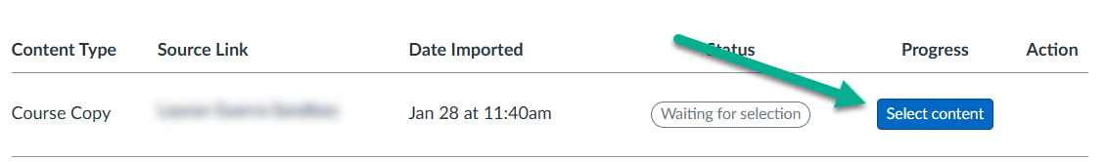
- On the Select Content for Import frame, select Modules ONLY! As long as your content is linked in the modules (e.g., quizzes, discussions, assignments), it will be brought over with the modules.
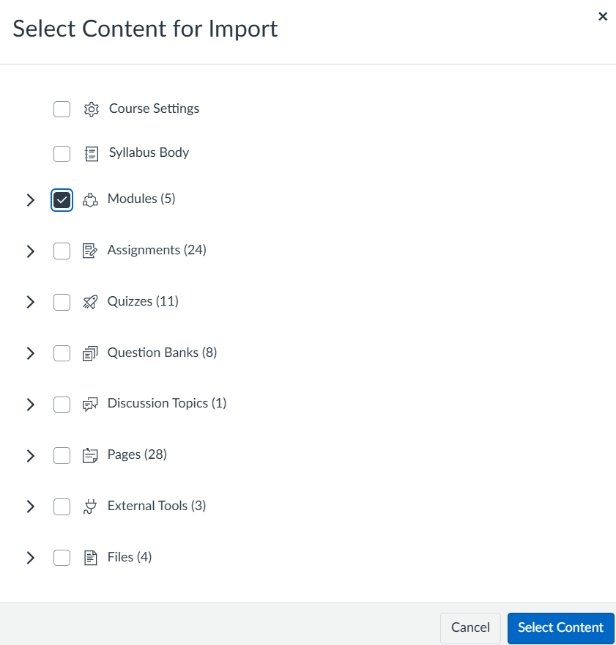
- If you would like to copy content not linked in the modules, expand the drop-down arrows and add your selections. Click the blue Select Content button and wait for the content to copy. Once ready, you will see the Completed Message in the Course Imports on the same page.
- Verify that the course content was copied correctly.
For more information, contact dlai@tamucc.edu

