Creating a Header
In Microsoft Word: MLA

Insert > Header > Select first header option > Click page number – select Top of Page, right aligned > Click in front of page number > Type your last name > Space > Close Header and Footer

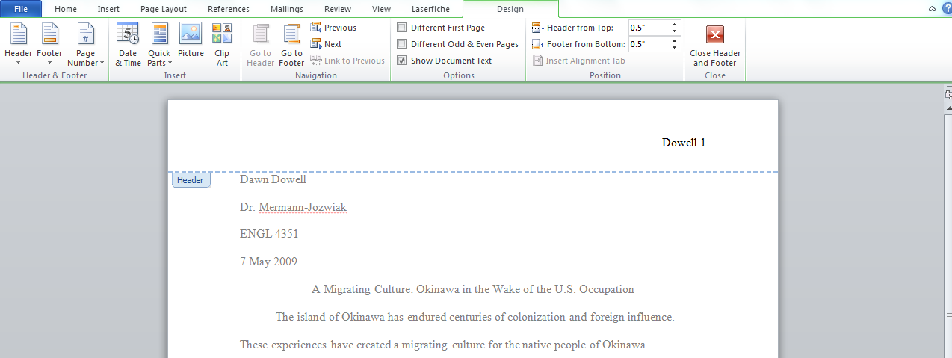

Scroll to page two to check your heading.

