Chicago Style

This handout covers the notes and bibliography citation style as outlined in The Chicago Manual of Style, 17th edition. You will cite each source in the text of your paper, using a footnote or endnote, and you will cite all sources used in your paper in a bibliography at the end of your paper.

Notes
- To acknowledge a source in the text of your paper, place a superscript number immediately after the end punctuation of a sentence.

- The first time a source is mentioned in a note, give the full citation. Subsequent uses can use a shortened version of the citation.

- Notes should be created by use of the footnote function of the word processor.
  - Under References > Insert Footnote
  - This should enter a number in the text of your paper and at the foot of your page.
  - Delete superscript number in footer.
  - Tab > Type Number of footnote
  - The first line of each note is indented, and subsequent lines return to left margin.
  - Format font to match font of document.

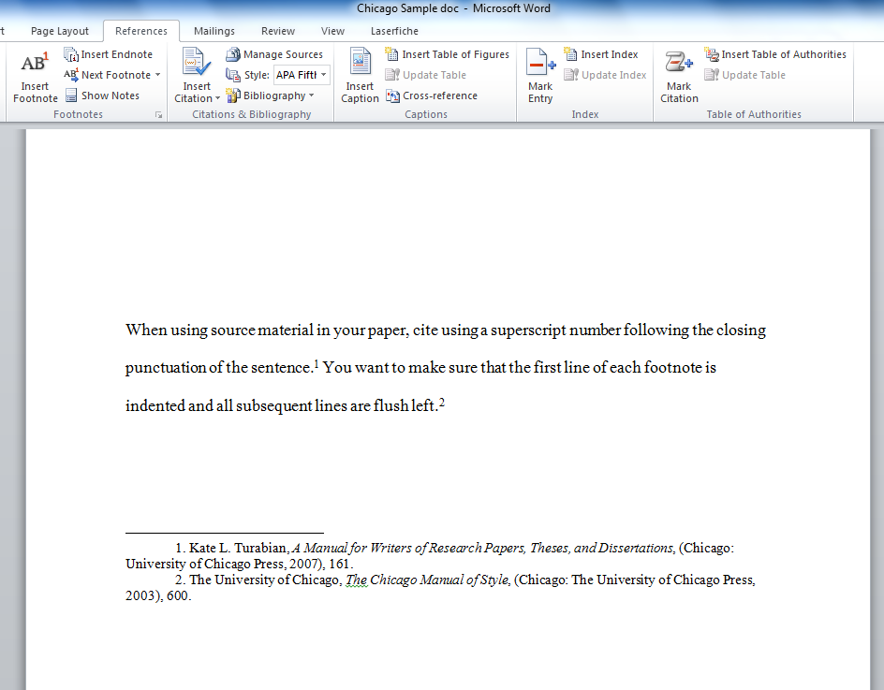

Chicago Style

Bibliography

- List of sources used within your paper, included at the end of your paper.
- Single-spaced
- Format citations using a hanging indent – the first line is flush left and all subsequent lines are indented.
- Sources are listed in alphabetical order by last name of author.
  - If multiple authors, only the name of the first author is inverted: Last Name, First Name
  - If no author or editor, order by title.
  - A single-author entry precedes a multi-author entry beginning with the same name.
- Notes use commas and parentheses to separate items in a citation; a bibliography uses periods.

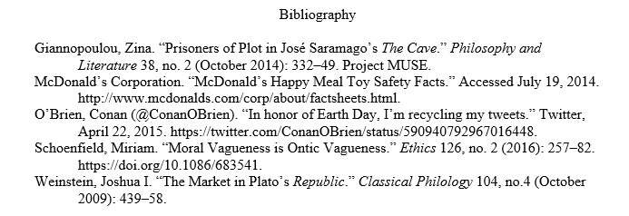

Chicago Style

Book – One Author (Chicago Manual, Section 14.100)

N:
1. Michael Pollan, The Omnivore’s Dilemma: A Natural History of Four Meals (New York: Penguin, 2006), 99.
2. Pollan, Omnivore’s Dilemma, 3.

B:

Pollan, Michael. The Omnivore’s Dilemma: A Natural History of Four Meals. New York: Penguin, 2006.

Book – Two or More Authors (Chicago Manual, Section 14.76)
(For four or more authors, list all authors in the bibliography; in the note, list the first author, followed by et al.)

N:
1. Geoffrey C. Ward and Ken Burns, The War: An Intimate History, 1941–1945 (New York: Knopf, 2007), 52.
2. Ward and Burns, Intimate History, 59–61.

B:
Ward, Geoffrey C., and Ken Burns. The War: An Intimate History, 1941–1945. New York: Knopf, 2007.

Chapter or Part of Book (Chicago Manual, Section 14.106–7)

N:
1. John D. Kelly, “Seeing Red: Mao Fetishism, Pax Americana, and the Moral Economy of War,” in Anthropology and Global Counterinsurgency, ed. John D. Kelly et al. (Chicago: University of Chicago Press, 2010), 77.
2. Kelly, “Seeing Red,” 81.

B:
Kelly, John D. “Seeing Red: Mao Fetishism, Pax Americana, and the Moral Economy of War.” In Anthropology and Global Counterinsurgency, edited by John D. Kelly, Beatrice Jauregui, Sean T. Mitchell, and Jeremy Walton, 67–83. Chicago: University of Chicago Press, 2010.

Newspaper or Magazine Article – Print (Chicago Manual, Section 14.188, 14.191)

N:
1. Daniel Mendelsohn, “But Enough About Me,” New Yorker, January 25, 2010, 68.
2. Mendelsohn, “But Enough About Me,” 69.

B:

Mendelsohn, Daniel. “But Enough About Me.” New Yorker, January 25, 2010.

YouTube Video (Chicago Manual, Section 14.209)

N:
1. Tara Stiles (TaraStiles), “10 Minute Yoga for Balance with the Baby Routine,” YouTube video, July 14, 2017, https://youtu.be/qs5bHcOf4xg.
2. Stiles, “10 Minute Yoga.”

B:
Stiles, Tara. “10 Minute Yoga for Balance with the Baby Routine.” YouTube video, July 14, 2017. https://youtu.be/qs5bHcOf4xg.

Chicago Style

Academic Journal Article – Print (Chicago Manual, Section 14.171)

N:
1. Joshua I. Weinstein, “The Market in Plato’s Republic,” Classical Philology 104, no. 4 (October 2009): 440.
2. Weinstein, “Plato’s Republic,” 452–53.

B:

Weinstein, Joshua I. “The Market in Plato’s Republic.” Classical Philology 104, no. 4 (October 2009): 439–58.

Academic Journal Article – Online with DOI (Chicago Manual, Section 14.175)

N:
1. Miriam Schoenfield, “Moral Vagueness is Ontic Vagueness,” Ethics 126, no. 2 (2016): 260–61, https://doi.org/10.1086/683541.
2. Schoenfield, “Moral Vagueness is Ontic Vagueness,” 270.

B:

Schoenfield, Miriam. “Moral Vagueness is Ontic Vagueness.” Ethics 126, no. 2 (2016): 257–82.

https://doi.org/10.1086/683541.

Academic Journal Article – Online without DOI (Chicago Manual, Section 14.175)

N:
1. Zina Giannopoulou, “Prisoners of Plot in José Saramago’s The Cave,” Philosophy and Literature 38, no. 2 (October 2014): 335, Project MUSE.
2. Giannopoulou, “Prisoners of Plot in José Saramago’s The Cave,” 337.

B:

Giannopoulou, Zina. “Prisoners of Plot in José Saramago’s The Cave.” Philosophy and Literature 38, no. 2

(October 2014): 332–49. Project MUSE.

Web Source (Chicago Manual, Section 14.206)

N:
1. Evanston Public Library Board of Trustees, “Evanston Public Library Strategic Plan, 2000-2010: A Decade of Outreach,” Evanston Public Library, accessed July 18, 2014, http://www.epl.org/library/strategic-plan-00.html.
2. Evanston Public Library, “Strategic Plan.”

B:

Evanston Public Library Board of Trustees. “Evanston Public Library Strategic Plan, 2000–2010: A Decade of
Outreach.” Evanston Public Library. Accessed July 18, 2014. http://www.epl.org/library/strategic-plan-00.html.

Web Source – No Author (Chicago Manual, Section 14.207)

N:
1. “McDonald’s Happy Meal Toy Safety Facts,” McDonald’s Corporation, accessed July 19, 2014, http://www.mcdonalds.com/corp/about/factsheets.html.
2. “Toy Safety Facts.”

B:
McDonald’s Corporation. “McDonald’s Happy Meal Toy Safety Facts.” Accessed July 19, 2014. http://www.mcdonalds.com/corp/about/factsheets.html.

Chicago Style

Personal Interview (Chicago Manual, Section 14.211)
Unpublished interviews are best cited in text or notes. A citation will begin with the name of the person interviewed, place and date of interview, and any other brief identifying information that is applicable.

N:
1. Dawn Dowell (CASA Writing Center Coordinator), interview by author, Corpus Christi, TX, October 12, 2014.
2. Dowell, interview.

Social Media – Twitter (Chicago Manual, Section 14.209)

N:
1. Conan O’Brien (@ConanOBrien), “In honor of Earth Day, I’m recycling my tweets,” Twitter, April 17, 2015, https//twitter.com/ConanOBrien/status/590940792967016448.
2. O’Brien, “In honor of Earth Day, I’m recycling my tweets.”

B:

O’Brien, Conan (@ConanOBrien). “In honor of Earth Day, I’m recycling my tweets.” Twitter, April 22, 2015.

https://twitter.com/ConanOBrien/status/590940792967016448.

