Taking Effective Notes

Whether listening to a lecture or reading a text, note-taking is an effective strategy to stay focused, keep track of information, and create a study/review sheet. Some professors provide access to their PowerPoint slides, which can be a helpful tool and foundation for the notes you take during lecture and while reading.

Tips for Taking Notes
- Do not try to write everything you hear/read. Focus on the main points of the lecture/reading.
- Keep your notes organized in a notebook, binder, or folder.
- Indicate important concepts or ideas with symbols (*, !, circle, box, highlight, underline, or bold).
  - When taking notes during lecture, listen for cues, such as:
    - “This is important” or “This will be on the test”
    - Repetition of words or concepts
    - Language that connects ideas, such as:
      - first, second, third
      - especially, most significant, most important
      - however, on the other hand
      - because, therefore, consequently
- Do not scratch out or erase mistakes. Draw a single line through them to save time and stay focused.

Methods for Note-taking
It is important to find a method that works best for your learning preferences. Some individuals prefer to type their notes using an outline formula, while others prefer to draw their notes. Different methods can be combined to create your own approach.

Outlining: Pay attention to important ideas and main points. Align the main points on the left margin and label with A, B, C, etc. or I, II, III, etc. Write down supporting ideas in short phrases using bullets or other symbols. Important vocabulary or examples can also be included.
- If taking notes on a computer, an outline can be quick and easy.
- If writing notes on paper, drawing lines or highlighting can help indicate separations in material.

- Ethical Theories (continued from 9/6)
  - Cultural Relativism: the meaning of “right” or “wrong” are decided (expected) by society’s moral guidelines.
**These guidelines vary from place to place.**
    - FOR
      - Social contexts are valuable b/c societies are different
      - One society cannot judge another society for “proper moral conduct”
    - AGAINST
      - What if a society has bad guidelines? Or neither?
      - How does an individual determine the moral guidelines of a society?
      - Cultural norms do not apply to all individuals; therefore, not all agree on right/wrong
      - Moral guidelines evolve – by what standard/value
      - How do we reconcile inevitable conflict b/w?
      - Just b/c it exists does not mean it is “acceptable” to others
      - Tradition is not based on reason
  - Divine Command Theory: good actions are aligned with the will of God and bad actions are contrary to the will of God

Taking Effective Notes

Mind Mapping: In the center of your paper, write the main topic of the lecture or reading and draw a shape around it. From this main point, create connections to related topics or terms using words, phrases, or images.
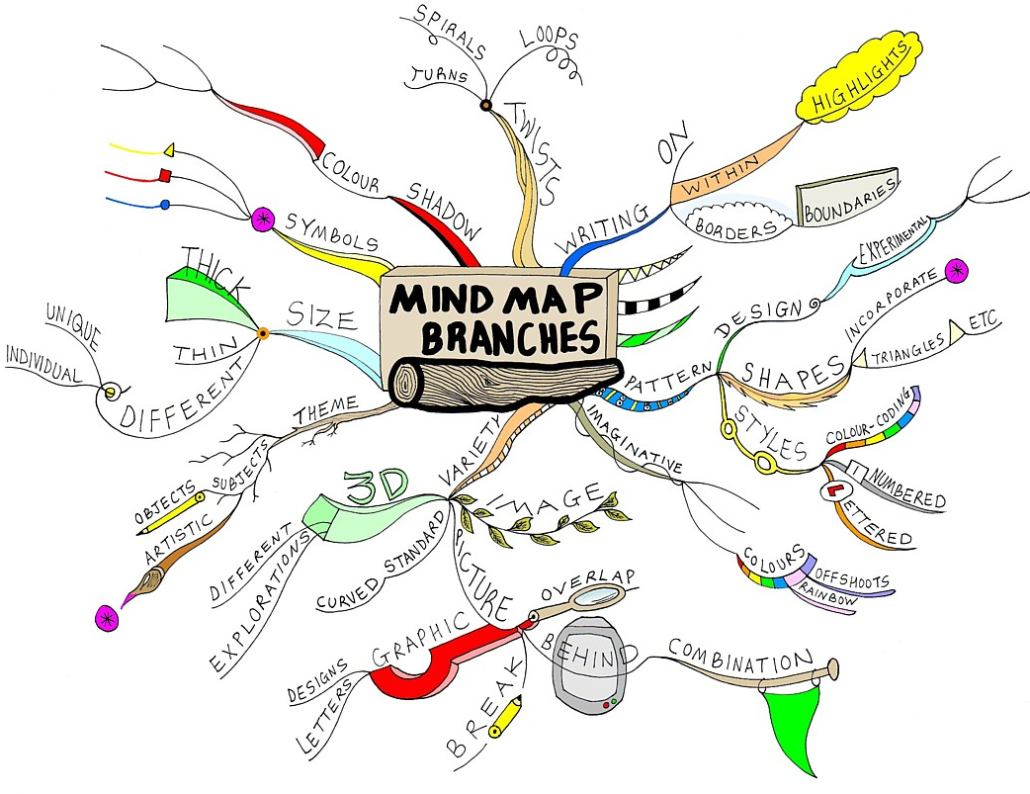 Image retrieved from http://www.mindmapinspiration.com/

The Cornell Note-taking System:
- Divide your page into two columns. Label the left column “Keywords” and the right column “Notes.” Save room for a “Summary” section under the “Keywords” and “Notes” columns
- During lecture, write your notes in the “Notes” column. Focus on the main points of the lecture. Use phrases, bullet points, and/or images.
- After lecture, write down keywords in the “Keywords” column. Review your notes in the “Notes” column and try to reduce each line of your notes into one keyword. Write down that keyword in the left-hand column.
- Review and test yourself using the “Keywords” column. Cover the “Notes” column with a sheet of paper, leaving the “Keywords” column visible. While looking at each keyword, try to recall as much information from your class notes as possible. Then, uncover the “Notes” section to verify what you said or wrote down.
- Once you have finished the recall exercise, write a brief summary of the notes in the “Summary.”
Note: This method of notetaking can also be utilized while reading.
Keywords | Notes
Summary

The information for this handout was compiled from the following sources:
Cornell University Learning Strategies Center. (2001). The Cornell note-taking system. Retrieved from
http://lsc.cornell.edu/LSC_Resources/cornellsystem.pdf
Dartmouth Academic Skills Center. (2013). Classes: Notetaking, listening, participation. Retrieved from
http://www.dartmouth.edu/~acskills/success/notes.html

