Align is the place to be if you are interested in reviewing an upcoming class schedule and comparing your currently planned courses and seats with course recommendations.

See What’s Recommended
- Review recommended changes to your course offerings for a given term. The analysis shows the courses that would make a high impact by suggesting addition or reduction candidates.
Get Some Details
- Drill in on a single course to get the course analysis and section details to help make decisions. Same Line as below.
See Who Needs the Course
- Departments can take a deep dive individual students that need the course in question as well as how they are progressing toward completion of their graduation plan.
Take Action
- Model the addition or reduction of sections based on recommendations. Mark the courses as reviewed, approved, or scheduled to track progress. Need to discuss? Send messages to other users to ask questions or get approval.

- Go to site: https://app.adastra.live
- Enter email and if you have never logged in, you will want to reset your password using the Forgot Password Link. (or temporary password)After successfully logging in, you will find the different modules on the left. Select: Align
- To get started: enter the term in which you are schedule building for in the term box. Quick filters have been created for departments to quickly only view courses that pertain to their department. You can also share filters with anyone that has access to Align.

- The Course List:
  - The course list becomes a convenient worksheet for those involved in the schedule review, approval, and update process. When section offering changes are entered into the Banner and re-imported, the Planned sections and status are reset.
    - Candidate Type and the Candidate (Courses) Detail: an explanation for the recommendation.
    - Offered: sections and seats currently offered in the analyzed term.
    - Needed: the total number of recommended sections and seats based upon the data analyzed.
    - Planned: total number of sections and seats that will be offered after the scheduling changes are confirmed. This value starts out equal to Offered and can be toggled up or down to model the addition or reduction of sections.
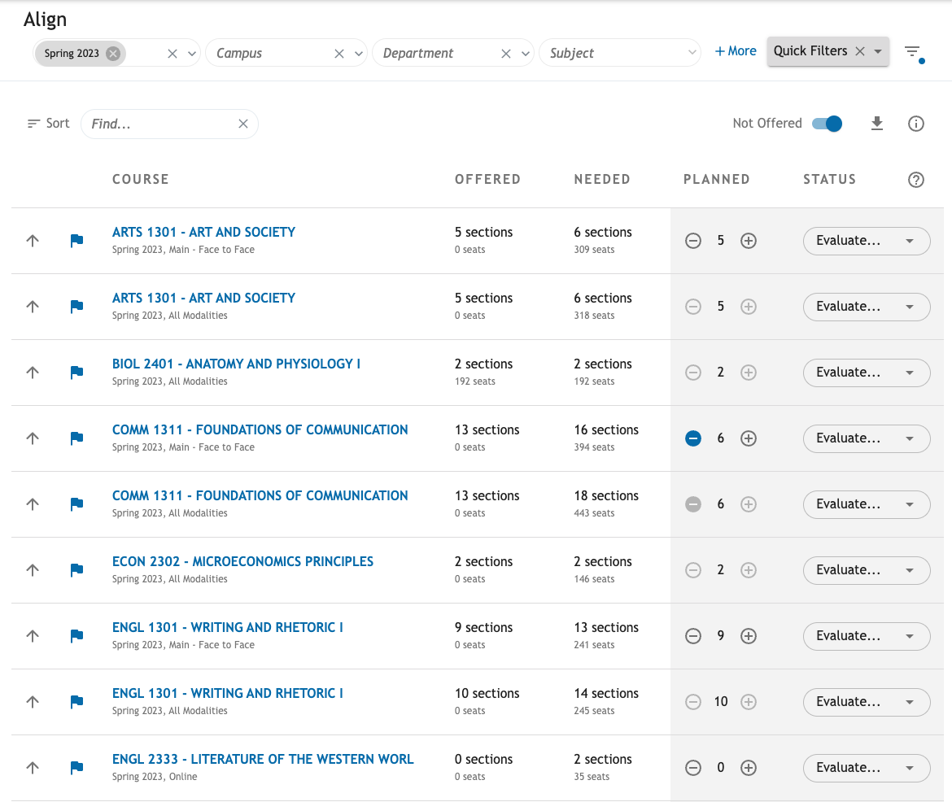
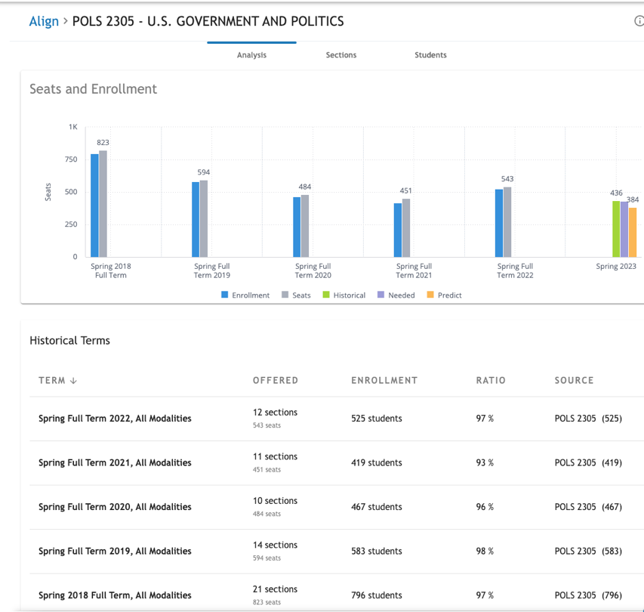
    - Status: the status of a course that can be changed relative to your schedule change process.
- These recommendations are a combination based on historical enrollment trends and predictions. Click on an individual course to dig in further. Notice that the "Recommendations" section includes a "Predict" column.

- Sections Tab- Drill in on a single course to get the course analysis.

- Student Tab- the list of students that the analysis sees as needing the course in question to continue to make progress on their graduation plan. The list sows the student’s name and ID with the total credit applied to their plana and which plan it is associated with.
You can filter the student type by choosing one of the student types listed below for the above chart.

Current Students
Students that were enrolled in the previous term and still have remaining credits.
New Students
Students that are expected to enroll in the institution without existing credits.
Transfer Students
Students that are expected to enroll in the institution with only transfer credits.

Returning Students
Students that once were enrolled in this institution, were not enrolled in the previous term, but are expected to return.
Departing Students
Students that are not expected to return to the institution even though they still have remaining credits.
We hope you will use Align data to make data-driven decisions. Please contact Schedule@tamucc.edu with any questions you may have!

