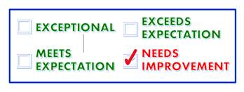

[Student],

Professor [Professor] has raised a [Flag Name] for you in [Course Name]. If your professor has provided additional comments regarding this alert, those details will be provided below.

**Professor Comments:**

[Professor Comments]

**A message from the Office of Student Success:**

We understand that managing life during a pandemic can be challenging. We believe that you can be successful in this course, however, some action will be required on your part.

We encouraged you to do one or more of the following:

1. Reply to this message to discuss your progress with your Professor
2. [Reach out to CASA](https://casa.tamucc.edu/) and check for tutoring or other resources available for you
3. Talk to your [academic advisor](https://www.tamucc.edu/academics/planning/academic-advising/index.php)

We care about your success and look forward to reaching out to you to offer our support.

Sincerely,

**Office of Student Success**

[starfish@tamucc.edu](mailto:starfish@tamucc.edu)