Creating a Header
In Microsoft Word: MLA (PC Version)

Insert > Header > Select first header option > Click page number – select Top of Page, right aligned > Click in front of page number > Type your last name > Space > Close Header and Footer

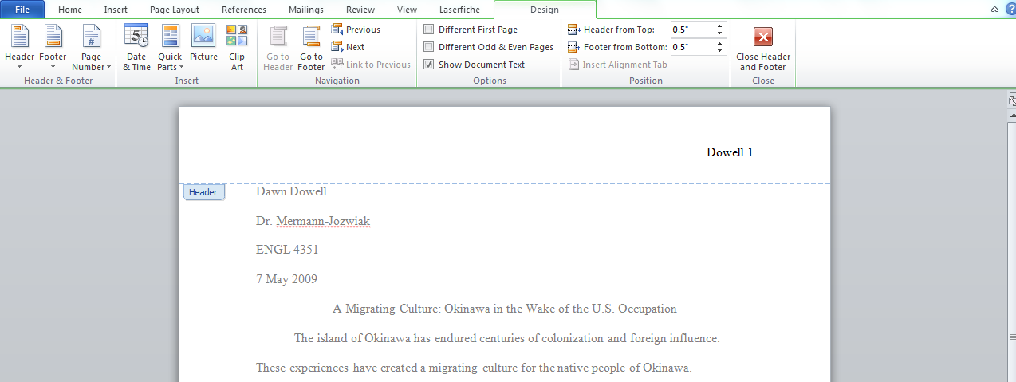

Scroll to page two to check your heading.

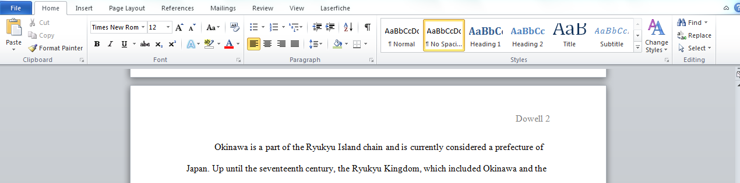

Creating a Header
In Microsoft Word: MLA (MAC Version)

Click on Document Elements > Header > Type your Last Name > Select Page # - right alignment

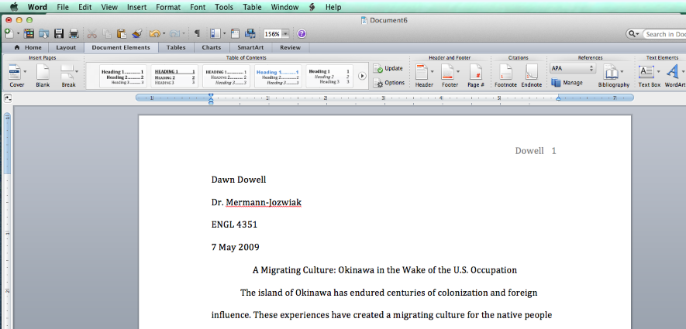

Scroll to page two to check your header.

